Aabenraa, Southern Jutland, Denmark
Once one of Denmark's greatest seafaring towns, Aabenraa sits at the head of a 10-km fjord with cobblestone streets, a 15th-century castle, and beach walks all within easy reach of the quay.
⚓ Docked (Sønderjyllandskajen) · 🕒 Typical call: 6-8 hrs · 💵 Danish Krone (DKK) · 🗣️ Danish / German
✍️ MY DAY IN PORT (FILL IN)
Ship / Date
In port | arrive ______ · all aboard ______
Booked excursion
Notes / meeting point
GETTING ASHORE
- Docking: Docked at Sønderjyllandskajen (Southern Jutland Quay); ships up to 250 m / 11 m draught
- Walk to centre: ~10 min on foot from the commercial quay to Storegade and the old town
- Best For: History buffs, harbour strolls, coastal hiking, Danish food culture
- Don't Miss: Brundlund Slot (castle art museum) and the Gendarmstien coastal trail
GETTING AROUND
- 🚕 Taxi: 55–130 DKK — Taxis are available at the port. A short ride into town starts around 55 DKK (flag fall) — but the city center is close
- 📱 Rideshare: ✅ Uber
TOP THINGS TO DO
- Brundlund Slot — Medieval Castle & Art Museum — This moated castle, built in 1411 by Queen Margrethe I, now houses a collection of regional art including works from the golden…
- Museum Sønderjylland — Maritime & Local History — Traces Aabenraa's golden age as one of Denmark's leading shipping and shipbuilding towns in the 18th–19th centuries — over 300…
- Gendarmstien Coastal Hike — This historic border-patrol trail runs roughly 84 km along the Flensburg Fjord from Padborg to Skovby on the island of Als.
- Frøslev Camp — WWII Internment Museum — A moving memorial near Padborg, about 28 km south: the largest German-operated internment camp on Danish soil during World War II.
- Sønderstrand Beach & Fjord Walk — A sandy Blue Flag beach on the Aabenraa Fjord, a short bus or taxi ride from the port.
BEST WALKS
- Old Town & Harbour Loop: ~3 km · 1 hr · Flat — From the quay, walk north along the harbour promenade to Nyhavn, then turn inland to Storegade.
- Fjord Shore to Felstedskov Forest Edge: ~5 km · 1.5 hrs · Easy — Head south along the fjord shore path, passing the marina and boat yards, before climbing gently…
WEATHER · DAYLIGHT · MONEY
Month | High °F | Low °F | Rainy days
May | 60 | 46 | 12
Jul | 69 | 56 | 14
Sep | 64 | 53 | 12
Daylight: May 5:14AM–9:23PM · Jul 5:03AM–9:51PM · Sep 6:55AM–7:38PM
cruiseports.org/aabenraa · Confirm terminal & all-aboard time with your ship

Aabenraa, Southern Jutland, Denmark — Port Map
Red = walkable sights · Amber = excursions farther out · P = cruise terminal
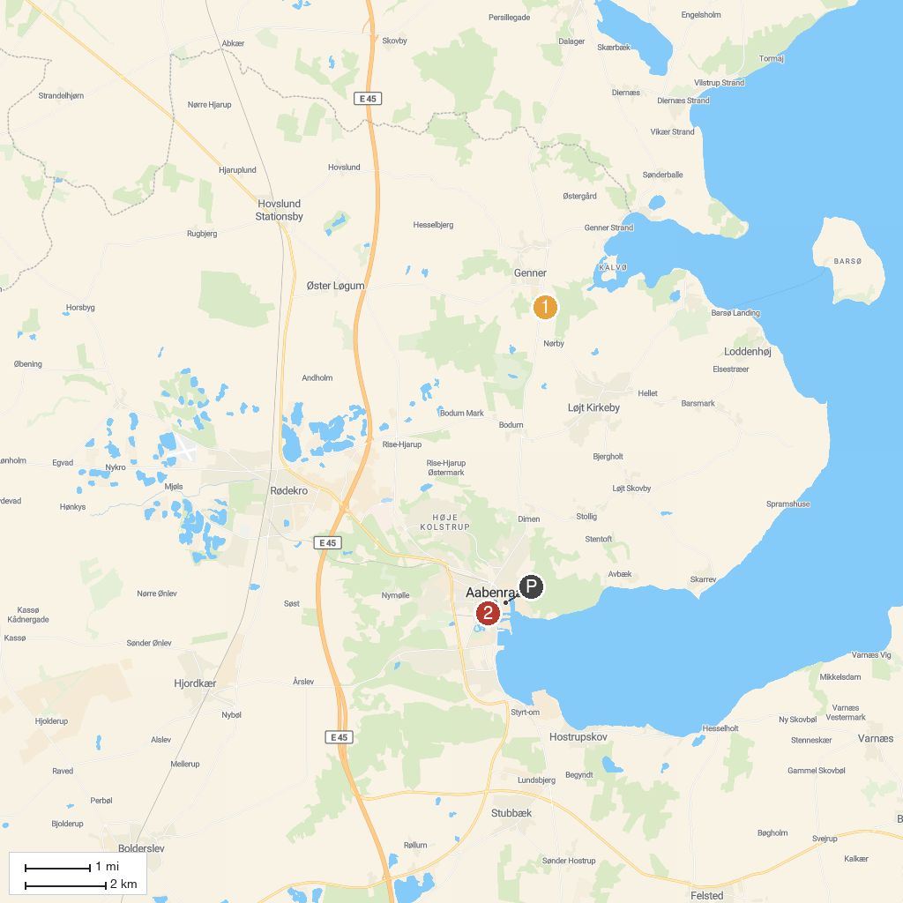
MAP KEY
1. HighPark Sønderjylland | 3. Aabenraa Historic City
2. Jump A Lot
P. Cruise port / terminal
Map © MapTiler © OpenStreetMap contributors · cruiseports.org

