Aasiaat, Disko Bay, Greenland
The "Town of the Whales" sits amid an archipelago of a thousand islands in Disko Bay. Expect tender landings, a compact colorful town, and some of Greenland's richest waters for humpbacks and icebergs.
⚓ Tender port · 🕒 Typical call: 4–7 hrs · 💵 Danish Krone (DKK) · 🗣️ Greenlandic & Danish · 🐋 Whale watching hub
✍️ MY DAY IN PORT (FILL IN)
Ship / Date
In port | arrive ______ · all aboard ______
Booked excursion
Notes / meeting point
GETTING ASHORE
- Docking: Tender only — no cruise pier; ships anchor offshore in the harbor
- Walk to center: 5 min from tender dock to town center; fully walkable
- Best For: Whale watching, Arctic kayaking, Inuit cultural history
- Don't Miss: Aasiaat Museum in the 1860 colonial residence & Egede's black church
GETTING AROUND
- 🚕 Taxi: ~90–130 DKK (≈–19 USD) — Local taxis are available for hire. Fares start around 30 DKK with ~20 DKK/km; taxis are considered expensive by local s
- 📱 Rideshare: ❌ not available
TOP THINGS TO DO
- Whale Watching in Disko Bay — Disko Bay is one of Greenland's most productive feeding grounds.
- Iceberg & Island Boat Tour — A short boat trip around the Aasiaat archipelago takes you past enormous drifting icebergs, low-lying islands, and quiet…
- Arctic Kayaking — Paddle among the sheltered island channels of the Aasiaat archipelago.
- Aasiaat Museum & Town Walk — The Aasiaat Museum (Katersugaasiviat) occupies the colonial administrator's 1860 residence and covers Inuit history, Thule…
- Dog Sledding (Winter Calls) — Ships calling November–April can arrange dog sled excursions across the frozen sea ice — a classic Arctic experience offered by…
BEST WALKS
- Town Center & Harbor Loop: 1.5 km · 30–45 min · Flat · Easy — From the tender landing, walk along the harbor quay to watch local fishing boats and shipwrights at…
WEATHER · DAYLIGHT · MONEY
Month | High °F | Low °F | Rainy days
May | 35 | 26 | 5
Jul | 52 | 41 | 7
Sep | 40 | 34 | 8
Daylight: Sep 7:48AM–9:02PM
cruiseports.org/aasiaat · Confirm terminal & all-aboard time with your ship

Aasiaat, Disko Bay, Greenland — Port Map
Red = walkable sights · Amber = excursions farther out · P = cruise terminal
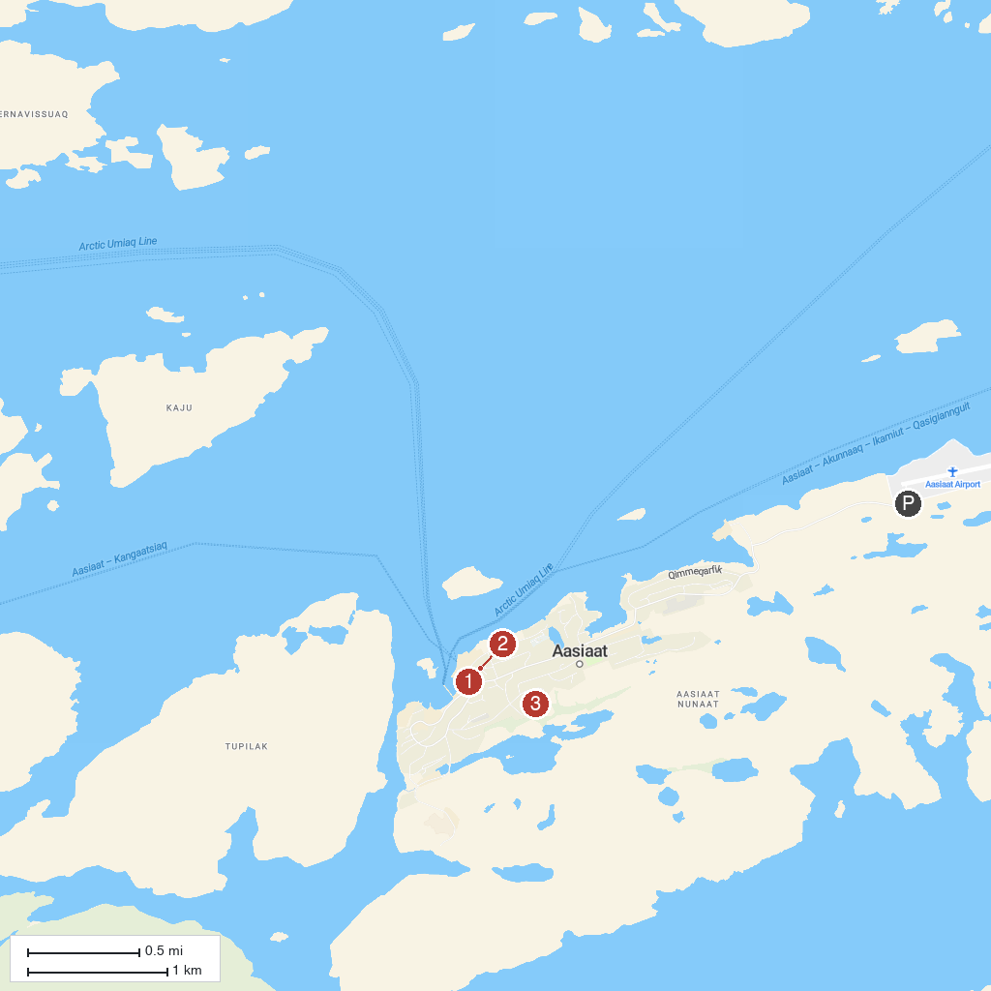
MAP KEY
1. Aasiaat Museum | 3. Disko Bay
2. Zion's Church, Aasiaat
P. Cruise port / terminal
Map © MapTiler © OpenStreetMap contributors · cruiseports.org

