Abu Simbel, Nubia, Egypt
Two colossal temples hewn from living rock by Ramesses II — then lifted, stone by stone, out of rising waters. A feat of ancient ambition matched only by a modern rescue mission that cut the temples into thousands of blocks and lifted them to higher ground.
⚓ Docked — small Lake Nasser ships tie up at the quay · 🕒 Typical call: 4-6 hrs · 💵 Egyptian Pound (EGP); USD widely accepted · 🗣️ Arabic; English spoken at tourist sites · ☀️ Extreme heat May–Sep; mild Nov–Feb
✍️ MY DAY IN PORT (FILL IN)
Ship / Date
In port | arrive ______ · all aboard ______
Booked excursion
Notes / meeting point
GETTING ASHORE
- Docking: Lake Nasser cruise ships tie up at Abu Simbel quay; larger vessels may tender
- Walk to temples: 5 min from quay; golf carts available for reduced mobility
- Best For: Ancient Egyptian history, photography, bucket-list monuments
- Don't Miss: Great Temple inner sanctuary — sun alignment twice yearly (Feb 22, Oct 22)
GETTING AROUND
- 🚕 Taxi: Ask the operator for the current fare — A small number of local taxis serve the village. Distances within Abu Simbel are very short; fares are minimal. Agree on
TOP THINGS TO DO
- Great Temple of Ramesses II — Four colossal seated statues of Ramesses II (20 m tall) guard a temple that plunges 60 m into the cliff.
- Small Temple of Nefertari — Dedicated to Ramesses II's chief queen and the goddess Hathor, this temple features six standing colossi — four of Ramesses II…
- Sound & Light Show (Evening) — After dark, the temples are illuminated and a narrated light show recounts the story of Ramesses II and the UNESCO relocation…
- Lake Nasser Nubian Temple Circuit — Multi-day Lake Nasser cruises stop at additional relocated Nubian temples — Wadi El Seboua (avenue of sphinxes), Amada (oldest…
BEST WALKS
- Temple Circuit Walk: 0.5 km · 20 min · Easy · Paved path — From the quay, follow the paved path past the ticket booth to the Great Temple of Ramesses II, then…
WEATHER · DAYLIGHT · MONEY
Month | High °F | Low °F | Rainy days
May | 100 | 77 | 0
Jul | 104 | 81 | 0
Sep | 101 | 79 | 0
Daylight: May 6:13AM–7:26PM · Jul 6:18AM–7:40PM · Sep 6:40AM–6:56PM
cruiseports.org/abu-simbel · Confirm terminal & all-aboard time with your ship

Abu Simbel, Nubia, Egypt — Port Map
Red = walkable sights · Amber = excursions farther out · P = cruise terminal
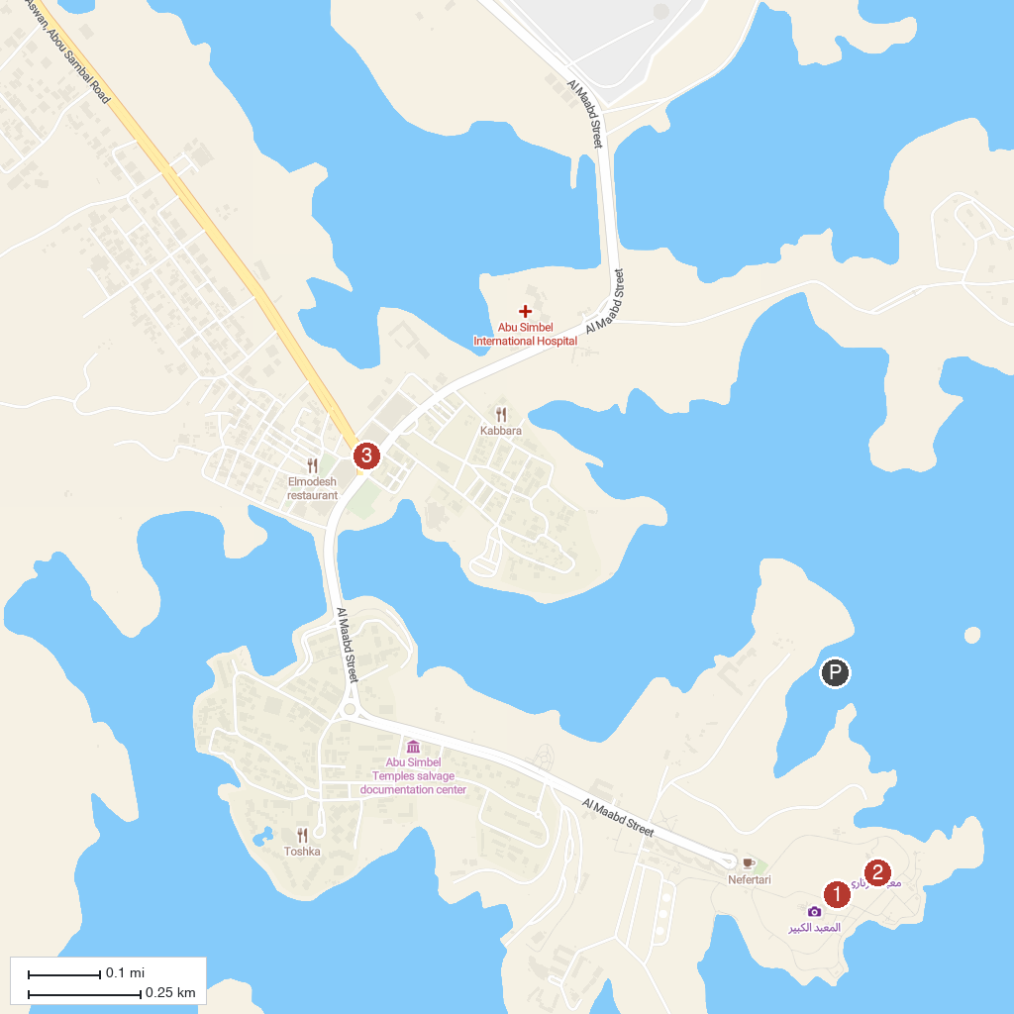
MAP KEY
1. Abu Simbel temples | 3. Lake Nasser
2. Small Temple of Nefertari
P. Cruise port / terminal
Map © MapTiler © OpenStreetMap contributors · cruiseports.org

