Aburatsu-Nichinan, Miyazaki, Japan
Where samurai streets meet subtropical coast. Nichinan packs cave shrines, Japan's only Easter Island–approved Moai replicas, and the Kyushu region's most atmospheric castle town into one shore day.
⚓ Docked (East Wharf, Aburatsu Port) · 🕒 Typical call: 8–10 hrs · 💴 Currency: Japanese Yen (JPY) · 🗣️ Language: Japanese · 🚌 Car/taxi recommended — sites are spread out
✍️ MY DAY IN PORT (FILL IN)
Ship / Date
In port | arrive ______ · all aboard ______
Booked excursion
Notes / meeting point
GETTING ASHORE
- Docking: Alongside at Aburatsu Port East Wharf; no tendering required
- Walk to center: ~10 min walk to Aburatsu town; Nichinan & Obi require a taxi or tour
- Best For: History lovers, shrine seekers, and anyone curious about samurai culture
- Don't Miss: Udo Shrine inside its seaside cave — unlike anything else in Japan
GETTING AROUND
- 🚕 Taxi: ¥2,500–¥3,000 to city center — Taxi stand is available at the pier. Fares run about ¥3,300 to Obi Castle Town and ¥4,500 to Udo Jingu Shrine. Cash pref
- 📱 Rideshare: ✅ Uber
TOP THINGS TO DO
- Udo Shrine — One of Japan's most dramatic Shinto shrines, built inside a sea cave on a rugged cliff above the Pacific.
- Obi Castle Town — The 'Little Kyoto of Kyushu,' Obi was a samurai stronghold for 500 years.
- Sun Messe Nichinan & Moai Statues — Seven full-size Moai replicas stand against the Pacific skyline — the only ones in the world created with official permission…
- Aoshima Island & Devil's Washboard — Connected by a small bridge, subtropical Aoshima Island is ringed by natural rock formations called the 'Devil's Washboard'…
- Cape Toi Wild Horses — At the tip of the Nichinan Coast, Misaki horses have roamed freely for over 300 years.
BEST WALKS
- Aburatsu Waterfront Stroll: 1–2 km | Flat | 30–45 min | From the pier — From the cruise pier, walk along the waterfront toward Aburatsu town center.
- Obi Castle Town Loop: 2 km | Flat | 1.5–2 hrs | In Obi (20 min taxi) — Obi's preserved samurai district is compact and walkable.
WEATHER · DAYLIGHT · MONEY
Month | High °F | Low °F | Rainy days
May | 74 | 61 | 11
Jul | 86 | 74 | 13
Sep | 83 | 70 | 12
Daylight: May 3:57AM–6:41PM · Jul 3:54AM–7:03PM · Sep 5:02AM–5:33PM
cruiseports.org/aburatsu-nichinan · Confirm terminal & all-aboard time with your ship

Aburatsu-Nichinan, Miyazaki, Japan — Port Map
Red = walkable sights · Amber = excursions farther out · P = cruise terminal
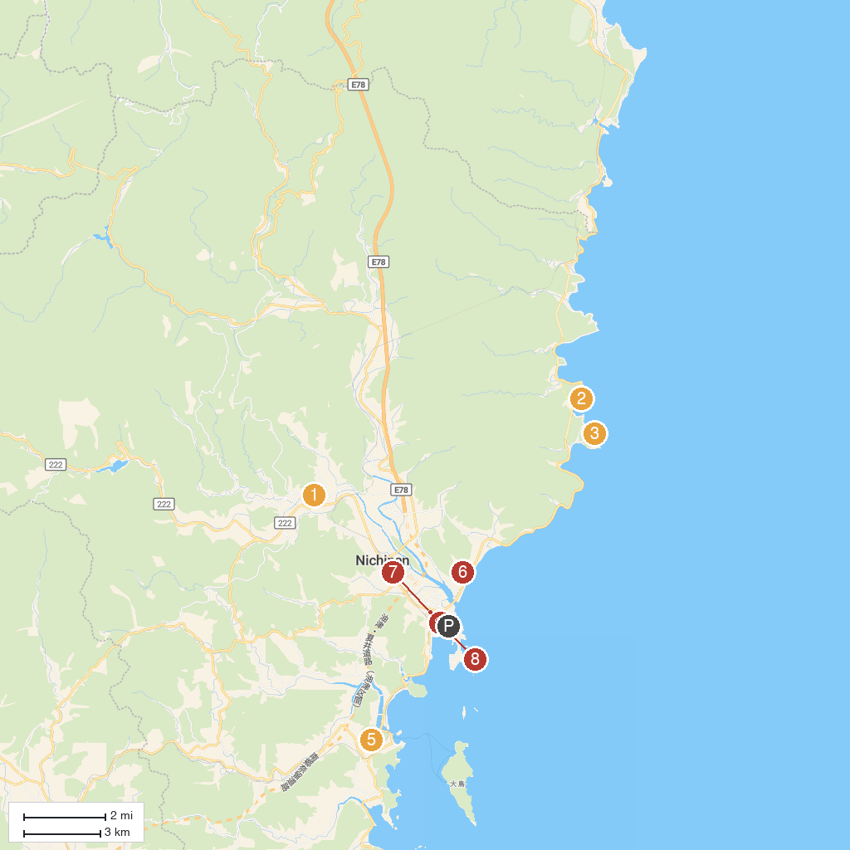
MAP KEY
1. Obi Castle Ruins | 5. Central Park
2. Sun Messe Nichinan | 6. Komamiya Shrine
3. Udo Shrine | 7. Aburatsu shopping street
4. Aburatsu red brick house | 8. Horikawa canal
P. Cruise port / terminal
Map © MapTiler © OpenStreetMap contributors · cruiseports.org

