Abydos, Sohag, Egypt
One of Egypt's oldest and most sacred cities, Abydos holds the hauntingly beautiful Temple of Seti I and the enigmatic Osireion — quieter than Luxor, and far more atmospheric.
⚓ River mooring (El Balyana bank) · 🕒 Typical call: 4-6 hrs · 💵 Egyptian Pound (EGP) · 🗣️ Arabic · 🏛️ UNESCO-listed archaeological zone
✍️ MY DAY IN PORT (FILL IN)
Ship / Date
In port | arrive ______ · all aboard ______
Booked excursion
Notes / meeting point
GETTING ASHORE
- Docking: Nile riverbank mooring at El Balyana; site is ~11 km by road
- Walk to site: Not walkable — transfer by minibus or taxi (~15-20 min)
- Best For: Ancient Egyptian history, temple reliefs, off-the-beaten-path archaeology
- Don't Miss: The Abydos King List inside the Temple of Seti I
GETTING AROUND
- 🚕 Taxi: ~10 EGP base + 3 EGP/km — Local taxis can be arranged from nearby El Balyana town (~11 km away). Tourist fares are typically inflated; agree on pr
TOP THINGS TO DO
- Temple of Seti I — Marvel at the extraordinary painted reliefs inside one of Egypt's finest surviving temples, built c.
- The Osireion — Adjacent to the Temple of Seti I, this massive granite structure is thought to be a symbolic tomb of Osiris.
- Umm el-Qa'ab Royal Cemetery — Egypt's earliest royal burial ground, containing tombs of First Dynasty pharaohs including Narmer and Den.
- Abydos & Dendera Combined Day — The most popular excursion from this stretch of the Nile.
BEST WALKS
- Temple Circuit Walk: 1 km | Easy | 45-60 min — From the ticket gate, walk through the forecourt into the seven sanctuaries of the Temple of Seti…
WEATHER · DAYLIGHT · MONEY
Month | High °F | Low °F | Rainy days
May | 101 | 72 | 0
Jul | 106 | 78 | 0
Sep | 103 | 75 | 0
Daylight: May 6:05AM–7:31PM · Jul 6:09AM–7:46PM · Sep 6:37AM–6:56PM
cruiseports.org/abydos · Confirm terminal & all-aboard time with your ship

Abydos, Sohag, Egypt — Port Map
Red = walkable sights · Amber = excursions farther out · P = cruise terminal
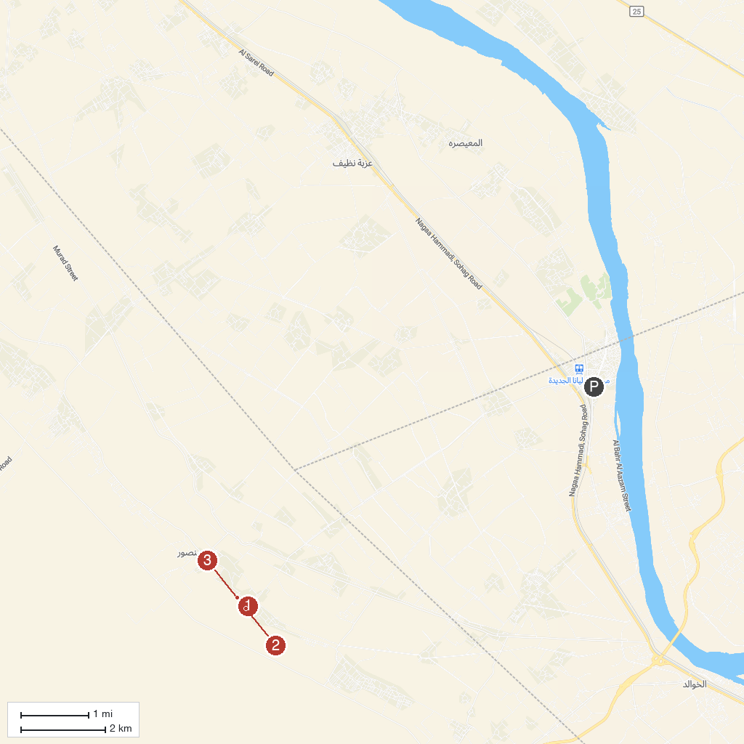
MAP KEY
1. Temple of Seti I, Abydos | 3. Temple of Ramesses II, Abydos
2. Osireion
P. Cruise port / terminal
Map © MapTiler © OpenStreetMap contributors · cruiseports.org

