Acapulco, Guerrero, Mexico
Once a Hollywood glamour destination, Acapulco delivers drama on every front — daredevil cliff divers, a Spanish colonial fortress, and a sweeping Pacific bay that still earns its postcard.
⚓ Pier (docked) · 🕒 Typical call: 7-9 hrs · 💵 Mexican Peso (USD widely accepted) · 🗣️ Spanish
✍️ MY DAY IN PORT (FILL IN)
Ship / Date
In port | arrive ______ · all aboard ______
Booked excursion
Notes / meeting point
GETTING ASHORE
- Docking: Pier — ships dock alongside at Terminal Marítima in Old Acapulco
- Walk to center: 5-10 min to Zócalo; 25-30 min (or short taxi) to La Quebrada
- Best For: La Quebrada cliff divers, colonial history, bay boat tours
- Don't Miss: Cliff diver show at La Quebrada (1 PM afternoon performance)
GETTING AROUND
- 🚕 Taxi: $3–8 USD — Taxis are plentiful at the port. Always negotiate and agree on the fare before you get in — no meters are used. Short ci
TOP THINGS TO DO
- La Quebrada Cliff Divers — Watch trained clavadistas plunge roughly 40 meters (130 ft) from sheer rock into a narrow ocean inlet — timing the dive to the…
- Fort San Diego & History Museum — This 17th-century Spanish star fort once fended off Dutch and English pirates guarding the Manila Galleon trade.
- Isla de la Roqueta Glass-Bottom Boat — A short glass-bottom boat crossing to Roqueta Island gives views of a submerged bronze Virgin statue and colorful reef fish.
- Old Acapulco City Walk — The Zócalo, Cathedral of Our Lady of Solitude, Mercado Central (complete with a witchcraft section), and the Diego Rivera mural…
- Coyuca Lagoon & Beach Day — North of the city, Coyuca Lagoon is a lush freshwater lake bordered by mangroves and used as filming location for Rambo II.
BEST WALKS
- Old Town Heritage Walk: 2-3 km · 45-60 min · Easy — From the pier, stroll the waterfront past the Costera to the Zócalo.
- La Quebrada Walk: 2 km · 25-30 min one-way · Moderate (uphill) — Head west along the waterfront boulevard from the terminal, then climb through the old neighborhood…
WEATHER · DAYLIGHT · MONEY
Month | High °F | Low °F | Rainy days
May | 89 | 76 | 6
Jul | 88 | 77 | 17
Sep | 86 | 76 | 23
Daylight: May 6:08AM–7:03PM · Jul 6:14AM–7:16PM · Sep 6:28AM–6:41PM
cruiseports.org/acapulco · Confirm terminal & all-aboard time with your ship

Acapulco, Guerrero, Mexico — Port Map
Red = walkable sights · Amber = excursions farther out · P = cruise terminal
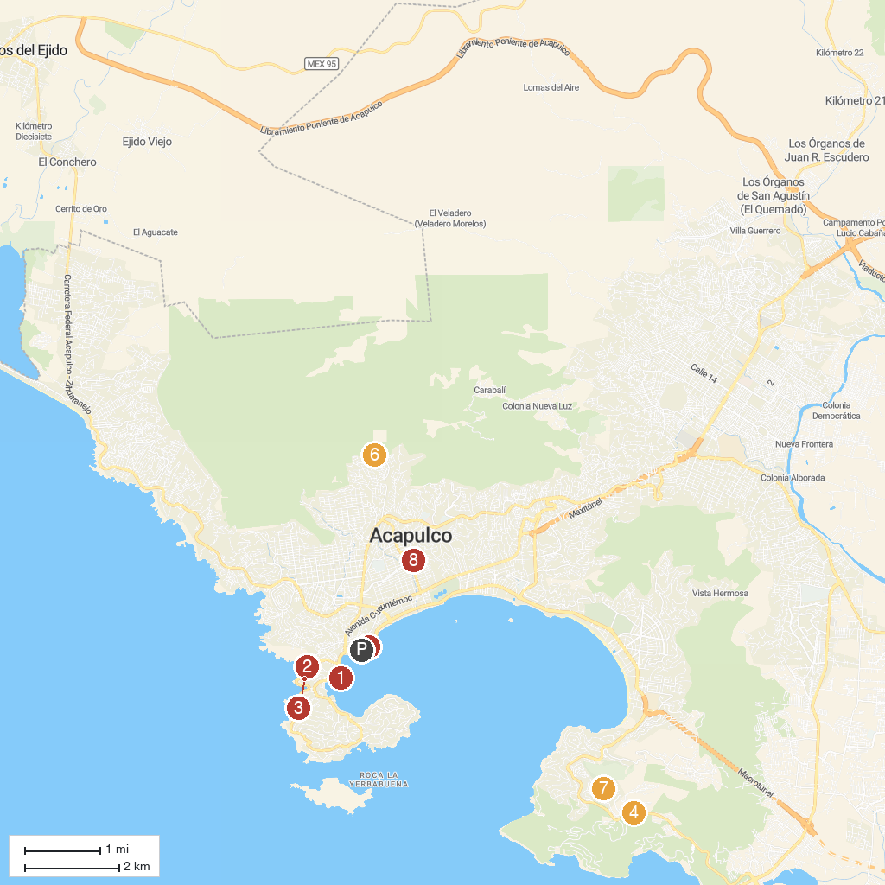
MAP KEY
1. Fiesta & Bonanza yachts | 5. Acapulco Historical Museum of Fort San Diego
2. La Quebrada | 6. Zona Arqueológica de Palma Sola
3. Centro Cultural La Casa de los Vientos | 7. Capilla de la Paz
4. Mirador Puerto Marqués | 8. Progreso Park
P. Cruise port / terminal
Map © MapTiler © OpenStreetMap contributors · cruiseports.org

