Addu Atoll, Maldives
The Maldives' southernmost atoll sits just south of the equator, where a former WWII British RAF base shares the island with coral-fringed lagoons and manta-rich dive sites.
⚓ Tender port · 🕒 Typical call: 6-8 hrs · 💵 Maldivian Rufiyaa / USD accepted · 🗣️ Dhivehi / English spoken
✍️ MY DAY IN PORT (FILL IN)
Ship / Date
In port | arrive ______ · all aboard ______
Booked excursion
Notes / meeting point
GETTING ASHORE
- Docking: Tender from ship to Gan Island pier
- Walk to center: Gan town is steps from the tender pier; Hithadhoo (~14 km via link road)
- Best For: Snorkeling, diving, WWII history, cycling the link road
- Don't Miss: British Loyalty Wreck dive, Addu Nature Park, cycling Gan–Hithadhoo link road
GETTING AROUND
- 🚕 Taxi: MVR 150–200 — Taxis wait near the pier and offer fixed-rate rides between Gan and Hithadhoo (the main town). Within a single island, f
- 📱 Rideshare: ❌ not available
TOP THINGS TO DO
- Snorkeling at Koattey & Addu Nature Park — Addu's reefs escaped the 1998 bleaching and remain vibrant.
- British Loyalty Wreck Dive — The SS British Loyalty, an oil tanker torpedoed in 1944, rests in 30 m of water near Gan.
- Manta Ray Encounter at Addu Manta Point — Addu Manta Point is a year-round cleaning station where reef mantas with wingspans up to 5 m congregate.
- WWII RAF Base & British War Memorial — Gan Island served as a Royal Air Force base from WWII through 1976.
- Cycling the Addu Link Road — A ~14 km causeway-connected road links Gan, Feydhoo, Maradhoo-Feydhoo, Maradhoo, and Hithadhoo across open ocean causeways.
BEST WALKS
- Gan Island Waterfront & RAF Base Loop: 1.5 km · 30 min · Easy — From the tender pier, walk south along the waterfront past Equator Village Resort, then loop…
- Link Road: Gan to Feydhoo: 4 km one-way · 45 min walk / 15 min cycle · Flat — Follow the causeway north from Gan to Feydhoo across open ocean with lagoon views on both sides.
WEATHER · DAYLIGHT · MONEY
Month | High °F | Low °F | Rainy days
May | 84 | 81 | 21
Jul | 83 | 80 | 18
Sep | 83 | 80 | 16
Daylight: May 6:01AM–6:06PM · Jul 6:11AM–6:15PM · Sep 5:59AM–6:05PM
Representative sunrise/sunset — 2025, 15th of each month; local civil time including DST (Indian/Maldives). Source: Astral; not a forecast or climate average.
cruiseports.org/addu-atoll-maldives · Confirm terminal & all-aboard time with your ship

Addu Atoll, Maldives — Port Map
Red = walkable sights · Amber = excursions farther out · P = cruise terminal
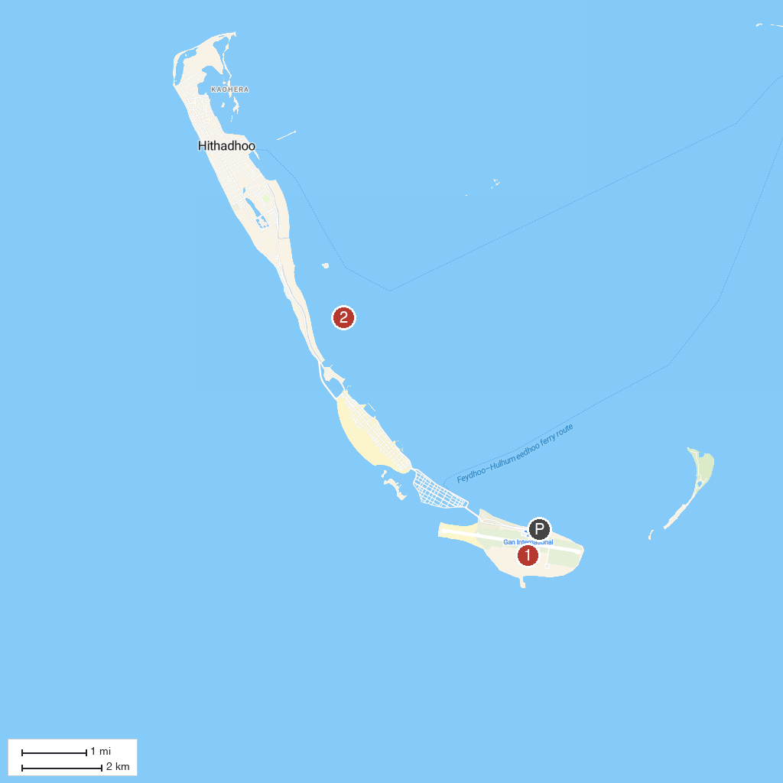
MAP KEY
1. Gan Island | 2. British Loyal Wreck
P. Cruise port / terminal
Map © MapTiler © OpenStreetMap contributors · cruiseports.org

