Adelaide, South Australia, Australia
South Australia's cultured capital parks cruise ships at the historic Outer Harbor, where a direct train whisks you to world-class wine country, a vibrant food market, and a sun-bleached waterfront lined with colonial mural art.
⚓ Docked (Outer Harbor) · 🕒 Typical call: 8-10 hrs · 💵 AUD (Australian Dollar) · 🗣️ English
✍️ MY DAY IN PORT (FILL IN)
Ship / Date
In port | arrive ______ · all aboard ______
Booked excursion
Notes / meeting point
GETTING ASHORE
- Docking: Outer Harbor Passenger Terminal — all major lines dock alongside
- Train to city: ~45 min direct to Adelaide Railway Station; ~20 min to Port Adelaide
- Best For: Wine lovers, foodies, and history buffs
- Don't Miss: Barossa Valley wine tour or Port Adelaide Maritime Museum precinct
GETTING AROUND
- 🚕 Taxi: AUD $40–75 — Taxis are available at the terminal. The fare to the Adelaide CBD is roughly AUD $50 and the journey takes 30–40 minutes
- 📱 Rideshare: ✅ Uber
TOP THINGS TO DO
- Barossa Valley Wine Tour — Australia's most celebrated wine region is 65 km from the port.
- Port Adelaide Maritime Precinct — A 20-minute train ride delivers you to a compact waterfront packed with the South Australia Maritime Museum, National Railway…
- Adelaide Central Market & Rundle Mall — The city's beloved Central Market has been running since 1869 — a vibrant covered market of fresh produce, cheese, charcuterie…
- Adelaide Dolphin Sanctuary River Cruise — A gentle cruise along the Port River to spot the resident wild bottlenose dolphins in the Adelaide Dolphin Sanctuary — one of the…
- Glenelg Beach — South Australia's most popular beach suburb sits 30 min by tram from the city centre.
BEST WALKS
- Port Adelaide Heritage & Murals Walk: 2–3 km · Easy · 1.5–2 hrs · Flat — From Port Adelaide Station, head to the waterfront and meander through the historic precinct.
- Semaphore Beach Stroll: 2 km · Easy · 1 hr · Flat seafront — The beachside suburb of Semaphore is a short hop from Port Adelaide.
WEATHER · DAYLIGHT · MONEY
Month | High °F | Low °F | Rainy days
May | 63 | 52 | 12
Jul | 57 | 47 | 13
Sep | 63 | 49 | 10
Daylight: May 7:02AM–5:20PM · Jul 7:21AM–5:22PM · Sep 6:15AM–6:06PM
cruiseports.org/adelaide · Confirm terminal & all-aboard time with your ship

Adelaide, South Australia, Australia — Port Map
Red = walkable sights · Amber = excursions farther out · P = cruise terminal
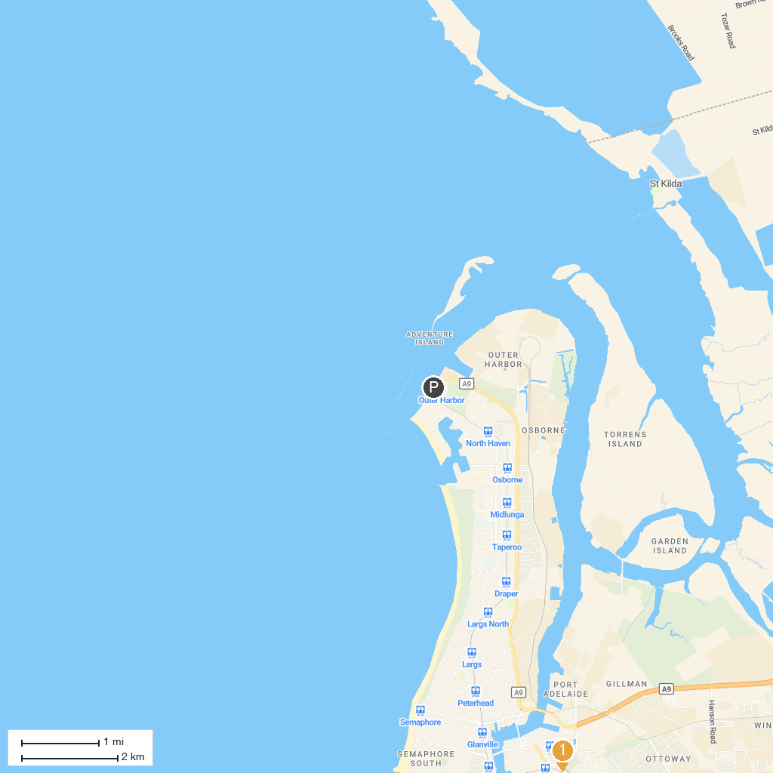
MAP KEY
1. Park 10 | 5. Adelaide Gaol
2. South Australian Aviation Museum | 6. South Australian Museum
3. Adelaide Botanic Garden | 7. Saint Francis Xavier's Cathedral
4. Adelaide Zoo | 8. St Peter's Cathedral
P. Cruise port / terminal
Map © MapTiler © OpenStreetMap contributors · cruiseports.org

