Admiralty Island, Southeast Alaska, USA
Called Kootznoowoo — 'Fortress of the Bears' — by the Tlingit people, Admiralty Island has one of the highest brown bear densities on Earth — roughly one bear per square mile, the highest in North America. Small expedition ships anchor off Angoon, the island's only village, for a rare day of wilderness and living Tlingit culture.
⚓ Tender port (anchor off Angoon) · 🕒 Typical call: 6-8 hrs · 💵 USD · 🗣️ English / Tlingit · 🐻 Small/expedition ships only
✍️ MY DAY IN PORT (FILL IN)
Ship / Date
In port | arrive ______ · all aboard ______
Booked excursion
Notes / meeting point
GETTING ASHORE
- Docking: Tender from anchorage off Angoon; no large-ship pier
- Walk to Center: Short tender ride to Angoon village dock
- Best For: Brown bear viewing, wildlife, Tlingit culture, kayaking
- Don't Miss: Pack Creek Bear Viewing Area (permit required); Danger Point Trail
GETTING AROUND
- 🚕 Taxi: Call for rates — Angoon Taxi is the only local taxi service, offering rides within the village and transfers from the ferry dock (~3 mile
- 📱 Rideshare: ❌ not available
TOP THINGS TO DO
- Pack Creek Brown Bear Viewing — One of Alaska's premier bear-viewing experiences: coastal brown bears feed on the tidal flats and fish for salmon at Stan Price…
- Danger Point Trail Hike — A 2.5-mile round-trip trail through old-growth Sitka spruce and hemlock forest north of Angoon, ending at sweeping views of…
- Kayaking & Canoe Route — Angoon is the launching point for the legendary 32-mile Cross Admiralty Canoe Route, linking seven mountain lakes via trails and…
- Angoon Tlingit Village Walk — Angoon is a living Tlingit community.
- Skiff Wildlife Cruise — Expedition ship operators run their own Zodiac or skiff tours around the island's bays and inlets, scanning for brown bears on…
BEST WALKS
- Angoon Village Stroll: 1 mile · Easy · 30-45 min — A relaxed walk through the village from the dock, passing the tribal community houses with their…
- Danger Point Trail: 2.5 miles round-trip · Moderate · 2-3 hrs — Head north from Angoon on the Danger Point Trail through dense old-growth forest.
WEATHER · DAYLIGHT · MONEY
Month | High °F | Low °F | Rainy days
May | 57 | 43 | 14
Jul | 64 | 53 | 15
Sep | 57 | 47 | 19
Daylight: May 4:36AM–9:14PM · Jul 4:24AM–9:43PM · Sep 6:30AM–7:15PM
cruiseports.org/admiralty-island · Confirm terminal & all-aboard time with your ship

Admiralty Island, Southeast Alaska, USA — Port Map
Red = walkable sights · Amber = excursions farther out · P = cruise terminal
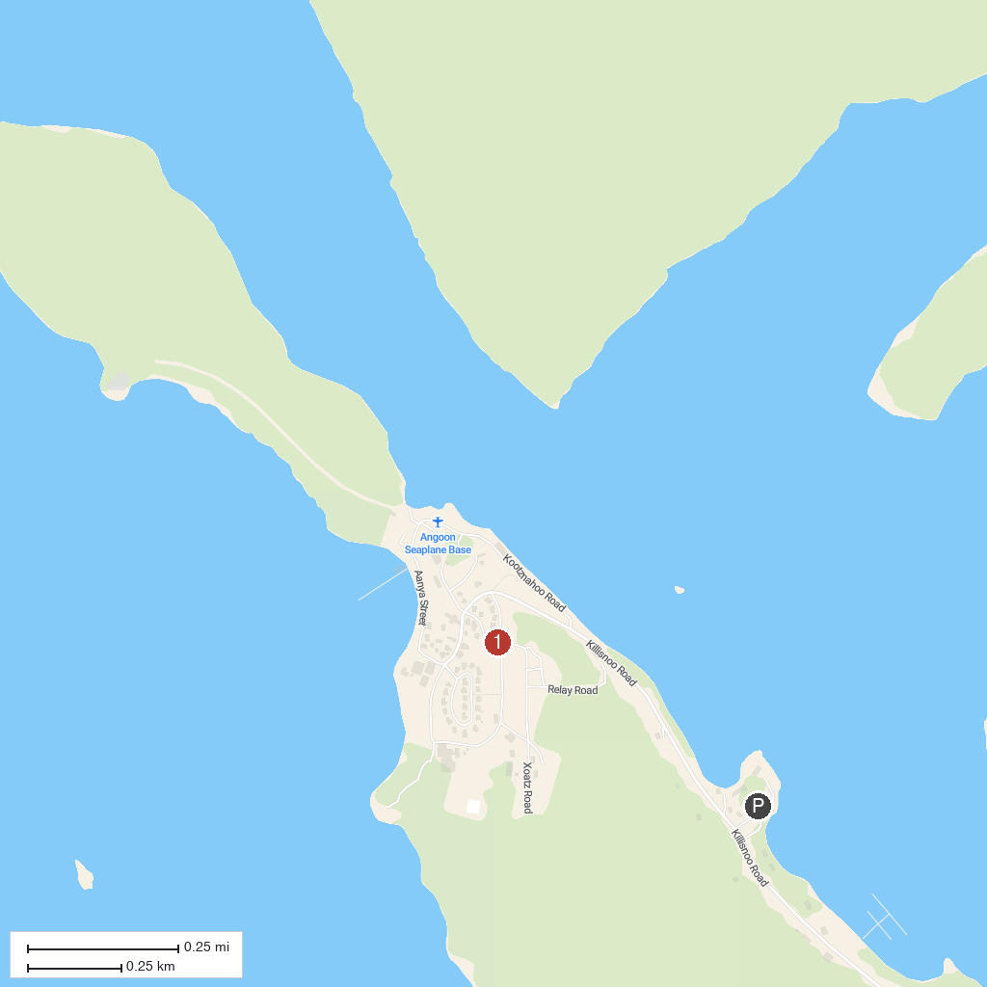
MAP KEY
1. Admiralty Island National Monument | 3. Angoon
2. Pack Creek
P. Cruise port / terminal
Map © MapTiler © OpenStreetMap contributors · cruiseports.org

