Adria, Veneto, Italy
One of Italy's oldest towns, Adria gave its name to the Adriatic Sea and now welcomes small river and barge cruises along the Canal Bianco through the misty Po Delta.
⚓ River/barge dock (Canal Bianco) · 🕒 Typical call: 4–6 hrs · 💵 Euro (€) · 🗣️ Italian
✍️ MY DAY IN PORT (FILL IN)
Ship / Date
In port | arrive ______ · all aboard ______
Booked excursion
Notes / meeting point
GETTING ASHORE
- Docking: Barge/river cruise vessels dock along the Canal Bianco, steps from the town center
- Walk to center: 5 min on foot to Piazza Garibaldi
- Best For: Etruscan history, archaeology, and Po Delta nature
- Don't Miss: National Archaeological Museum — one of Italy's finest collections of Greek and Etruscan finds
GETTING AROUND
- 🚕 Taxi: €5–€15 locally; €60–€80 to Venice — Local taxis are available in town for short rides. A taxi to Venice (approx. 60 km) is an expensive but convenient optio
TOP THINGS TO DO
- National Archaeological Museum of Adria — One of northeastern Italy's most important museums, holding Greek painted pottery, Etruscan bronzes, Roman glass, and the…
- Cathedral & Cathedral Museum — The 19th-century Cathedral of Santi Pietro e Paolo conceals a Byzantine crypt, early Christian bas-reliefs, and carved cupboards…
- Po Delta Natural Park Boat Tour — The Po Delta is one of Italy's great birdwatching and wetland destinations.
- Cycling the Po Delta Embankments — Flat river levees make the Po Delta ideal for cycling.
- Day Trip to Venice — Adria sits roughly 60 km southwest of Venice (about 75 km in a straight line, less by road).
BEST WALKS
- Adria Old Town Loop: 1.5 km · 30–45 min · Flat — From the Canal Bianco dock, walk up Via Roma to Piazza Garibaldi, the main square.
- Basilica della Tomba & Old Quarter: 1 km · 20 min · Flat — A short walk from Piazza Garibaldi leads to the Basilica of Santa Maria Assunta della Tomba, the…
WEATHER · DAYLIGHT · MONEY
Month | High °F | Low °F | Rainy days
May | 72 | 56 | 14
Jul | 86 | 69 | 9
Sep | 77 | 62 | 9
Daylight: May 5:42AM–8:34PM · Jul 5:39AM–8:55PM · Sep 6:50AM–7:22PM
cruiseports.org/adria · Confirm terminal & all-aboard time with your ship

Adria, Veneto, Italy — Port Map
Red = walkable sights · Amber = excursions farther out · P = cruise terminal
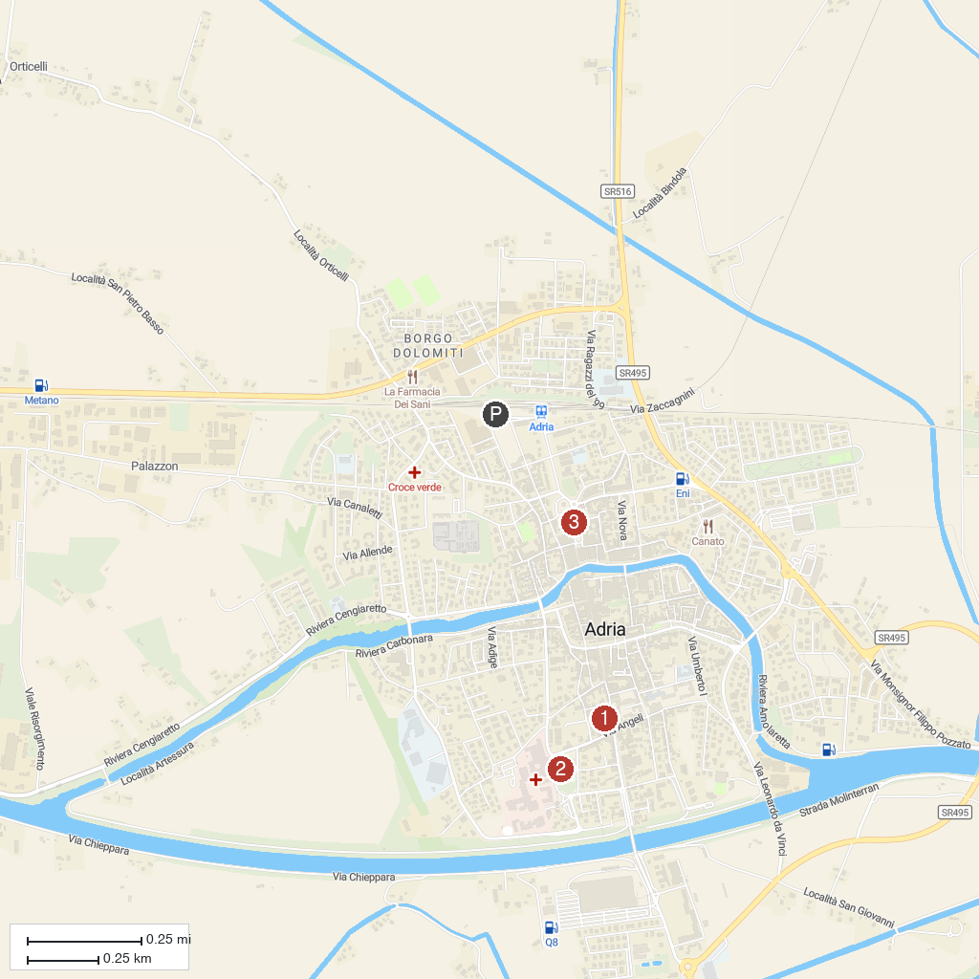
MAP KEY
1. Giardini Scarpari | 3. Adria Cathedral
2. Museo Archeologico Nazionale di Adria | 4. Parco Regionale Veneto del Delta del Po
P. Cruise port / terminal
Map © MapTiler © OpenStreetMap contributors · cruiseports.org

