Agios Nikolaos, Crete, Greece
A jewel of East Crete wrapped around a mythically deep lake, Agios Nikolaos offers postcard-perfect waterfront promenades just steps from the pier — and day-trip access to Spinalonga's haunting fortress and the ancient palace of Knossos.
⚓ Docked (small ships) / Tender (large ships) · 🕒 Typical call: 6-8 hrs · 💶 Currency: Euro (€) · 🗣️ Language: Greek
✍️ MY DAY IN PORT (FILL IN)
Ship / Date
In port | arrive ______ · all aboard ______
Booked excursion
Notes / meeting point
GETTING ASHORE
- Docking: Small ships dock at the town quay; large vessels anchor and tender in. Pier is steps from the waterfront.
- Walk to Center: 2-5 min on foot — the port sits right on the town marina.
- Best For: Spinalonga island, East Crete day trips, waterfront strolling, Cretan food
- Don't Miss: Lake Voulismeni — a deep lake (about 49 m at its deepest) connected to the sea by a narrow channel, surrounded by cafés.
GETTING AROUND
- 🚕 Taxi: ~€7 — Taxis are readily available at the port. A short ride within Agios Nikolaos runs about €7; pre-agree fares for longer tr
TOP THINGS TO DO
- Spinalonga Island — A short boat ride from Elounda brings you to Spinalonga — a Venetian sea fortress turned leper colony until 1957, now one of…
- Knossos Palace & Heraklion — The Bronze Age palace of Knossos — legendary home of King Minos and the Minotaur — is about 65 km west of Agios Nikolaos.
- Zeus Cave & Lassithi Plateau — Drive up into the Dikti mountains to the Diktaion Cave, traditionally revered as the birthplace of Zeus, then cross the Lassithi…
- Elounda & Gulf Cruise — The upscale village of Elounda, 11 km north, sits on a stunning lagoon.
- Vai Palm Forest & Toplou Monastery — Head east to Europe's largest natural palm forest at Vai Beach, then visit the 15th-century Toplou Monastery — known for its icon…
BEST WALKS
- Waterfront & Lake Voulismeni Loop: 1.5 km · 20-30 min · Flat — From the pier, walk south along the marina promenade to Lake Voulismeni — a dramatically deep lake…
- Archaeological Museum & Town: 2 km round-trip · 45 min · Easy — Walk north from the lake up to the Agios Nikolaos Archaeological Museum on Konstantinou Paleologou…
WEATHER · DAYLIGHT · MONEY
Month | High °F | Low °F | Rainy days
May | 79 | 63 | 6
Jul | 90 | 75 | 2
Sep | 85 | 70 | 4
Daylight: May 6:13AM–8:14PM · Jul 6:14AM–8:31PM · Sep 7:00AM–7:23PM
cruiseports.org/agios-nikolaos · Confirm terminal & all-aboard time with your ship

Agios Nikolaos, Crete, Greece — Port Map
Red = walkable sights · Amber = excursions farther out · P = cruise terminal
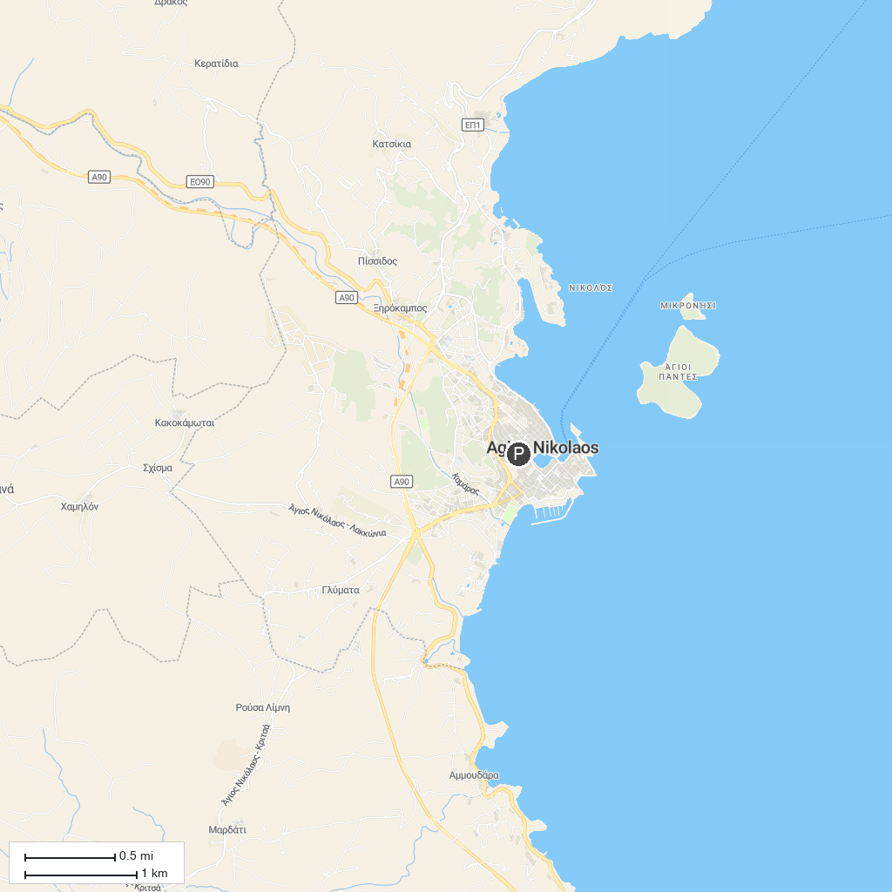
MAP KEY
1. Folklore Museum of Gavalochori | 3. Stone Museum
2. Georgioupolis harbour
P. Cruise port / terminal
Map © MapTiler © OpenStreetMap contributors · cruiseports.org

