Agra, Uttar Pradesh, India
Agra is the Taj Mahal — but also Agra Fort, the Baby Taj, and a city that was once the heart of the Mughal Empire. Cruise passengers arrive by overland transfer and are rewarded with three UNESCO World Heritage Sites within a single day.
🚌 Overland transfer (no pier) · 🕒 Typical visit: 1-2 days · 💵 Indian Rupee (INR) · 🗣️ Hindi / English widely spoken
✍️ MY DAY IN PORT (FILL IN)
Ship / Date
In port | arrive ______ · all aboard ______
Booked excursion
Notes / meeting point
GETTING ASHORE
- Access: Overland by road or rail from Delhi (200 km) or coastal ports via domestic flight + transfer
- Must See: Taj Mahal, Agra Fort, Tomb of Itimad-ud-Daulah (Baby Taj)
- Best For: History, Mughal architecture, photography, UNESCO site-collecting
- Don't Miss: Sunrise at the Taj Mahal — arrive before 7 AM for golden light and thin crowds
GETTING AROUND
- 🚕 Taxi: ₹800–₹1,500 (~$9–18 USD) for half-day hire — Hiring a private car with driver for a half or full day is the most comfortable way to cover multiple sights in Agra. Ma
- 📱 Rideshare: ✅ Uber, Ola
TOP THINGS TO DO
- Taj Mahal at Sunrise — The 17th-century marble mausoleum built by Emperor Shah Jahan for Mumtaz Mahal is the defining image of India.
- Agra Fort — This massive red sandstone fortress served as the main residence of Mughal emperors for generations.
- Tomb of Itimad-ud-Daulah (Baby Taj) — This exquisite Mughal mausoleum across the Yamuna was commissioned by Empress Nur Jahan for her father.
- Fatehpur Sikri Day Trip — Emperor Akbar's extraordinary abandoned Mughal capital, built entirely of red sandstone, sits about 40 km west of Agra.
- Mehtab Bagh & Yamuna Boat Ride — The Moonlight Garden directly across the Yamuna River from the Taj offers the classic rear view of the monument at sunset.
BEST WALKS
- Taj Mahal Complex Walk: 1-2 hrs | Easy | Flat paved gardens — Enter via the East Gate (recommended) and walk through the grand gateway (Darwaza-i-Rauza) to the…
- Agra Fort Ramparts Walk: 1-1.5 hrs | Moderate | Uneven stone — Enter at Amar Singh Gate and walk the interior courtyards — Diwan-i-Am, Diwan-i-Khas, Khas Mahal…
WEATHER · DAYLIGHT · MONEY
Month | High °F | Low °F | Rainy days
May | 103 | 78 | 4
Jul | 93 | 81 | 21
Sep | 91 | 77 | 13
Daylight: May 5:30AM–6:58PM · Jul 5:33AM–7:14PM · Sep 6:03AM–6:22PM
cruiseports.org/agra · Confirm terminal & all-aboard time with your ship

Agra, Uttar Pradesh, India — Port Map
Red = walkable sights · Amber = excursions farther out · P = cruise terminal
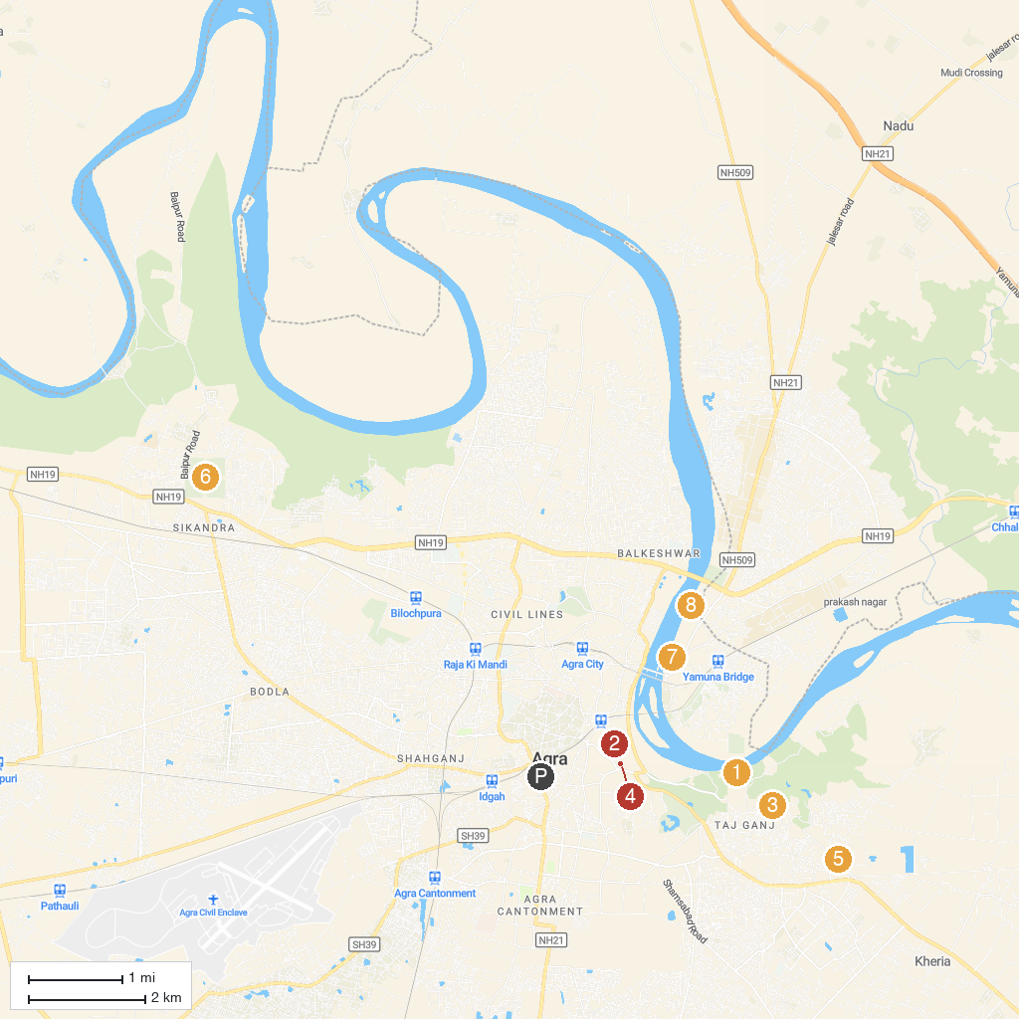
MAP KEY
1. Taj Mahal | 5. Kalakriti cultural and convention centre
2. Agra Fort | 6. Tomb of Akbar
3. Taj Nature Walk | 7. Itmad-ud-Daula
4. Amar Singh Gate | 8. Chini Ka Rauza
P. Cruise port / terminal
Map © MapTiler © OpenStreetMap contributors · cruiseports.org

