Agropoli, Campania, Italy
A sun-bleached medieval promontory rising above the Tyrrhenian, Agropoli is the quiet gateway to Cilento — where Greek temples, Blue Flag beaches, and fresh buffalo mozzarella await within minutes of the dock.
⚓ Docked (marina pier) · 🕒 Typical call: 6-8 hrs · 💶 Euro (€) · 🗣️ Italian
✍️ MY DAY IN PORT (FILL IN)
Ship / Date
In port | arrive ______ · all aboard ______
Booked excursion
Notes / meeting point
GETTING ASHORE
- Docking: Ships tie up directly at Agropoli marina — ~500 m flat walk to town center
- Walk to center: 10 min on foot; old town is uphill with steps
- Best For: Greek antiquities (Paestum), coastal walks, authentic Campania cuisine
- Don't Miss: Paestum temples (UNESCO) — 15 min by train or taxi
GETTING AROUND
- 🚕 Taxi: €5–€15 — Local taxis are available at the marina. Short rides within Agropoli are inexpensive; a taxi to Paestum (ancient Greek t
TOP THINGS TO DO
- Paestum Greek Temples — Just 9 km north, Paestum contains three of the world's best-preserved ancient Greek temples (6th–5th century BC), a rich museum…
- Cilento Coast Boat Tour — Depart from Agropoli's own port on a 2-4 hour cruise along the wild Cilento coastline — sea caves, hidden coves, and a stop at…
- Agropoli Medieval Castle & Old Town — Hike the cobbled lanes to the 15th-century Angevin-Aragonese Castle at the crown of the promontory.
- Mozzarella Farm & Paestum Combo — The Paestum plain is buffalo country — join a guided half-day combining the temples with a working mozzarella dairy for a tasting.
- Castellabate Village Walk — This medieval hilltop village 15 km south is a UNESCO-listed borgo with sea views, 13th-century walls, and a spectacular castello.
BEST WALKS
- Marina to Borgo Antico (Old Town Loop): 2.5 km round trip · 45-60 min · Moderate (uphill) — From the marina, follow the promenade north, then climb Via Castello through the medieval gate into…
- Waterfront Promenade to Trentova Bay: 3 km one-way · 40 min · Easy (flat) — Head south from the marina along the lungomare past Lido Azzurro beach and continue on the coastal…
WEATHER · DAYLIGHT · MONEY
Month | High °F | Low °F | Rainy days
May | 72 | 57 | 11
Jul | 86 | 70 | 4
Sep | 80 | 65 | 9
Daylight: May 5:44AM–8:09PM · Jul 5:43AM–8:28PM · Sep 6:41AM–7:08PM
cruiseports.org/agropoli · Confirm terminal & all-aboard time with your ship

Agropoli, Campania, Italy — Port Map
Red = walkable sights · Amber = excursions farther out · P = cruise terminal
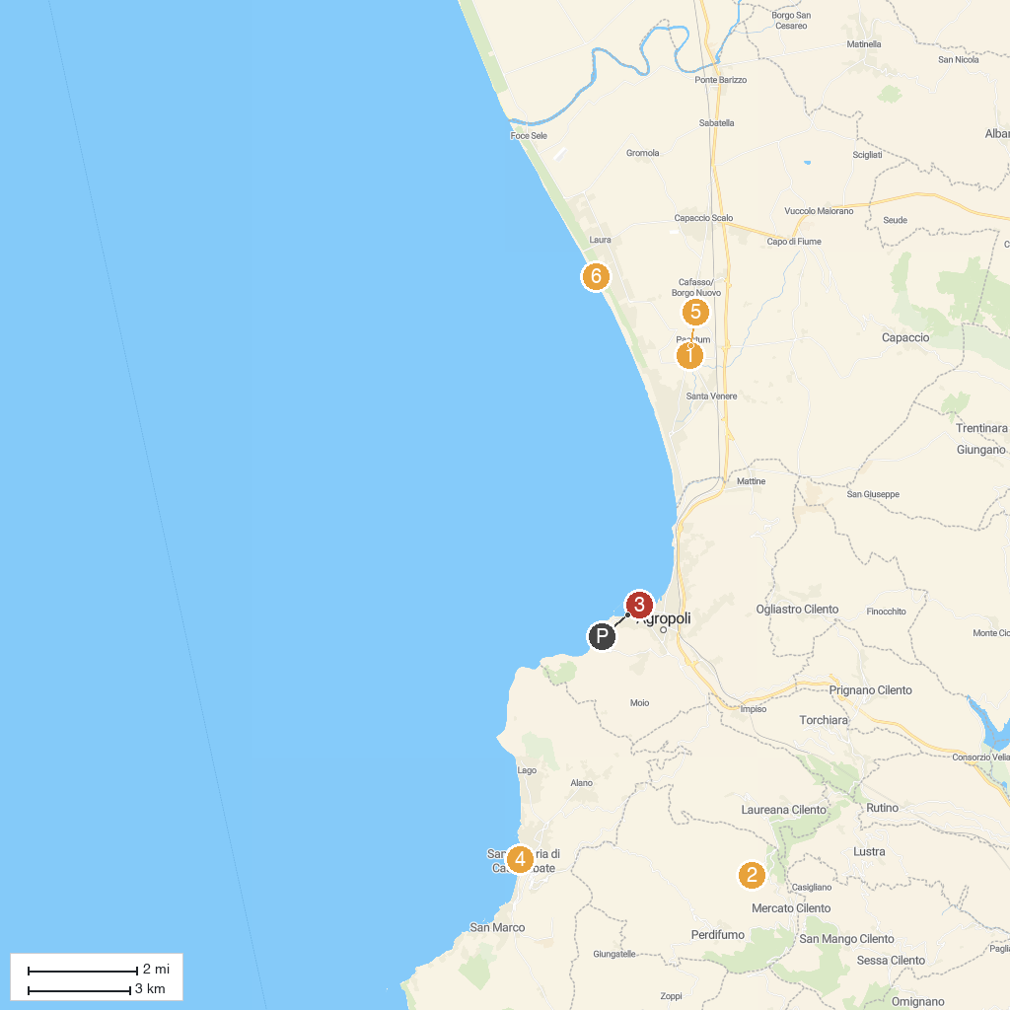
MAP KEY
1. Archaeological Park of Paestum | 5. Amphitheatre of Paestum
2. Castle De Vargas - Vatolla | 6. Lido Conchiglia
3. Castello Angioino Aragonese | 7. Sanctuary of Our Lady of the Pomegranate of the Carmelite Fathers
4. Sanctuary of Holy Mary at the Sea
P. Cruise port / terminal
Map © MapTiler © OpenStreetMap contributors · cruiseports.org

