Aitutaki Island, Cook Islands
A shimmering atoll lagoon ringed by white-sand motus — Aitutaki is a rare South Pacific stop where the water really is that turquoise, and the hardest decision is which deserted islet to lunch on.
⚓ Tender port (anchor offshore) · 🕒 Typical call: 7-9 hrs · 💵 NZD (New Zealand Dollar) · 🗣️ English / Cook Islands Māori · 🌊 Lagoon-focused destination
✍️ MY DAY IN PORT (FILL IN)
Ship / Date
In port | arrive ______ · all aboard ______
Booked excursion
Notes / meeting point
GETTING ASHORE
- Docking: Tender to Arutanga Wharf — ships anchor outside the reef; Zodiacs used by smaller expedition vessels
- Walk to Center: Immediate — Arutanga village is right at the wharf
- Best For: Lagoon cruises, snorkeling, motu hopping, One Foot Island stamp
- Don't Miss: Book a lagoon cruise before your port day — they sell out and don't run Sundays
GETTING AROUND
- 🚕 Taxi: NZ$20–$30 — A small number of taxis serve the island with no meters — negotiate fares before travel. Typical trips to Ootu Beach run
- 📱 Rideshare: ❌ not available
TOP THINGS TO DO
- Aitutaki Lagoon Cruise — A half-day cruise by catamaran or traditional vaka visiting multiple motus inside the lagoon, with snorkeling stops, a beachside…
- One Foot Island (Tapuaetai) Visit — The most photographed motu in the Cook Islands — pristine white sand, turquoise shallows, and a tiny post office where you can…
- Maungapu Summit Hike — A short but steep hike to the highest point on Aitutaki (123m) rewards with panoramic views of the entire atoll, the lagoon, and…
- Ootu Beach Day — Ootu Beach on the eastern side of the main island offers calm, shallow water ideal for swimming and paddleboarding.
- Arutanga Village & CICC Church Walk — The Cook Islands Christian Church in Arutanga is the oldest church in the country, featuring carved woodwork and stained-glass…
BEST WALKS
- Arutanga Village Stroll: 30-45 min | Easy | Flat — From the wharf, walk north along the main road past local shops and the post office to the Cook…
- Coastal Road to Ootu Beach: 45-60 min each way | Easy | Flat road — A scenic road walk (or cycle) along Aitutaki's eastern coast from Arutanga to Ootu Beach.
WEATHER · DAYLIGHT · MONEY
Month | High °F | Low °F | Rainy days
May | 80 | 77 | 16
Jul | 77 | 75 | 11
Sep | 77 | 75 | 12
Daylight: May 6:59AM–6:11PM · Jul 7:12AM–6:18PM · Sep 6:34AM–6:33PM
cruiseports.org/aitutaki-island · Confirm terminal & all-aboard time with your ship

Aitutaki Island, Cook Islands — Port Map
Red = walkable sights · Amber = excursions farther out · P = cruise terminal
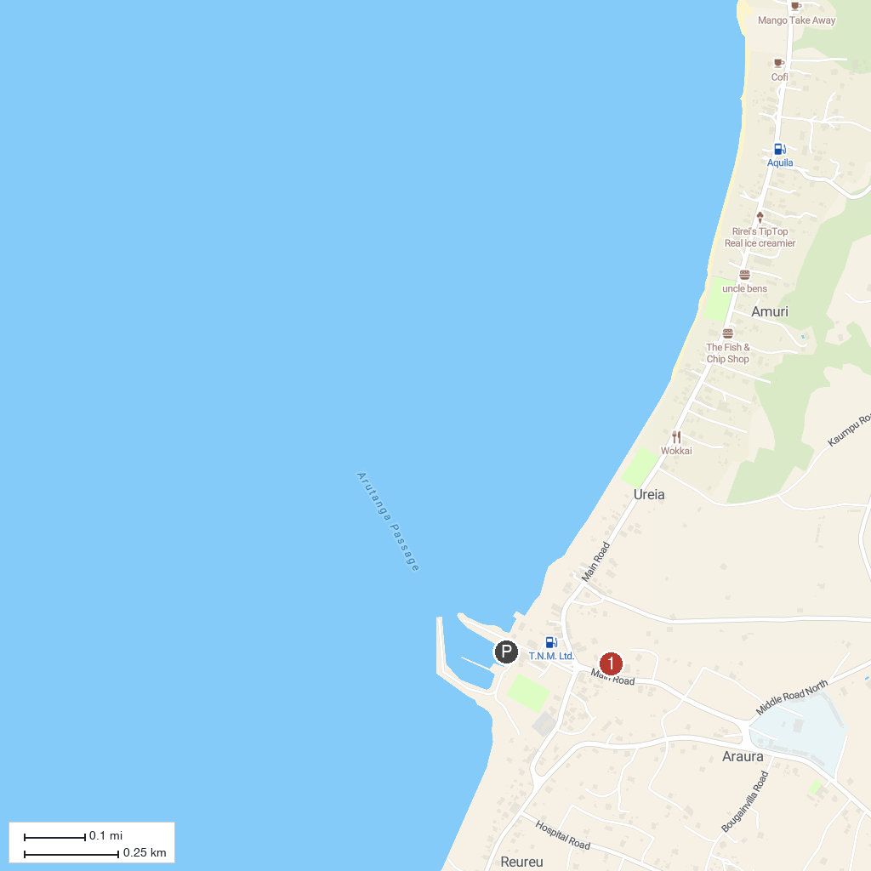
MAP KEY
1. Arutanga
P. Cruise port / terminal
Map © MapTiler © OpenStreetMap contributors · cruiseports.org

