Akita City, Tohoku, Japan
Gateway to Tohoku's samurai heartland — where weeping cherry trees line preserved feudal streets and Japan's deepest lake shimmers azure inland. Akita rewards those who venture beyond the pier.
⚓ Docked (Nakashima Wharf) · 🕒 Typical call: 8-10 hrs · 💴 Japanese Yen (JPY) · 🗣️ Japanese (some English at terminal)
✍️ MY DAY IN PORT (FILL IN)
Ship / Date
In port | arrive ______ · all aboard ______
Booked excursion
Notes / meeting point
GETTING ASHORE
- Docking: Nakashima Wharf, ~7 km west of city center; shuttle buses to Akita Station
- Walk to center: Not walkable — use cruise shuttle or taxi (~15 min)
- Best For: History lovers, day-trippers to Kakunodate samurai district & Lake Tazawa
- Don't Miss: Kakunodate's samurai residences, Akita Port Tower Selion, Kanto Festival Museum
GETTING AROUND
- 🚕 Taxi: ¥3,900–¥5,500 one way — Taxis queue at the pier and reach Akita Station in about 7–12 minutes. Most reliable direct option; meters are used.
- 📱 Rideshare: ✅ Uber
TOP THINGS TO DO
- Kakunodate Samurai District — Often called the 'Little Kyoto of Tohoku,' Kakunodate preserves original samurai manors (buke-yashiki) lining a boulevard shaded…
- Lake Tazawa Day Trip — Japan's deepest lake (~423 m) is famous for its deep azure color and the golden Tatsuko statue on the shore.
- Kanto Festival Museum (Neburi Nagashi Kan) — Akita's famous Kanto Festival (early August) involves balancing enormous bamboo poles hung with paper lanterns.
- Akita Museum of Art — Designed by Tadao Ando, this landmark museum houses an impressive permanent collection including large-scale works by Akita-born…
- Oga Peninsula & Namahage Experience — The rugged Oga Peninsula (~60 min drive from the port) is home to the Namahage tradition — fearsome demon-deity figures that…
BEST WALKS
- Senshu Park & City Center Loop: 2-3 km · 45-60 min · Easy — From Akita Station, walk west to Senshu Park — the tranquil grounds of the former Kubota Castle…
WEATHER · DAYLIGHT · MONEY
Month | High °F | Low °F | Rainy days
May | 66 | 52 | 14
Jul | 80 | 69 | 17
Sep | 76 | 64 | 15
Daylight: May 4:25AM–6:46PM · Jul 4:24AM–7:06PM · Sep 5:20AM–5:48PM
cruiseports.org/akita-city · Confirm terminal & all-aboard time with your ship

Akita City, Tohoku, Japan — Port Map
Red = walkable sights · Amber = excursions farther out · P = cruise terminal
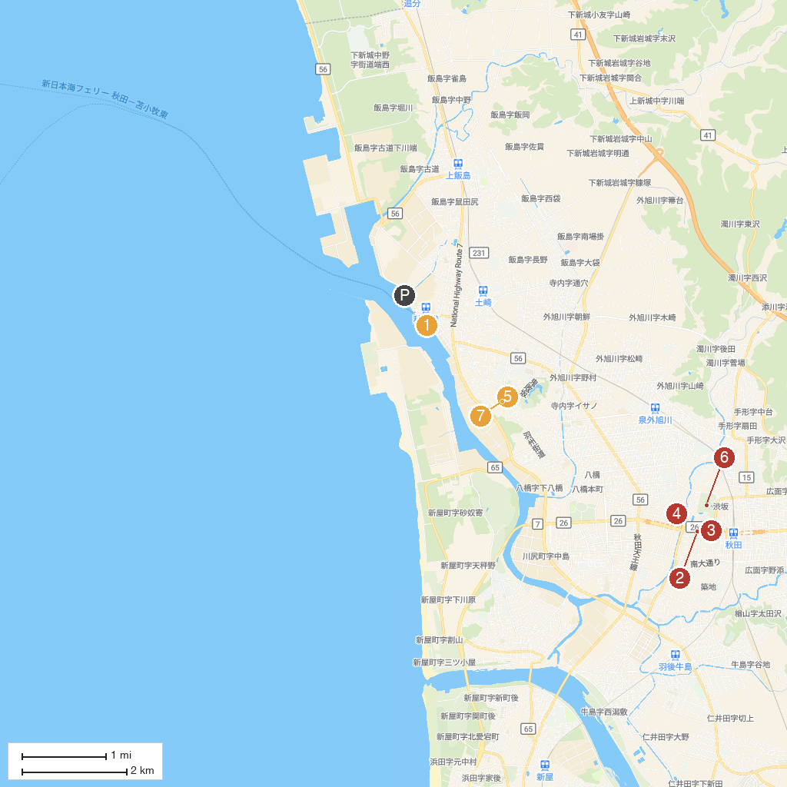
MAP KEY
1. Roadside Station Akitakō | 5. Akita Castle Ruins(Government house)
2. Akita Museum of Art | 6. Kubota Castle Ruins
3. Akita City Senshū Museum of Art | 7. Goshono Park
4. Akita City Folk Arts Center (Neburinagashi-Kan) | 8. 秋田市立秋田城跡歴史資料館
P. Cruise port / terminal
Map © MapTiler © OpenStreetMap contributors · cruiseports.org

