Akureyri, Iceland
The 'Capital of the North' — a compact, friendly town at the head of Eyjafjörður fjord, with a walk-off pier, a hilltop church, and Iceland's most dramatic inland landscapes right on the doorstep.
⚓ Docked — walk right off · 🕒 Typical call: 8–10 hrs · 💵 Icelandic Króna (ISK) · cards everywhere · 🗣️ Icelandic · English widely spoken
✍️ MY DAY IN PORT (FILL IN)
Ship / Date
In port | arrive ______ · all aboard ______
Booked excursion
Notes / meeting point
GETTING ASHORE
- Docking: Oddeyrarbryggja / Tangabryggja
- To center: 5-min walk
- Best For: Nature · Waterfalls · Geology
- Don't Miss: Godafoss & Lake Myvatn
GETTING AROUND
- 🚕 Taxi: ~2,000–2,500 ISK (~$14–18 USD) to city center — BSO-Taxi is the main local company (available 24/7). The port is only a 5-minute drive to town; base fare ~800 ISK + ~30
- 📱 Rideshare: ❌ not available
- 🚌 Hop-on hop-off: ✅
TOP THINGS TO DO
- Godafoss & Lake Myvatn — Iceland's 'Waterfall of the Gods' cascades in a dramatic horseshoe arc, then it's on to the otherworldly Lake Myvatn — volcanic…
- Whale Watching from Akureyri — Eyjafjörður is one of Iceland's best whale-watching fjords.
- Myvatn Nature Baths — Soak in geothermal mineral-rich waters with a backdrop of volcanic highlands — Myvatn's answer to the Blue Lagoon, but far less…
- Hrisey Island Ferry & Village — A short ferry hop takes you to tiny Hrisey, the 'Pearl of Eyjafjörður' — a tranquil fishing village known for its Arctic terns…
BEST WALKS
- Pier to Akureyrarkirkja & Town: ~1.5 km · 1 hr · easy — Walk off the pier along Hafnarstræti, the buzzing main street, then climb the 112 steps to…
- Lystigardurinn Botanical Garden: ~2 km · 1.5 hrs · easy — The world's most northerly botanical garden (66°N) has been blooming since 1912.
- Christmas Garden (Jólagarðurinn): ~10 min drive · 1.5 hrs · easy — Akureyri is Iceland's Christmas-obsessed town — even its traffic lights are heart-shaped.
WEATHER · DAYLIGHT · MONEY
Month | High °F | Low °F | Rainy days
May | 45 | 36 | 13
Jul | 58 | 48 | 16
Sep | 51 | 42 | 17
Daylight: Sep 6:34AM–7:39PM
cruiseports.org/akureyri · Confirm terminal & all-aboard time with your ship

Akureyri, Iceland — Port Map
Red = walkable sights · Amber = excursions farther out · P = cruise terminal
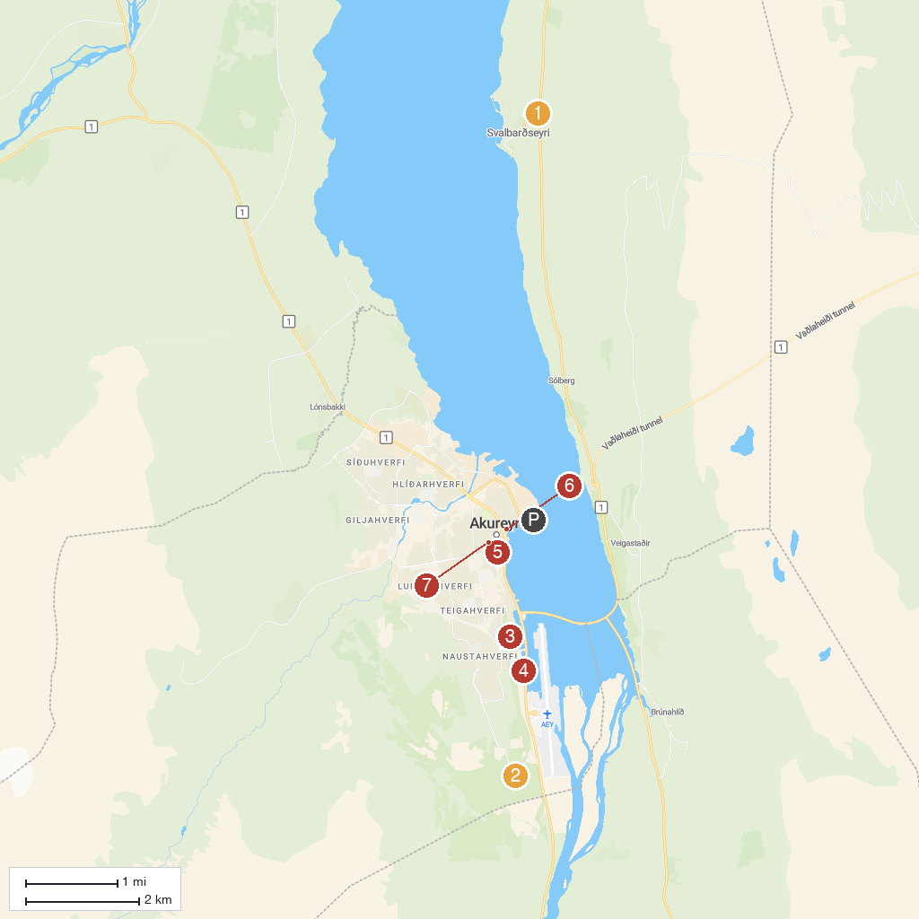
MAP KEY
1. Safnasafnið - Alþýðulist Íslands | 5. Akureyrarkirkja
2. Kjarnaskógur | 6. Hof Cultural and Conference Centre
3. Akureyri Museum | 7. Fairytale figures
4. Motorcycle Museum of Iceland
P. Cruise port / terminal
Map © MapTiler © OpenStreetMap contributors · cruiseports.org

