Alanya, Antalya, Turkey
A Seljuk castle crowns a dramatic sea-cliff peninsula, while Cleopatra Beach stretches along a turquoise bay below — and you can walk to both from the pier.
⚓ Docked (dedicated pier) · 🕒 Typical call: 8-10 hrs · 💵 Turkish Lira (TRY) · 🗣️ Turkish
✍️ MY DAY IN PORT (FILL IN)
Ship / Date
In port | arrive ______ · all aboard ______
Booked excursion
Notes / meeting point
GETTING ASHORE
- Docking: Dedicated cruise pier; no tender required
- Walk to center: 5–10 min along the harbor promenade
- Best For: History, beaches, boat tours, and bazaar shopping
- Don't Miss: Cable car to Alanya Castle for panoramic Riviera views
GETTING AROUND
- 🚕 Taxi: ₺180–₺300 (≈$5–$9) — Taxis queue at the port gate. Updated April 2025 fares: ₺35 flag-fall, ₺50/km, ₺180 minimum. Negotiate for longer trips
- 📱 Rideshare: ✅ Uber, BiTaksi, inDrive
TOP THINGS TO DO
- Alanya Castle & Red Tower — The 13th-century Seljuk castle sits 250 m above sea level with 6.5 km of walls, 83 towers, and sweeping Riviera panoramas.
- Sea Cave Boat Tour — Classic Alanya day boat circles the castle peninsula visiting Pirate Cave, Lovers Cave, and luminescent Phosphorus Cave, with…
- Sapadere Canyon Jeep Safari — Bump through the Taurus foothills by jeep to reach Sapadere Canyon, where wooden walkways follow a cool mountain stream past…
- Cleopatra Beach — Legend says Mark Antony shipped this fine golden sand from Egypt as a gift to Cleopatra.
- Ancient Side Day Trip — A 1-hour drive west brings you to the Roman city of Side, with its well-preserved amphitheatre, Temple of Apollo on the sea, and…
BEST WALKS
- Harbour Promenade to Red Tower & Old Bazaar: 1.5 km · Easy · 20–30 min — Stroll east from the pier along the waterfront promenade to the Red Tower, then climb into the Old…
- Damlataş Cave & Cleopatra Beach Walk: 2 km · Easy · 30–40 min — Head west from the pier past the beach promenade to Damlataş Cave at the base of the castle…
WEATHER · DAYLIGHT · MONEY
Month | High °F | Low °F | Rainy days
May | 76 | 62 | 6
Jul | 89 | 75 | 2
Sep | 85 | 71 | 3
Daylight: May 5:45AM–7:51PM · Jul 5:45AM–8:10PM · Sep 6:34AM–6:59PM
cruiseports.org/alanya · Confirm terminal & all-aboard time with your ship

Alanya, Antalya, Turkey — Port Map
Red = walkable sights · Amber = excursions farther out · P = cruise terminal
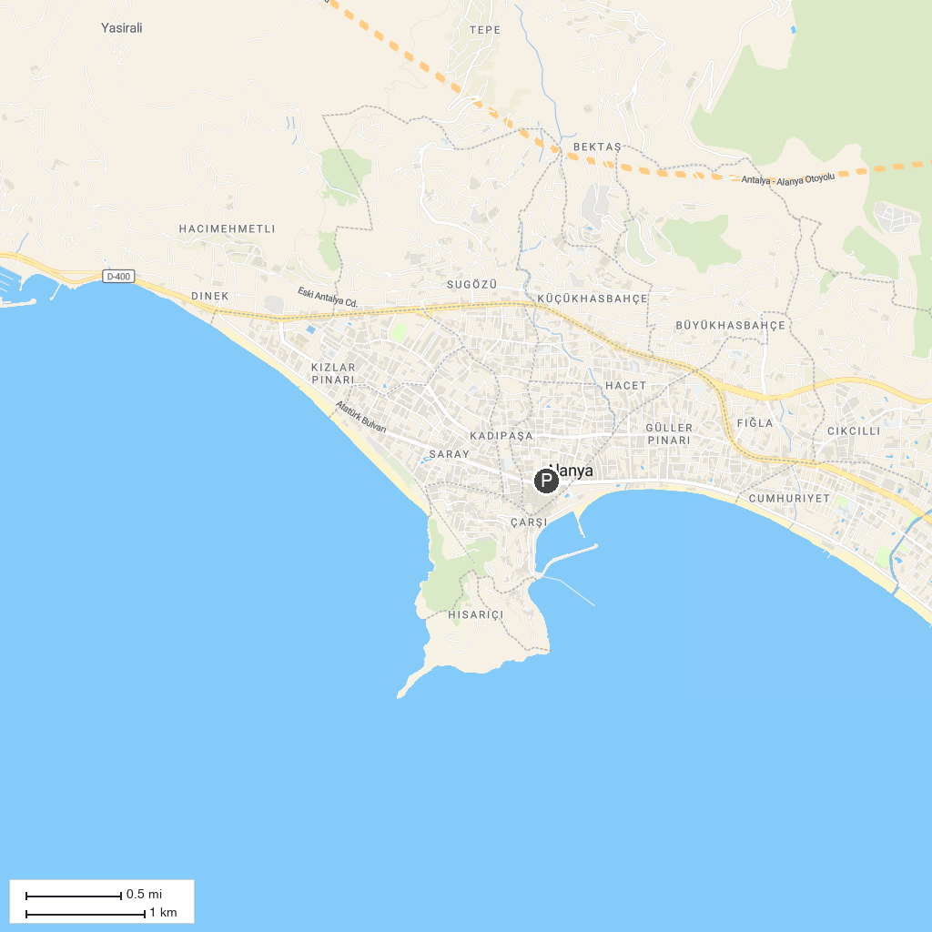
MAP KEY
1. Antalya Archaeology Museum | 5. İsmet İnönü Parkı
2. Say Antalya Tourism and Transport | 6. Kuba Cami
3. Soğuksu Cami | 7. Wild Park Antalya
4. Waterhill | 8. Beach Park
P. Cruise port / terminal
Map © MapTiler © OpenStreetMap contributors · cruiseports.org

