Albany, Western Australia, Australia
Western Australia's oldest European settlement, Albany rewards cruise visitors with world-class ANZAC heritage, a dramatic Southern Ocean coastline, and wild national parks just minutes from the pier.
⚓ Docked (Princess Royal Harbour) · 🕒 Typical call: 8-10 hrs · 💵 Australian Dollar (AUD) · 🗣️ English
✍️ MY DAY IN PORT (FILL IN)
Ship / Date
In port | arrive ______ · all aboard ______
Booked excursion
Notes / meeting point
GETTING ASHORE
- Docking: Cruise ships dock at the Port of Albany commercial terminal in Princess Royal Harbour; occasional anchor-and-tender in strong winds
- Walk to Centre: ~1.5–2 km (20 min walk); free shuttle buses run to York Street near Albany Visitor Centre
- Best For: ANZAC history, dramatic coastal formations, whale watching (May–Oct), Great Southern wine region
- Don't Miss: National Anzac Centre on Mount Clarence and Discovery Bay Historic Whaling Station
GETTING AROUND
- 🚕 Taxi: A$11-A$13 to central Albany; about A$13-A$16 from town to the National Anzac Centre — Local taxis are useful for short hops or when the shuttle timing does not suit. Expect limited supply on busy cruise day
- 📱 Rideshare: ✅ Uber
TOP THINGS TO DO
- National Anzac Centre — This award-winning interactive museum on Mount Clarence tells the stories of individual ANZACs who departed from Albany in 1914.
- Discovery Bay Historic Whaling Station — Australia's last operating whaling station, now an interactive museum.
- The Gap & Natural Bridge, Torndirrup National Park — Stand on a suspended platform 40 m above the Southern Ocean at The Gap, where swells thunder through a granite chasm — one of…
- Whale Watching (May–October) — Albany is one of Australia's best whale watching spots.
- Great Southern Wine Region & Denmark — Albany sits within one of Australia's premier cool-climate wine regions.
BEST WALKS
- York Street Heritage Stroll: 1.5 km · 30 min · Easy — From the Albany Visitor Centre on York Street, walk south along the historic main street past the…
- Foreshore Footbridge to Town: 0.5 km · 10 min · Easy — Walk the 250 m footbridge directly from the port precinct across to the CBD waterfront — the…
WEATHER · DAYLIGHT · MONEY
Month | High °F | Low °F | Rainy days
May | 65 | 53 | 8
Jul | 60 | 49 | 13
Sep | 63 | 50 | 11
Daylight: May 6:56AM–5:13PM · Jul 7:14AM–5:14PM · Sep 6:08AM–5:59PM
cruiseports.org/albany-wa · Confirm terminal & all-aboard time with your ship

Albany, Western Australia, Australia — Port Map
Red = walkable sights · Amber = excursions farther out · P = cruise terminal
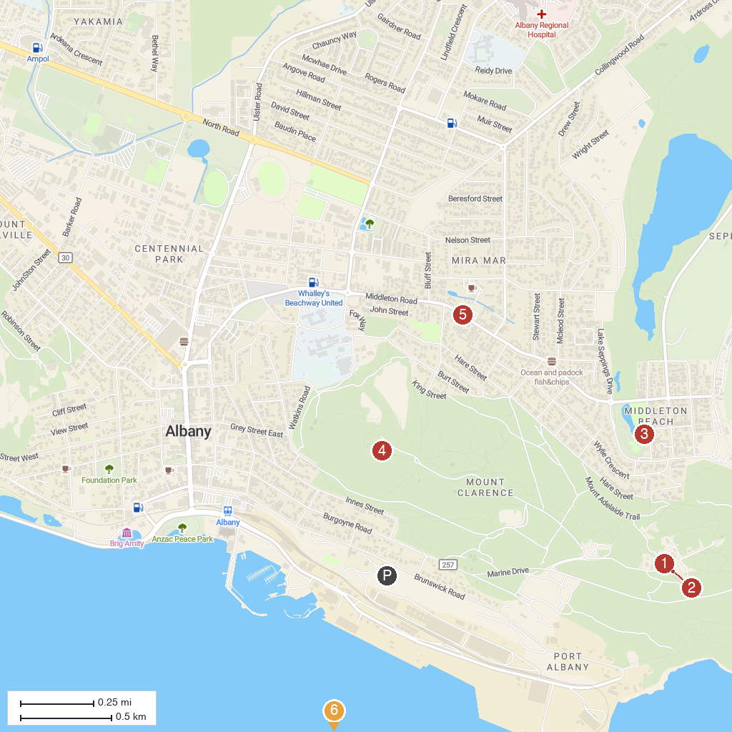
MAP KEY
1. National Anzac Centre | 4. Desert Mounted Corps Memorial, Albany
2. Princess Royal Fortress | 5. Strawberry Hill Farm, Albany
3. Eyre Park, Albany | 6. The Gap and Natural Bridge, Torndirrup
P. Cruise port / terminal
Map © MapTiler © OpenStreetMap contributors · cruiseports.org

