Alcoutim, Algarve, Portugal
Perched on the Guadiana River with Spain a stone's throw across the water, Alcoutim is eastern Algarve at its most unhurried — whitewashed lanes, a castle with 5,000 years of history beneath its walls, and the world's only cross-border zipline just a ferry ride away.
⚓ River pontoon / marina berth · 🕒 Typical call: 6–8 hrs · 💶 Euro (€) · 🗣️ Portuguese · 🌊 River cruise port
✍️ MY DAY IN PORT (FILL IN)
Ship / Date
In port | arrive ______ · all aboard ______
Booked excursion
Notes / meeting point
GETTING ASHORE
- Docking: River pontoon/marina on the Guadiana; small river cruise vessels only
- Walk to centre: 2 min from pontoon to Praça da República
- Best For: History, cross-border day trips, peaceful Algarve scenery
- Don't Miss: Castelo de Alcoutim and the zipline from Spain into Portugal
GETTING AROUND
- 🚕 Taxi: €10–€20 (within town/area) — A small number of local taxis serve the area, mainly for longer trips such as transfers to Faro Airport (~96 km, €80–€10
TOP THINGS TO DO
- Castelo de Alcoutim & Archaeological Museum — The 13th-century hilltop castle dominates the village and the river valley.
- Limite Zero — Cross-Border Zipline — Take the ferry to Sanlúcar de Guadiana in Spain, then ride the 720-metre zipline back into Portugal at up to 70 km/h — the…
- Ferry to Sanlúcar de Guadiana, Spain — The five-minute ferry crossing to the Spanish village of Sanlúcar de Guadiana offers a completely different atmosphere — explore…
- Guadiana River Cruise to Mértola — Board a small boat for a scenic upstream cruise along the Guadiana to Mértola, a hilltop medieval town in the Alentejo region…
- Praia Fluvial do Pego Fundo River Beach — About 500 m from the village centre on the Ribeira de Cadavais (near where it meets the Guadiana), this river beach offers calm…
BEST WALKS
- Riverside Promenade & Historic Centre: 1–1.5 hrs | Easy | Flat + one hill — Start at the marina and walk north along the Guadiana riverfront promenade, taking in views across…
WEATHER · DAYLIGHT · MONEY
Month | High °F | Low °F | Rainy days
May | 82 | 59 | 4
Jul | 95 | 68 | 0
Sep | 87 | 65 | 4
Daylight: May 6:20AM–8:32PM · Jul 6:21AM–8:50PM · Sep 7:12AM–7:37PM
cruiseports.org/alcoutim · Confirm terminal & all-aboard time with your ship

Alcoutim, Algarve, Portugal — Port Map
Red = walkable sights · Amber = excursions farther out · P = cruise terminal
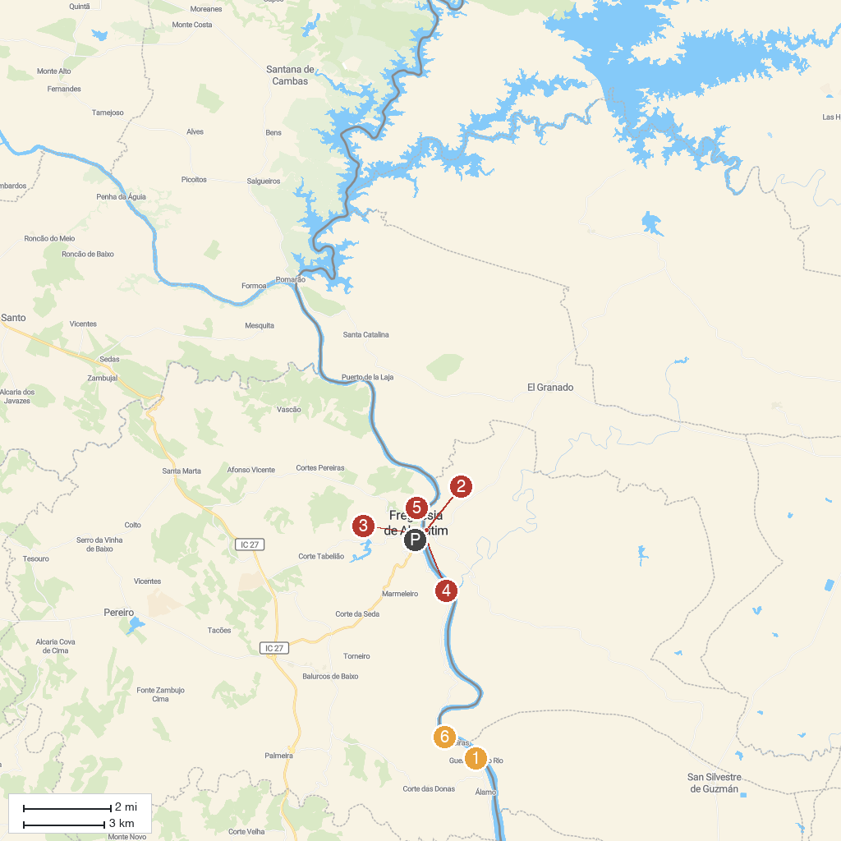
MAP KEY
1. River Museum | 4. Playa fluvial de Sanlúcar de Guadiana
2. Limitezero | 5. Alcoutim old Castle
3. Castelo de Alcoutim | 6. Villa Romana do Montinho das Laranjeiras
P. Cruise port / terminal
Map © MapTiler © OpenStreetMap contributors · cruiseports.org

