Alert Bay, British Columbia, Canada
A small island steeped in living Indigenous culture — where towering totem poles line the waterfront, orcas patrol the strait, and every corner tells a Kwakwaka'wakw story.
⚓ Tender port · 🕒 Typical call: 5–7 hrs · 💵 Canadian Dollar (CAD) · 🗣️ English / Kwak'wala
✍️ MY DAY IN PORT (FILL IN)
Ship / Date
In port | arrive ______ · all aboard ______
Booked excursion
Notes / meeting point
GETTING ASHORE
- Docking: Tender port — ships anchor offshore; tenders ferry passengers to the village dock
- Walk to centre: Village is immediate from the tender dock; all main sights within 1.5 km
- Best For: Indigenous culture, whale watching, totem poles
- Don't Miss: U'mista Cultural Centre and the 173-ft world's tallest totem pole
GETTING AROUND
- 🚕 Taxi: Call for rates — 40K Taxi & Charters is the primary local taxi service, reachable at (250) 974-5525. They offer village transport and can
- 📱 Rideshare: ❌ not available
TOP THINGS TO DO
- U'mista Cultural Centre — The centrepiece of any Alert Bay visit.
- World's Tallest Totem Pole & 'Namgis Big House — A 20-minute walk from the dock brings you to the 173-foot 'Namgis totem pole — the world's tallest — adjacent to the traditional…
- Orca & Whale Watching in Johnstone Strait — Johnstone Strait is one of the world's premier locations to see orcas, especially from late June through September.
- Gator Gardens Ecological Park — A peaceful boardwalk trail winds through ancient cedar and Sitka spruce rainforest, coastal wetlands, and wildflower bogs.
- Waterfront Path & 'Namgis Burial Grounds — A 1.8 km waterfront walking path runs nearly the full length of Alert Bay, past heritage houses, 'awakwes' shelters with ancestor…
BEST WALKS
- Village Waterfront & Cultural Loop: 2.5 km return | 1–1.5 hrs | Easy | Free — Start at the tender dock, walk to the U'mista Cultural Centre, then continue along the waterfront…
- Gator Gardens Ecological Park: 1 km loop | 45 min | Easy | Free — A signed boardwalk trail through old-growth coastal rainforest, wetlands, and bog.
WEATHER · DAYLIGHT · MONEY
Month | High °F | Low °F | Rainy days
May | 60 | 47 | 13
Jul | 67 | 55 | 12
Sep | 64 | 53 | 15
Daylight: May 5:39AM–9:09PM · Jul 5:33AM–9:33PM · Sep 7:04AM–7:40PM
cruiseports.org/alert-bay-bc · Confirm terminal & all-aboard time with your ship

Alert Bay, British Columbia, Canada — Port Map
Red = walkable sights · Amber = excursions farther out · P = cruise terminal
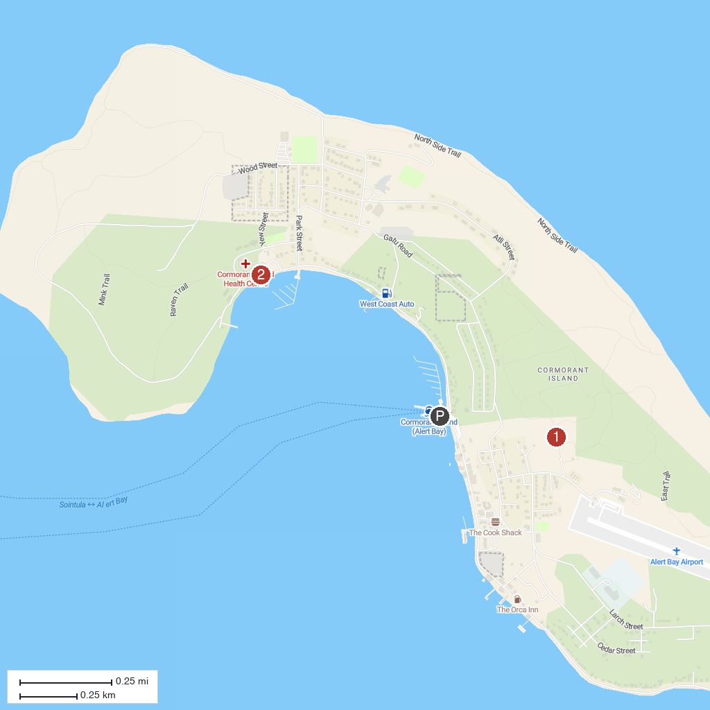
MAP KEY
1. Alert Bay Ecological Park | 2. U'mista Cultural Centre
P. Cruise port / terminal
Map © MapTiler © OpenStreetMap contributors · cruiseports.org

