Ålesund, Møre og Romsdal, Norway
Rebuilt after a 1904 fire in a single coherent burst of Art Nouveau, Ålesund is Norway's most distinctive small city — an island town where ships dock steps from ornate facades, a canal full of old boats, and a staircase to one of Norway's finest viewpoints.
⚓ Docked (pier) · 🕒 Typical call: 6–8 hrs · 💵 Norwegian Krone (NOK) · 🗣️ Norwegian (English widely spoken) · 🏛️ Art Nouveau architecture
✍️ MY DAY IN PORT (FILL IN)
Ship / Date
In port | arrive ______ · all aboard ______
Booked excursion
Notes / meeting point
GETTING ASHORE
- Docking: Alongside at Storneskaia or Prestebrygga — both central
- Walk to centre: 2–5 min from pier to city centre
- Best For: Art Nouveau architecture, Aksla viewpoint, fjord day trips
- Don't Miss: 418 steps up Aksla Hill — views of the whole archipelago
GETTING AROUND
- 🚕 Taxi: 99 NOK base + ~20 NOK/km — Traditional taxis (Ålesund Taxi, Norgestaxi) plus Uber and Bolt are available. Norwegian taxis are metered; a 5 km ride
- 📱 Rideshare: ✅ Uber, Bolt
- 🚌 Hop-on hop-off: ✅ City Sightseeing (Stromma)
TOP THINGS TO DO
- Aksla Viewpoint (418 Steps) — From Byparken (Town Park), climb 418 steps to Fjellstua for sweeping panoramas of Ålesund's island cityscape, the surrounding…
- Art Nouveau Walking Tour — Stroll Kongens Gate and Apotekergata past ornate Jugendstil facades — all built in one rebuilding campaign after the 1904 fire.
- Geirangerfjord Full-Day Excursion — UNESCO-listed Geirangerfjord — Norway's most dramatic fjord, with sheer cliffs and cascading waterfalls — is about 2.5 hours from…
- Atlantic Sea Park (Atlanterhavsparken) — One of Northern Europe's largest saltwater aquariums, 3 km west of the pier.
- RIB Coastal Safari — Zip around Ålesund's island archipelago by rigid inflatable boat — spot sea eagles, seals, and seabirds while taking in the…
BEST WALKS
- Art Nouveau Quarter & Brosundet Canal: 1.5–2 hrs | Easy | ~2 km — From the pier, head into the city centre along the Brosundet canal with its colourful warehouses…
- Aksla Hill Viewpoint Climb: 60–90 min round trip | Moderate | 418 steps — From Byparken (Town Park), follow the signposted path up 418 steps to Fjellstua — the summit…
WEATHER · DAYLIGHT · MONEY
Month | High °F | Low °F | Rainy days
May | 53 | 42 | 16
Jul | 62 | 53 | 17
Sep | 59 | 50 | 18
Daylight: May 4:37AM–10:27PM · Sep 7:01AM–7:58PM
cruiseports.org/alesund · Confirm terminal & all-aboard time with your ship

Ålesund, Møre og Romsdal, Norway — Port Map
Red = walkable sights · Amber = excursions farther out · P = cruise terminal
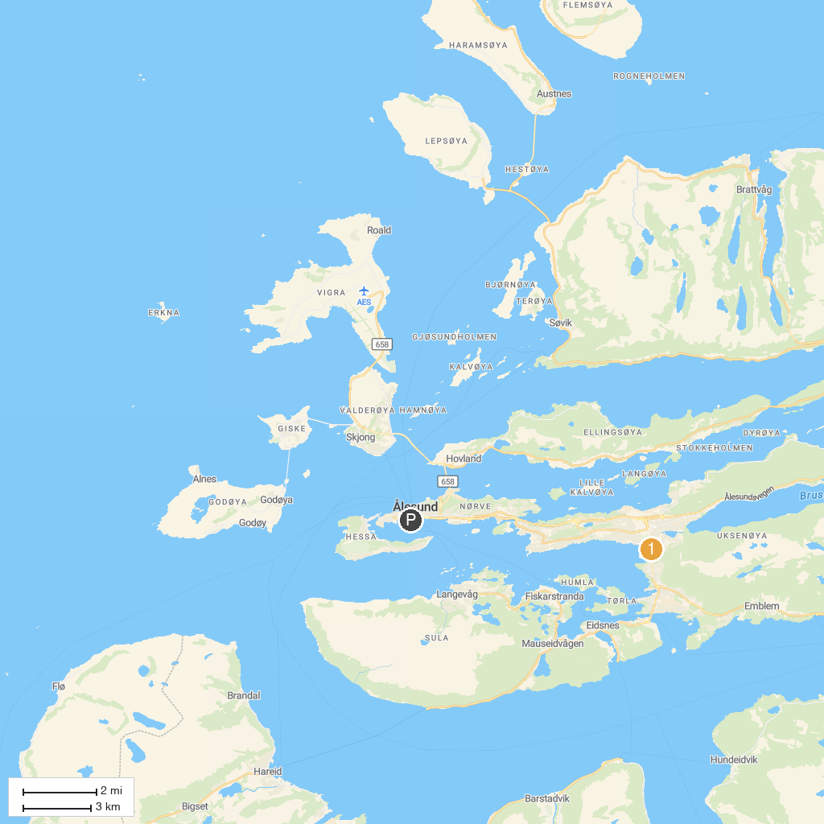
MAP KEY
1. Høgkubben | 3. Sandingane
2. Blakstad Gard | 4. Elvastien
P. Cruise port / terminal
Map © MapTiler © OpenStreetMap contributors · cruiseports.org

