Alexandria, Alexandria Governorate, Egypt
Egypt's second city sits on the Mediterranean coast, blending Pharaonic grandeur with Greco-Roman history. Most cruisers use it as the jumping-off point for Cairo and the Pyramids — but Alexandria itself rewards those who stay.
⚓ Docked (cruise terminal) · 🕒 Typical call: 8-12 hrs · 💵 Egyptian Pound (USD/EUR accepted at tourist sites) · 🗣️ Arabic (English widely spoken at tourist sites)
✍️ MY DAY IN PORT (FILL IN)
Ship / Date
In port | arrive ______ · all aboard ______
Booked excursion
Notes / meeting point
GETTING ASHORE
- Docking: Alexandria Cruise Terminal — 4 berths, ships dock alongside; ~1.5 km from city center
- Cairo/Pyramids: ~2.5-3 hr drive each way — a full-day commitment, usually 10-12 hrs round trip
- Best For: Ancient history lovers, Cairo day-trippers, architecture fans
- Don't Miss: Bibliotheca Alexandrina, Catacombs of Kom El Shoqafa, or the Giza Pyramids if time allows
GETTING AROUND
- 🚕 Taxi: ~$10–15 USD — City center (Corniche waterfront) is only 1.5–2 km from the cruise terminal — a 5–10 minute ride. Taxis do not use meter
- 📱 Rideshare: ✅ Uber, Careem
TOP THINGS TO DO
- Cairo, Giza Pyramids & Sphinx — The classic full-day run: ~3 hours each way by private air-conditioned vehicle, with an Egyptologist guide.
- Catacombs of Kom El Shoqafa — Descend into Alexandria's most remarkable underground site — a 2nd-century AD multi-level tomb complex blending Egyptian, Greek…
- Bibliotheca Alexandrina — The modern successor to the ancient Library of Alexandria is an architectural showpiece on the Corniche waterfront.
- Pompey's Pillar & Serapeum — A ~27-meter red granite column — one of the largest ancient monolithic columns ever erected — standing on a hill amid fragmentary…
- Corniche Waterfront & Stanley Beach — Alexandria's sweeping Mediterranean seafront promenade stretches for miles.
BEST WALKS
- Corniche Waterfront Walk: 2-3 km | Easy | Flat seafront promenade — Alexandria's Mediterranean seafront is the city's main public space.
- Central Alexandria: Tahrir Square to the Corniche: 1.5 km | Easy | City streets — From Misr Station (the historic railway terminus) walk down Nabi Daniel Street past the Roman…
WEATHER · DAYLIGHT · MONEY
Month | High °F | Low °F | Rainy days
May | 80 | 64 | 1
Jul | 87 | 74 | 0
Sep | 87 | 74 | 1
Daylight: May 6:04AM–7:48PM · Jul 6:07AM–8:05PM · Sep 6:44AM–7:05PM
cruiseports.org/alexandria · Confirm terminal & all-aboard time with your ship

Alexandria, Alexandria Governorate, Egypt — Port Map
Red = walkable sights · Amber = excursions farther out · P = cruise terminal
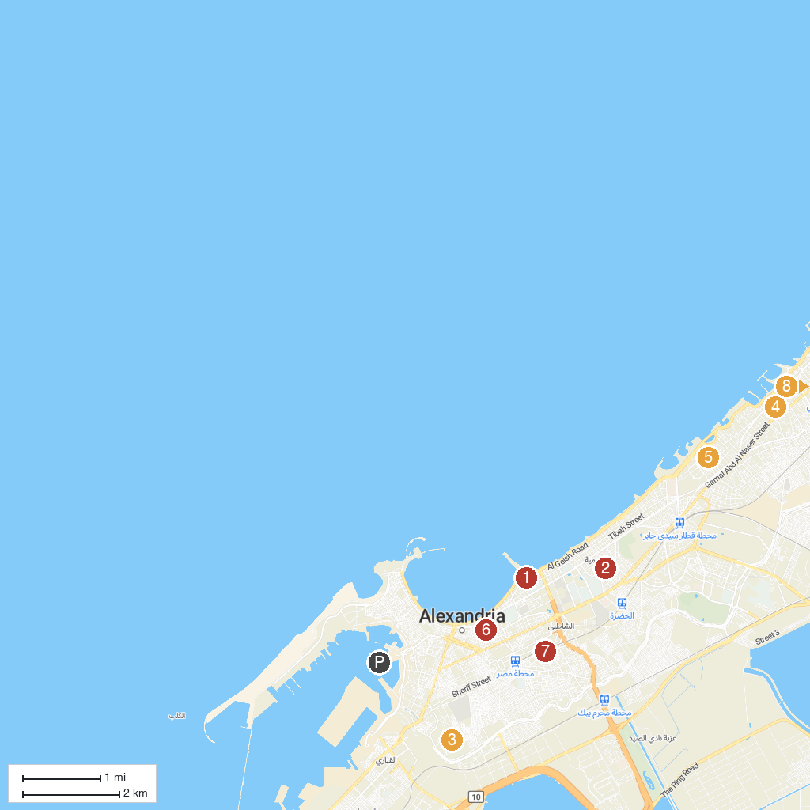
MAP KEY
1. Alexandria Bibliotheca | 5. A Travel
2. St. Takla Church | 6. Eliahu Hanavi Synagogue
3. Catacombs of Kom el Shoqafa | 7. Museum of Fine Arts, Alexandria
4. Royal Jewelry Museum Alexandria | 8. Mahmoud Said Museum
P. Cruise port / terminal
Map © MapTiler © OpenStreetMap contributors · cruiseports.org

