Alghero, Sardinia, Italy
Sardinia's most charming port town wraps Catalan Gothic towers, honey-coloured sea walls, and crystal-clear coves into a single shore day that feels twice as long as it is.
⚓ Mostly tender port · 🕒 Typical call: 6–9 hrs · 💶 Euro (€) · 🗣️ Italian / Algherese Catalan
✍️ MY DAY IN PORT (FILL IN)
Ship / Date
In port | arrive ______ · all aboard ______
Booked excursion
Notes / meeting point
GETTING ASHORE
- Docking: Tender for most ships; small vessels may dock at Banchina Dogana
- Walk to centre: Tender drops at Old Town edge — 0 min walk
- Best For: Medieval old town, Neptune's Grotto, red coral shopping, beaches
- Don't Miss: Bastioni sea walls at golden hour & aragosta alla Catalana
GETTING AROUND
- 🚕 Taxi: €13–€15 (short city trip) — Licensed taxis start at ~€3 plus ~€2/km. A 5 km city ride runs roughly €13–€15. Stand near the port or book via algherot
- 📱 Rideshare: ✅ Uber
TOP THINGS TO DO
- Neptune's Grotto (Grotta di Nettuno) — Sardinia's most spectacular sea cave sits inside the limestone cliffs of Capo Caccia.
- Old Town & Sea Walls Walk — Alghero's walled centro storico is one of the best-preserved in Sardinia.
- Nuraghe Palmavera Archaeological Site — A ~15-min taxi ride northwest toward Porto Conte brings you to one of Sardinia's best-preserved Bronze Age nuragic complexes — a…
- Spiaggia del Lido & San Giovanni Beach — Alghero's main city beaches begin just a 15-min walk north of the old town along the promenade.
- Riviera del Corallo Boat Tour — Catamaran or sailing-boat trips cruise the Coral Riviera coastline, including swimming stops in rocky coves, snorkelling over…
BEST WALKS
- Sea Walls & Old Town Loop: 2–3 km · 1–1.5 hrs · Easy — From the tender landing at Molo Dogana, climb to the Bastioni Marco Polo sea walls and follow them…
- Promenade to Lido Beach: 3 km one-way · 45 min · Flat — Head north from the old town along Lungomare Dante and the coastal promenade to Spiaggia del Lido…
WEATHER · DAYLIGHT · MONEY
Month | High °F | Low °F | Rainy days
May | 71 | 59 | 8
Jul | 86 | 72 | 2
Sep | 80 | 68 | 6
Daylight: May 6:10AM–8:36PM · Jul 6:09AM–8:55PM · Sep 7:07AM–7:35PM
cruiseports.org/alghero · Confirm terminal & all-aboard time with your ship

Alghero, Sardinia, Italy — Port Map
Red = walkable sights · Amber = excursions farther out · P = cruise terminal
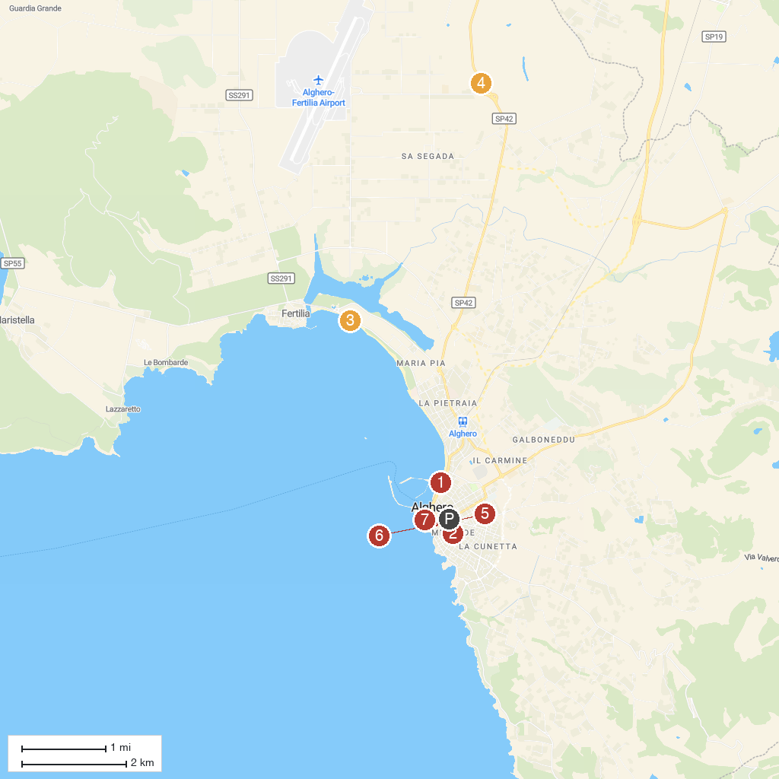
MAP KEY
1. Grotta di Nettuno | 5. Necropolis of Anghelu Ruju
2. Progetto Natura | 6. Alghero
3. Parco Tarragona | 7. Church of Saint Michael
4. Splash Aquapark | 8. Church of San Francesco
P. Cruise port / terminal
Map © MapTiler © OpenStreetMap contributors · cruiseports.org

