Aliağa, İzmir Province, Turkey
A port where ships come to die — and history stretches back 2,500 years. The rusting hulks of former cruise giants line a 10-kilometre beach, while ancient Aeolian cities crumble quietly in the hills above.
⚓ Industrial berth (no passenger terminal) · 🕒 Typical call: transit / viewing · 💵 Currency: Turkish Lira (TRY) · 🗣️ Language: Turkish · 🚢 Ship-breaking capital of Europe
✍️ MY DAY IN PORT (FILL IN)
Ship / Date
In port | arrive ______ · all aboard ______
Booked excursion
Notes / meeting point
GETTING ASHORE
- Docking: Industrial commercial berths; no dedicated cruise terminal
- Ship-breaking yard: ~10 km of coastline, 132 plots — Europe's largest
- Best For: Industrial heritage enthusiasts, photography, maritime history
- Don't Miss: Foça (ancient Phocaea), ~40 km, and ruins of Kyme within Aliağa itself
GETTING AROUND
- 🚕 Taxi: ₺150–300 (~$5–10 USD) — Taxis are available at the port for the short ride into Aliağa city center. Meters apply; confirm the fare before depart
- 📱 Rideshare: ✅ Uber
TOP THINGS TO DO
- Ship-Breaking Beach Panorama — Drive the coastal road alongside the 10-kilometre breaking beach.
- Foça (Ancient Phocaea) — About 40 km south by road, the charming harbour town of Foça sits atop the ruins of ancient Phocaea — the Ionian city whose…
- Ancient Kyme & Aigai Ruins — Kyme — the largest of the twelve Aeolian cities — lies within Aliağa itself near Çakmaklı neighbourhood.
- Pergamon (Bergama) — Turkey's most dramatic acropolis rises above Bergama, about 46 km north.
- Aliağa Bird Sanctuary & Güzelhisar Delta — The Güzelhisar Delta wetland north of town hosts a wide range of bird species.
BEST WALKS
- Breaking Beach Coastal Road Walk: 2 km one-way · Easy · Best light: morning or evening — Ask your taxi to drop you at the northern end of the Aliağa industrial shore road.
- Aliağa Town Centre & Waterfront: 2 km loop · Easy · Cafes along the waterfront — From the port gate, take a taxi to Aliağa town centre.
WEATHER · DAYLIGHT · MONEY
Month | High °F | Low °F | Rainy days
May | 68 | 45 | 9
Jul | 85 | 59 | 6
Sep | 74 | 52 | 7
Daylight: May 6:46AM–9:12PM · Jul 6:44AM–9:32PM · Sep 7:43AM–8:11PM
cruiseports.org/aliaga-ship-breaking-yard · Confirm terminal & all-aboard time with your ship

Aliağa, İzmir Province, Turkey — Port Map
Red = walkable sights · Amber = excursions farther out · P = cruise terminal
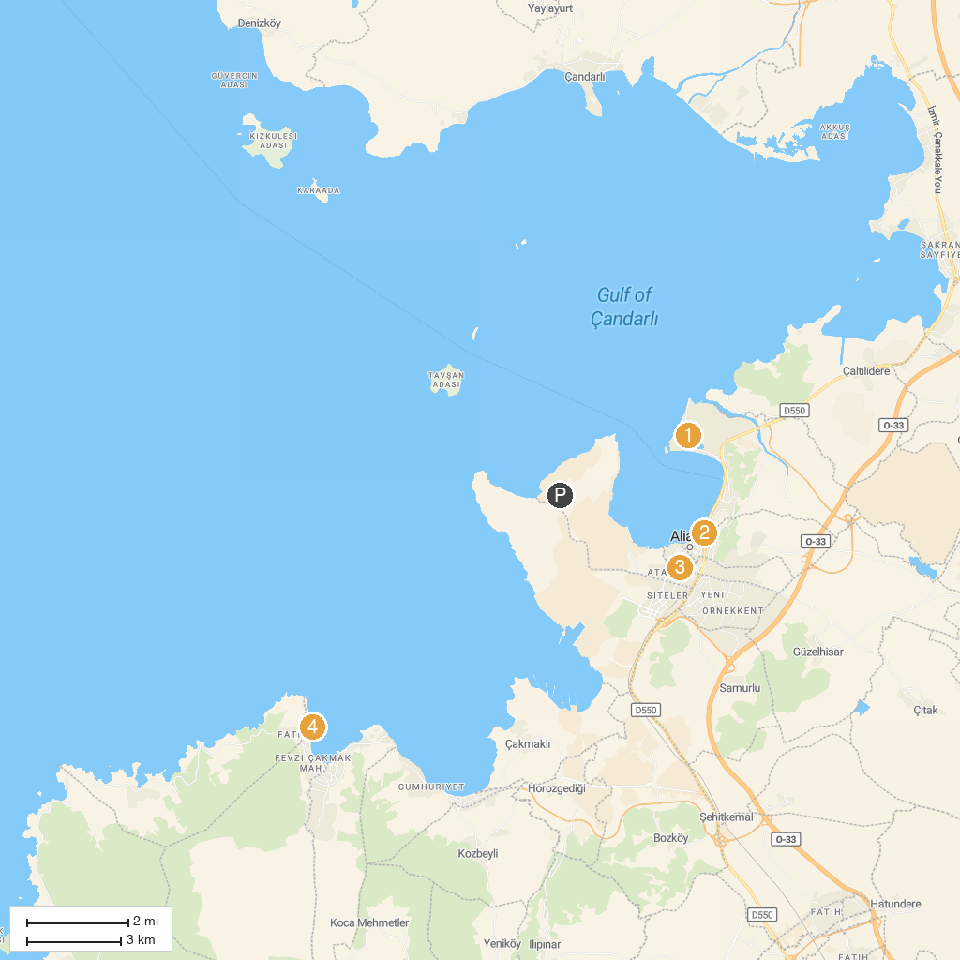
MAP KEY
1. Aliağa Kuş Cenneti | 5. Yenişakran plajı
2. Çandarlı Castle | 6. Şakran, Aliağa/İzmir
3. Uğur Mumcu Parkı | 7. Yeni Foça BURUNUCU
4. Atatürk Parkı
P. Cruise port / terminal
Map © MapTiler © OpenStreetMap contributors · cruiseports.org

