Alicante, Valencia, Spain
Sun-drenched and walkable, Alicante rewards cruise visitors with a Moorish hilltop fortress, the wave-patterned Explanada promenade, a beach right by the port entrance, and tapas bars that open for lunch right when you need them.
⚓ Docked (deep-water berths) · 🕒 Typical call: 6–9 hrs · 💶 Euro (€) · 🗣️ Spanish (Valencian)
✍️ MY DAY IN PORT (FILL IN)
Ship / Date
In port | arrive ______ · all aboard ______
Booked excursion
Notes / meeting point
GETTING ASHORE
- Docking: Berthed at the cruise quay (Muelle 14); free shuttle ~1.5 km to port gate
- Walk to center: 15–20 min on foot from port gate; Explanada is the landmark to aim for
- Best For: History, beaches, tapas, easy day-trips to Elche or Tabarca Island
- Don't Miss: Santa Bárbara Castle — free entry, 360° coastal views (lift ~€3)
GETTING AROUND
- 🚕 Taxi: €5–€7 — Metered taxis are plentiful at the port. The short ride to the city center (2–10 minutes) costs roughly €5–€7 depending
- 📱 Rideshare: ✅ Uber, Bolt
- 🚌 Hop-on hop-off: ✅ Alicante Turibus
TOP THINGS TO DO
- Santa Bárbara Castle — Alicante's defining landmark crowns Mount Benacantil with 360° views over the city, port, and Costa Blanca.
- Old Town (Barrio de Santa Cruz) & Explanada — Wander the colorful flower-pot lanes of Santa Cruz, drop into the Gothic Basilica de Santa María, then stroll the Explanada de…
- Playa del Postiguet — Blue-flag city beach just east of the port entrance.
- Tabarca Island Day Trip — Spain's only inhabited marine reserve sits 11 nautical miles offshore.
- Elche & the Palmeral — 30 km southwest lies Elche, home to the largest palm grove in Europe — a UNESCO World Heritage Site with over 200,000 date palms.
BEST WALKS
- Port Gate to Castle Loop: 3–4 km | 2–3 hrs | Moderate (uphill to castle) — From Plaza Puerta del Mar, walk along the marina to the Explanada de España, then head inland to…
- Market & Tapas Stroll: 1.5 km | 1 hr | Easy — A flat, leisurely loop through the city center.
WEATHER · DAYLIGHT · MONEY
Month | High °F | Low °F | Rainy days
May | 74 | 61 | 4
Jul | 86 | 74 | 1
Sep | 82 | 70 | 7
Daylight: May 6:50AM–9:06PM · Jul 6:50AM–9:24PM · Sep 7:43AM–8:09PM
cruiseports.org/alicante · Confirm terminal & all-aboard time with your ship

Alicante, Valencia, Spain — Port Map
Red = walkable sights · Amber = excursions farther out · P = cruise terminal
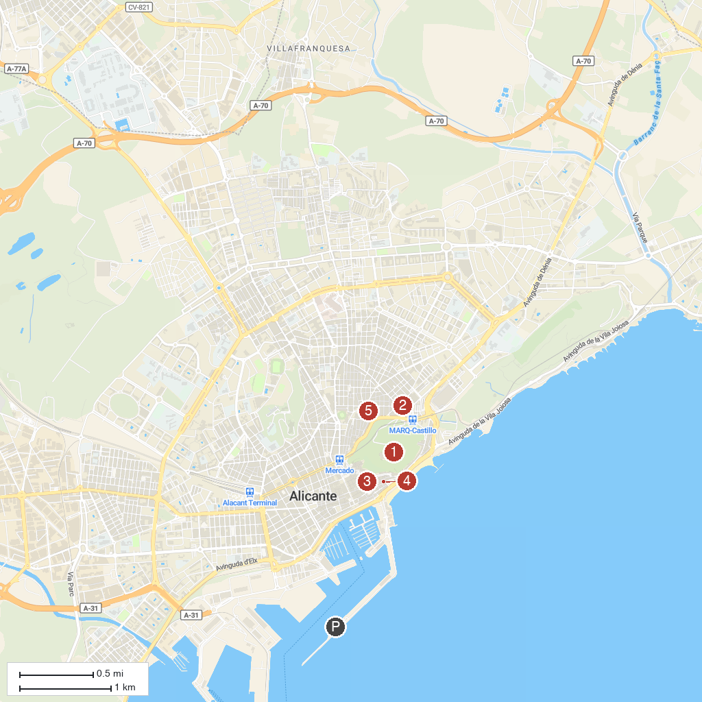
MAP KEY
1. Castle of Santa Barbara | 4. Basilica of St Mary of Alicante
2. Archaeological Museum of Alicante | 5. Las Cigarreras
3. Consell Regulador Denominació d’Origen Vins d’Alacant
P. Cruise port / terminal
Map © MapTiler © OpenStreetMap contributors · cruiseports.org

