Almería, Andalusia, Spain
Where Moorish fortresses meet Europe's only true desert — and every drink comes with a free tapa.
⚓ Docked (Muelle de Levante) · 🕒 Typical call: 8-10 hrs · 💶 Euro (€) · 🗣️ Spanish
✍️ MY DAY IN PORT (FILL IN)
Ship / Date
In port | arrive ______ · all aboard ______
Booked excursion
Notes / meeting point
GETTING ASHORE
- Docking: All ships dock at Muelle de Levante — no tender required
- Walk to center: ~15-20 min (1.5 km) to Plaza Vieja; taxis also available at pier
- Best For: History buffs, foodies (free tapas culture), desert & nature lovers
- Don't Miss: Alcazaba fortress, free tapas on Calle Lope de Vega, Cabo de Gata
GETTING AROUND
- 🚕 Taxi: €5-10 center; tours €40-60 per taxi — Taxis are available at the port and are the easiest option if you do not want to walk. Short city rides are inexpensive;
TOP THINGS TO DO
- Alcazaba & Cathedral Fortress — The Alcazaba is Spain's second-largest Moorish fortress (after the Alhambra), perched above the city with sweeping sea views.
- Tabernas Desert & Mini Hollywood — Europe's only true desert, 30 min from the port.
- Cabo de Gata-Níjar Natural Park — A protected volcanic coastline with hidden coves, crystal-clear water and near-zero development.
- Free Tapas Crawl — Almería has one of Spain's last remaining free-tapas cultures — order a drink and a tapa arrives automatically.
- Civil War Air-Raid Shelters — Over 4 km of tunnels dug under the city to shelter 40,000 residents from Franco-era bombing raids.
BEST WALKS
- Port to Plaza Vieja & Cathedral: 1.5 km | ~20 min | flat — Walk west from the port gate along the Paseo de Almería, the main shopping boulevard, to Plaza…
- Alcazaba Climb & Old Town Loop: 2.5 km | ~60-75 min | moderate uphill — From the Cathedral, follow signs uphill to the Alcazaba entrance.
WEATHER · DAYLIGHT · MONEY
Month | High °F | Low °F | Rainy days
May | 78 | 63 | 3
Jul | 90 | 75 | 0
Sep | 84 | 70 | 3
Daylight: May 7:02AM–9:10PM · Jul 7:02AM–9:28PM · Sep 7:52AM–8:16PM
cruiseports.org/almeria · Confirm terminal & all-aboard time with your ship

Almería, Andalusia, Spain — Port Map
Red = walkable sights · Amber = excursions farther out · P = cruise terminal
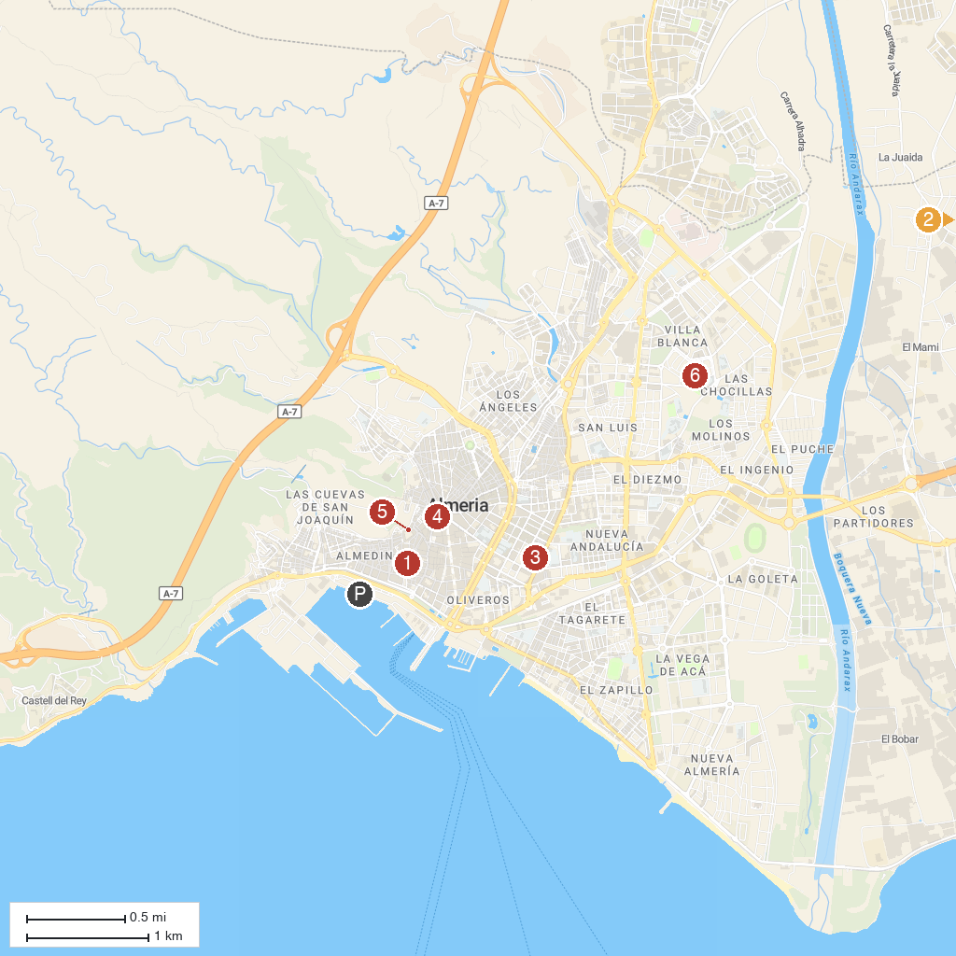
MAP KEY
1. Cathedral Encarnación de Almería | 5. Refugios de la Guerra Civil Española de Almería
2. El Boticario | 6. Heritage Interpretation Center of Almeria
3. Museo de Almería | 7. Casa del Cine Almeria
4. Mariposario de Nijar
P. Cruise port / terminal
Map © MapTiler © OpenStreetMap contributors · cruiseports.org

