Alta, Finnmark, Norway
The City of the Northern Lights sits above the Arctic Circle where prehistoric rock carvings meet a 24-hour summer sun and jaw-dropping winter auroras. Alta punches well above its size.
⚓ Docked (pier at Bukta) · 🕒 Typical call: 7-10 hrs · 💵 Norwegian Krone (NOK) · 🗣️ Norwegian · 🌞 Midnight Sun (Jun–Jul) / Aurora (Oct–Mar)
✍️ MY DAY IN PORT (FILL IN)
Ship / Date
In port | arrive ______ · all aboard ______
Booked excursion
Notes / meeting point
GETTING ASHORE
- Docking: Ships dock at Bukta Quay, 3–4 km from city center; shuttle usually provided
- Walk to Center: ~40 min on foot or 10 min by shuttle/taxi
- Best For: Northern Lights, UNESCO rock art, Sami culture, Arctic nature
- Don't Miss: Alta Museum's rock carvings (UNESCO) and the Northern Lights Cathedral
GETTING AROUND
- 🚕 Taxi: 170–200 NOK (~$15–19 USD) — Alta Taxi serves the port area. The city center is about 3.5–4 km from the pier; metered fares start at 109 NOK plus 18
TOP THINGS TO DO
- Alta Museum & UNESCO Rock Carvings — Over 6,000 prehistoric petroglyphs — some 7,000 years old — are preserved in their original setting at Hjemmeluft, a short drive…
- Sautso–Alta Canyon Hike — Northern Europe's largest canyon drops 400 metres through wild Finnmark plateau.
- Northern Lights Cathedral & City Walk — Alta's titanium-clad cathedral spirals skyward in a design inspired by the Aurora Borealis.
- Sami Reindeer Farm Experience — Boazo Sami Siida, a working reindeer farm 20 minutes from Alta, offers guided introductions to Sami herding culture, traditional…
- Dog Sledding on the Finnmarksvidda (Winter) — From December to April, husky sled tours depart into the vast Finnmark plateau.
BEST WALKS
- Northern Lights Cathedral to Alta Museum: 3 km | 40 min | Easy — Start at the striking Northern Lights Cathedral in the center, walk along the Alta River path to…
- Alta City Center Stroll: 1–2 km | 20 min | Easy — A relaxed loop around the pedestrian center takes in the main square, local shops, Æventyr…
WEATHER · DAYLIGHT · MONEY
Month | High °F | Low °F | Rainy days
May | 46 | 33 | 14
Jul | 63 | 50 | 13
Sep | 51 | 41 | 13
Daylight: Sep 5:40AM–7:01PM
cruiseports.org/alta · Confirm terminal & all-aboard time with your ship

Alta, Finnmark, Norway — Port Map
Red = walkable sights · Amber = excursions farther out · P = cruise terminal
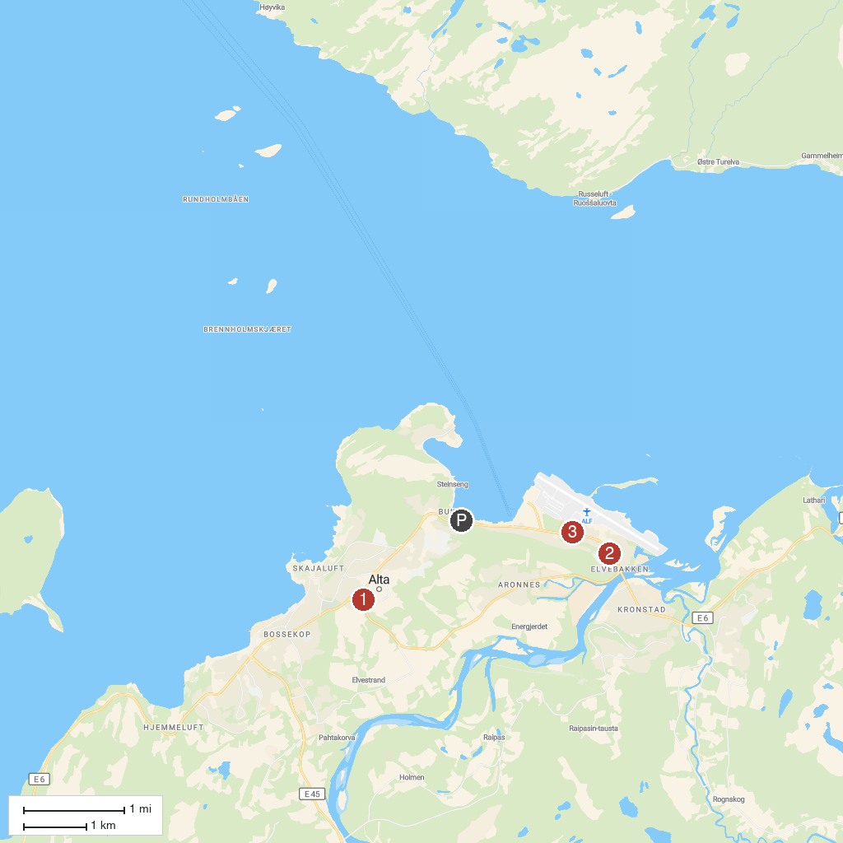
MAP KEY
1. Cathedral of The Northern Lights | 4. Peskatun
2. Elvebakken Church | 5. Northern Lights Observatory at Haldde
3. Tirpitz Museum | 6. Altagård
P. Cruise port / terminal
Map © MapTiler © OpenStreetMap contributors · cruiseports.org

