Amalfi, Campania, Italy
Perched between cliffs and turquoise sea, Amalfi delivers medieval grandeur, lemon-scented lanes and one of the world's great coastal drives — all within steps of the tender dock.
⚓ Tender port (no pier docking) · 🕒 Typical call: 6-8 hrs · 💶 Currency: Euro (€) · 🗣️ Language: Italian · 🌊 Weather-dependent tendering
✍️ MY DAY IN PORT (FILL IN)
Ship / Date
In port | arrive ______ · all aboard ______
Booked excursion
Notes / meeting point
GETTING ASHORE
- Docking: Tender only — ships anchor in the bay; tender to Marina Coppola
- Walk to centre: ~1 min from tender dock to Piazza del Duomo
- Best For: Scenic drives, Amalfi Cathedral, coastal village-hopping
- Don't Miss: Cattedrale di Sant'Andrea and the Museo della Carta (Paper Museum)
GETTING AROUND
- 🚕 Taxi: €17–€55+ — Taxis are available at Piazza Flavio Gioia, just meters from the tender pier. Fares are fixed (not metered); inter-town
TOP THINGS TO DO
- Amalfi Cathedral & Piazza del Duomo — The Cattedrale di Sant'Andrea, with 9th-century origins and largely rebuilt from 987 onward, dominates Amalfi's main square with…
- Museo della Carta — Amalfi Paper Museum — Amalfi was Europe's first paper-making centre.
- Positano & the Amalfi Drive — A scenic taxi, bus, or boat ride takes you to Positano's pastel houses, Spiaggia Grande beach, and the Church of Santa Maria…
- Ravello Villa Gardens — High above the sea, Ravello's Villa Rufolo and Villa Cimbrone offer world-class gardens and the Terrace of Infinity viewpoint.
- Path of the Gods Hike (Sentiero degli Dei) — One of Italy's most celebrated coastal hikes, linking Agerola to Nocelle with panoramic clifftop views over the coast.
BEST WALKS
- Waterfront to Cathedral Walk: 30-45 min | Easy | Mostly flat — From Marina Coppola, cross the waterfront promenade and head straight up Via Lorenzo d'Amalfi to…
- Paper Museum & Valle delle Ferriere Trail Start: 1-2 hrs | Easy-moderate | Some uphill — Follow Via delle Cartiere uphill from the town centre to the Museo della Carta, then continue on…
- Atrani Village Loop: 45-60 min | Easy | Flat coastal path — Walk east from the Amalfi waterfront along the shore to neighbouring Atrani — one of Italy's…
WEATHER · DAYLIGHT · MONEY
Month | High °F | Low °F | Rainy days
May | 70 | 55 | 6
Jul | 84 | 67 | 2
Sep | 79 | 63 | 6
Daylight: May 5:44AM–8:11PM · Jul 5:43AM–8:30PM · Sep 6:42AM–7:10PM
Representative sunrise/sunset — 2025, 15th of each month; local civil time including DST (Europe/Rome). Source: Astral; not a forecast or climate average.
cruiseports.org/amalfi · Confirm terminal & all-aboard time with your ship

Amalfi, Campania, Italy — Port Map
Red = walkable sights · Amber = excursions farther out · P = cruise terminal
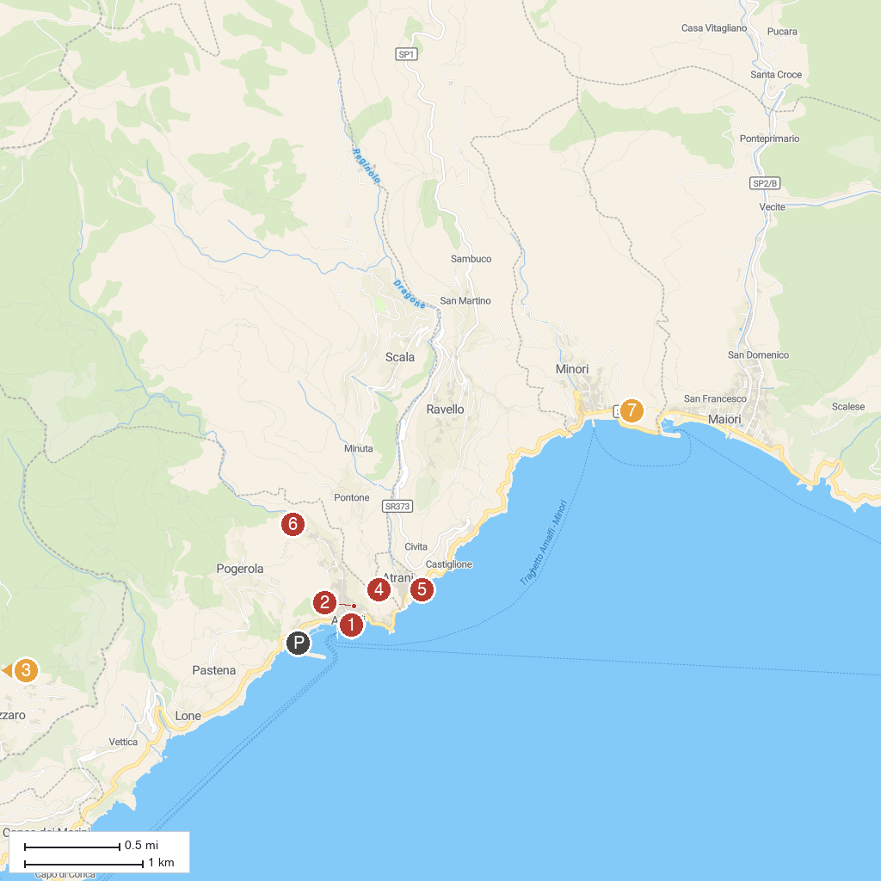
MAP KEY
1. Castello del Parco Fienga | 5. Torre dello Ziro
2. Amalfi Coast | 6. Collegiate Church of Saint Mary Magdalene 'Penitente'
3. Paradise Cloister | 7. Amalfi Lemon Experience
4. Path of the Gods | 8. Path of the Lemons
P. Cruise port / terminal
Map © MapTiler © OpenStreetMap contributors · cruiseports.org

