Amarna, El-Minia, Egypt
Abandoned by pharaohs and forgotten by time, Akhenaten's short-lived capital rises from the desert cliffs of Middle Egypt — its painted tombs and boundary stelae intact after 3,300 years. Nile river cruise ships moor directly at the riverside for one of Egypt's most haunting shore days.
⚓ River moorage / Nile bank · 🕒 Typical call: 6-8 hrs · 💵 Egyptian Pound (EGP) · 🗣️ Arabic · 🏺 Archaeological site
✍️ MY DAY IN PORT (FILL IN)
Ship / Date
In port | arrive ______ · all aboard ______
Booked excursion
Notes / meeting point
GETTING ASHORE
- Docking: Nile river cruise ships moor along the east bank at El-Till; no tender required
- Walk to centre: Visitor Centre is steps from the mooring; ruins span 12+ km — a vehicle is essential
- Best For: Egyptology enthusiasts, off-the-beaten-path history, Amarna art and Akhenaten's story
- Don't Miss: North Tombs reliefs, the Royal Tomb in the Royal Wadi, and the Visitor Centre replica house
GETTING AROUND
- 🚕 Taxi: Negotiable — Basic local taxis and tuktuks are available in nearby villages but are unmetered. Agree on a price beforehand and expect
TOP THINGS TO DO
- North Tombs of Amarna — Six richly decorated rock-cut tombs of Akhenaten's senior courtiers — including Huya, Meryra and Ahmose — preserving vivid relief…
- Royal Tomb & Royal Wadi — A 30-minute desert drive up the Royal Wadi leads to Akhenaten's own tomb (TA26) — where his daughter Princess Meketaten was also…
- Amarna Visitor Centre & Small Aten Temple — The riverside Visitor Centre gives context for the site before you explore.
- South Tombs & Kom el-Nana — The southern cluster of noble tombs (including the tomb of Ay) and the enclosure of Kom el-Nana — believed to be a sun temple or…
- North Palace & North City — The North Palace was likely a residence for the royal family — its painted 'Green Room' frieze of birds in a papyrus marsh is one…
BEST WALKS
- Riverside Walk — El-Till to Visitor Centre: 1.5 km · 20 min · Easy · Flat — A short, flat stroll along the Nile corniche from the ship mooring through the village of El-Till…
- North City Ground Walk: 2 km · 30 min · Easy · Unpaved desert — From the Visitor Centre, walk south along the edge of the ancient North City — the outlines of…
WEATHER · DAYLIGHT · MONEY
Month | High °F | Low °F | Rainy days
May | 96 | 70 | 0
Jul | 101 | 77 | 0
Sep | 97 | 74 | 0
Daylight: May 6:07AM–7:38PM · Jul 6:10AM–7:53PM · Sep 6:41AM–7:00PM
cruiseports.org/amarna · Confirm terminal & all-aboard time with your ship

Amarna, El-Minia, Egypt — Port Map
Red = walkable sights · Amber = excursions farther out · P = cruise terminal
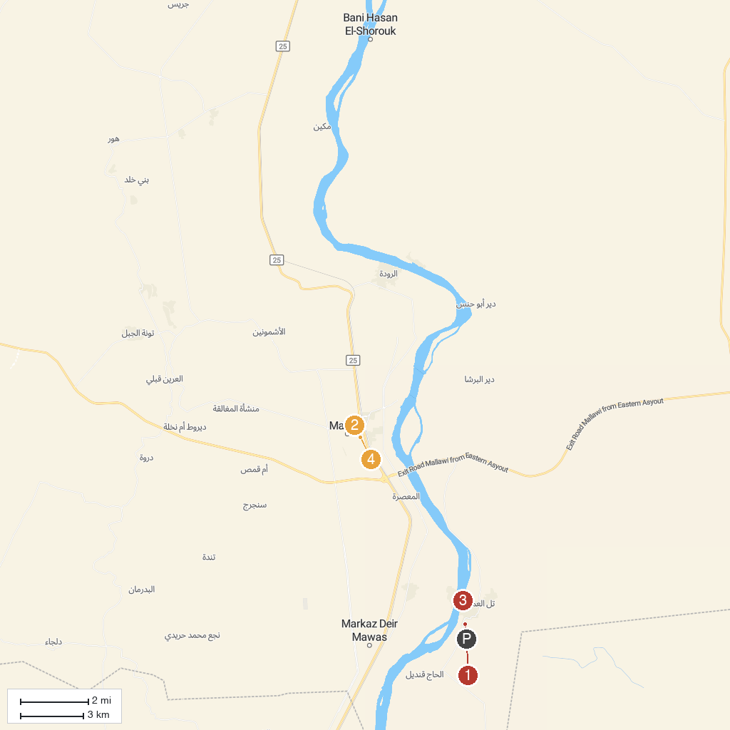
MAP KEY
1. Great Aten Temple | 3. Tell el Amarna Visitor Center مركز زوار تل العمارنة
2. Mallawi Museum | 4. مسجد اليوسفي
P. Cruise port / terminal
Map © MapTiler © OpenStreetMap contributors · cruiseports.org

