Amelia Island, Florida, USA
Florida's northeasternmost barrier island trades theme-park crowds for 50 blocks of gas-lit Victorian streets, a real Civil War fort, and wide Atlantic beaches where wild horses once roamed.
⚓ Pier (docked) · 🕒 Typical call: 6-9 hrs · 💵 US Dollar · 🗣️ English · 🏖️ Beach & history
✍️ MY DAY IN PORT (FILL IN)
Ship / Date
In port | arrive ______ · all aboard ______
Booked excursion
Notes / meeting point
GETTING ASHORE
- Docking: Pier — Port of Fernandina deep-water pier (1,200 ft), central to town
- Walk to centre: ~5-10 min walk from pier to Centre Street historic district
- Best For: Victorian architecture, Civil War history, beaches, nature walks
- Don't Miss: Fort Clinch State Park & the Palace Saloon (Florida's oldest)
GETTING AROUND
- 🚕 Taxi: $10–$25 — Local taxis (Daniel Transportation and others) serve the island 24/7. Short rides within town are typically a minimum fa
- 📱 Rideshare: ✅ Uber, Lyft
TOP THINGS TO DO
- Fort Clinch State Park — Explore a remarkably intact 19th-century brick fort garrisoned during the Civil War and Spanish-American War.
- Historic Downtown Fernandina Beach — Stroll 50 blocks of Victorian-era architecture recognized on the National Register of Historic Places.
- Amelia River & Cumberland Island Cruise — Amelia River Cruises runs narrated tours between Amelia and Georgia's wild Cumberland Island — spot wild horses, dolphins, and…
- Horseback Riding on the Beach — Amelia Island State Park on the southern tip of the island offers guided horseback rides along a wide, uncrowded Atlantic beach…
- Main Beach Park & Egans Creek Greenway — Main Beach Park offers a family-friendly Atlantic beach with a playground, pavilion, and calm surf.
BEST WALKS
- Centre Street Historic District Loop: 1-2 hrs · Flat · Self-guided — From the pier, head south to Centre Street and walk east through the 50-block Victorian historic…
- Fort Clinch Beach & Fort Walk: 2-4 hrs · Easy-moderate · Bike or ride-share to park — Enter Fort Clinch State Park and tour the brick fort interior, then follow the beach trail south…
WEATHER · DAYLIGHT · MONEY
Month | High °F | Low °F | Rainy days
May | 81 | 68 | 10
Jul | 88 | 76 | 20
Sep | 83 | 74 | 18
Daylight: May 6:31AM–8:13PM · Jul 6:33AM–8:29PM · Sep 7:10AM–7:30PM
cruiseports.org/amelia-island-florida · Confirm terminal & all-aboard time with your ship

Amelia Island, Florida, USA — Port Map
Red = walkable sights · Amber = excursions farther out · P = cruise terminal
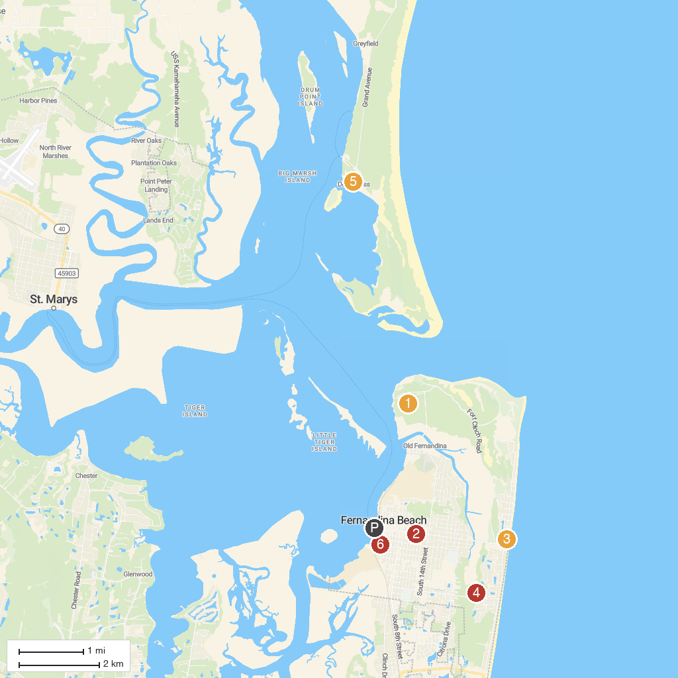
MAP KEY
1. Fort Clinch State Park | 4. Egan's Creek Greenway
2. Central Park, Fernandina Beach | 5. Dungeness Ruins, Cumberland Island
3. Main Beach Park, Amelia Island | 6. Amelia Island Museum of History
P. Cruise port / terminal
Map © MapTiler © OpenStreetMap contributors · cruiseports.org

