Anacortes, Washington, USA
Fidalgo Island's working port is the launching pad for the San Juan Islands — whale-rich waters, a walkable arts downtown, and Deception Pass all within reach of a single shore day.
⚓ Docked (Pier 1 / Cap Sante Marina) · 🕒 Typical call: 6-9 hrs · 💵 US Dollar · 🗣️ English
✍️ MY DAY IN PORT (FILL IN)
Ship / Date
In port | arrive ______ · all aboard ______
Booked excursion
Notes / meeting point
GETTING ASHORE
- Docking: Pier 1 or Cap Sante Marina; small/expedition ships typical
- Walk to center: 5-10 min to Commercial Ave downtown
- Best For: Whale watching, San Juan Islands, Deception Pass
- Don't Miss: Orca sightings in the Salish Sea (spring–summer)
GETTING AROUND
- 🚕 Taxi: About $15-25 local; longer trips vary — Local taxis and private shuttle operators can handle short hops or prearranged transfers. A ride between the ferry dock
- 📱 Rideshare: ✅ Uber, Lyft
TOP THINGS TO DO
- Whale Watching in the Salish Sea — The waters around the San Juan Islands are among the best orca habitat in the world.
- Deception Pass State Park — Washington's most-visited state park sits 30 minutes north.
- Sea Kayaking — Fidalgo Island — Paddle calm Fidalgo waters on a guided kayak tour.
- Washington Park Loop — A scenic 2.25-mile paved loop at the west end of Fidalgo Island frames views of the San Juan Islands and Olympic Peninsula.
- Downtown Anacortes & Commercial Avenue — Anacortes's arts-forward downtown is packed with galleries, boutiques, and brewpubs.
BEST WALKS
- Cap Sante Marina to Commercial Avenue: 0.3 miles · 10 min · Easy — A short stroll from the marina through the heart of downtown Anacortes.
- Tommy Thompson Trestle Walk: 2-4 miles round trip · 1-1.5 hrs · Easy — A car-free trail along the waterfront with views of Fidalgo Bay, Mount Baker, and ferry traffic.
- Washington Park Loop: 2.25 miles · 45-60 min · Easy paved — A paved scenic loop at the island's western tip with panoramic San Juan Islands views, beach…
WEATHER · DAYLIGHT · MONEY
Month | High °F | Low °F | Rainy days
May | 61 | 48 | 9
Jul | 70 | 56 | 4
Sep | 65 | 53 | 10
Daylight: May 5:29AM–8:44PM · Jul 5:25AM–9:07PM · Sep 6:48AM–7:21PM
cruiseports.org/anacortes-wa · Confirm terminal & all-aboard time with your ship

Anacortes, Washington, USA — Port Map
Red = walkable sights · Amber = excursions farther out · P = cruise terminal
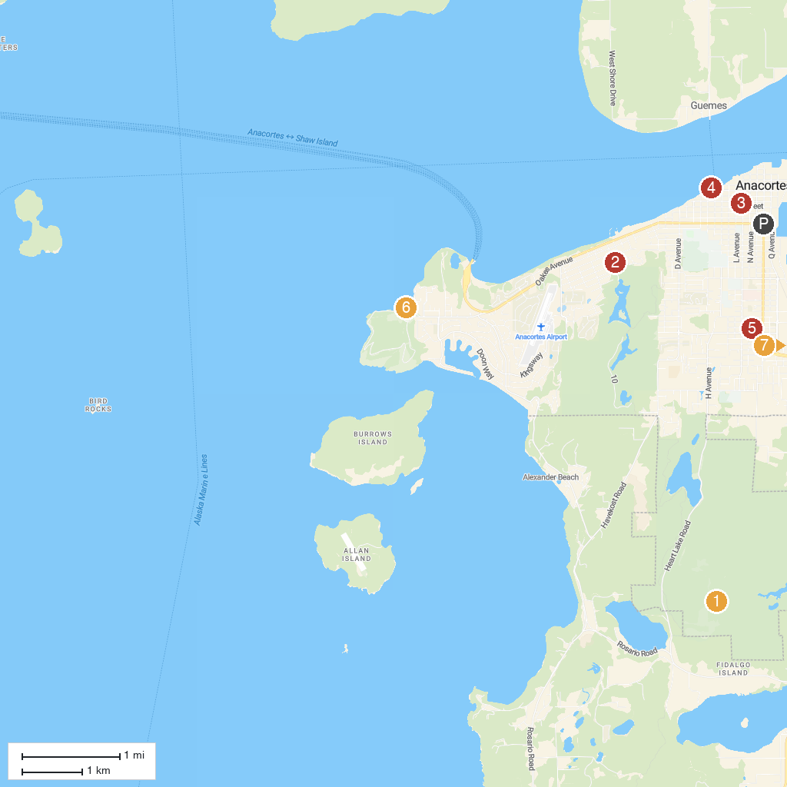
MAP KEY
1. Mount Erie Summit Trail | 5. John Storvik Playground
2. Cranberry Lake Park | 6. Washington Park Boat Launch
3. Anacortes Museum | 7. Breazeale Interpretive Center and Aquarium
4. Kiwanis Waterfront Park | 8. Ala Spit County Park
P. Cruise port / terminal
Map © MapTiler © OpenStreetMap contributors · cruiseports.org

