Ancenis, Loire-Atlantique, France
A quiet Loire riverbank town where a medieval château overlooks vine-covered hills — and the Muscadet flows as freely as the river below.
⚓ River dock (quay) · 🕒 Typical call: 6-8 hrs · 💶 Euro (EUR) · 🗣️ French
✍️ MY DAY IN PORT (FILL IN)
Ship / Date
In port | arrive ______ · all aboard ______
Booked excursion
Notes / meeting point
GETTING ASHORE
- Docking: River quay dock; ships tie up along the Loire embankment within easy walk of the château
- Walk to centre: 5-10 min from the quay to the old town and Château d'Ancenis
- Best For: Wine lovers, cyclists, and château enthusiasts wanting an unhurried Loire village
- Don't Miss: Muscadet wine tasting at a Coteaux d'Ancenis vineyard and the panoramic view from the château ramparts
GETTING AROUND
- 🚕 Taxi: €8–€15 — Local taxis and VTC (private hire) services are available in Ancenis for transport within town or to nearby areas. Uber
- 📱 Rideshare: ✅ Uber
TOP THINGS TO DO
- Château d'Ancenis — The town's dominant landmark, this fortress traces its origins to around 990 AD and gained an early-Renaissance dwelling in the…
- Muscadet & Coteaux d'Ancenis Wine Tasting — Ancenis sits at the heart of the Coteaux d'Ancenis AOC — a lesser-known appellation producing crisp whites and fruity reds.
- Loire à Vélo Cycling — Rent a bike and roll along the Loire à Vélo trail (EuroVelo 6) that passes through town.
- Château Médiéval d'Oudon — A short drive or bike ride west toward Nantes, this 14th-century octagonal keep perches dramatically above the Loire near the…
- Île Mouchet & Loire Riverside Walk — Île Mouchet, a 40-hectare Natura 2000 green space on the Loire's north bank, has a marked riverside circuit.
BEST WALKS
- Quay to Château & Old Town: 1.5 km loop · Easy · 30-45 min — Walk from the river quay up through the old town to the Château d'Ancenis for Loire views, then…
- Loire Riverside Promenade: 2-3 km · Easy · 45-60 min — Stroll the Loire embankment toward the Pont d'Ancenis bridge.
WEATHER · DAYLIGHT · MONEY
Month | High °F | Low °F | Rainy days
May | 67 | 50 | 11
Jul | 78 | 60 | 7
Sep | 73 | 56 | 8
Daylight: May 6:28AM–9:34PM · Jul 6:23AM–9:56PM · Sep 7:42AM–8:16PM
cruiseports.org/ancenis · Confirm terminal & all-aboard time with your ship

Ancenis, Loire-Atlantique, France — Port Map
Red = walkable sights · Amber = excursions farther out · P = cruise terminal
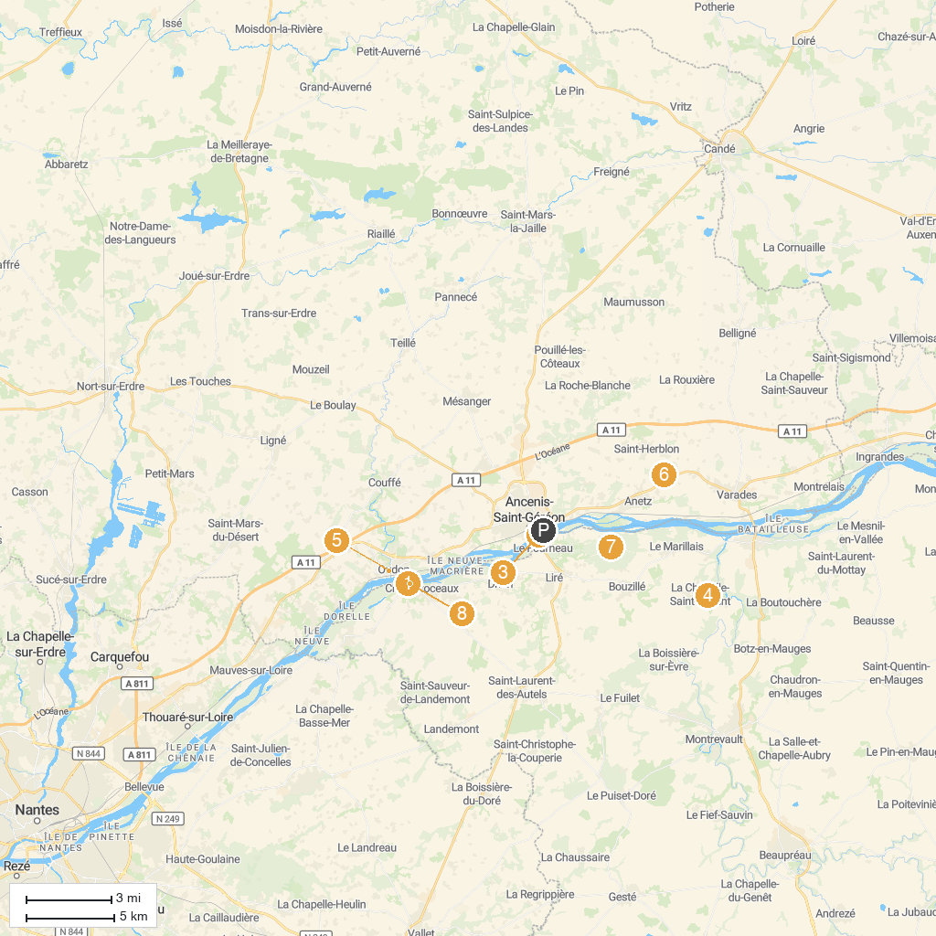
MAP KEY
1. Boat Luce - Cruises in Loire | 5. Château d'Oudon
2. Château d'Ancenis | 6. Chateau de Vair
3. Jardin De L'Eperon | 7. Boire Sainte-Catherine
4. Moulin de L'Epinay | 8. hanging mill in Champtoceaux
P. Cruise port / terminal
Map © MapTiler © OpenStreetMap contributors · cruiseports.org

