Ancona, Marche, Italy
Ancona rewards curious walkers with a Roman arch at the waterfront, a Romanesque cathedral crowning the hilltop, and one of Italy's most underrated Adriatic Old Towns — all a short stroll from the pier.
⚓ Docked (pier) · 🕒 Typical call: 7-10 hrs · 💶 Currency: Euro (EUR) · 🗣️ Language: Italian · 🚶 Walkable old town
✍️ MY DAY IN PORT (FILL IN)
Ship / Date
In port | arrive ______ · all aboard ______
Booked excursion
Notes / meeting point
GETTING ASHORE
- Docking: Ships berth at Molo Clementino or XXIX Settembre pier; old town is a 15-20 min walk or short taxi ride
- Walk to center: ~2 km along the port road to Piazza del Plebiscito; mostly flat with a hill for the Duomo
- Best For: Roman ruins, Adriatic seafood, day trips to Urbino and the Conero Riviera
- Don't Miss: Arch of Trajan right at the port entrance and the Duomo of San Ciriaco on Guasco Hill
GETTING AROUND
- 🚕 Taxi: €8–€12 — Metered taxis are available at the port. The short ride to the city center typically costs €8–€12; the port and downtown
TOP THINGS TO DO
- Arch of Trajan & Mole Vanvitelliana — The 115 AD triumphal arch marking ancient Ancona's harbour entrance stands metres from the dock.
- Duomo of San Ciriaco — Ancona's cathedral crowns Guasco Hill in a blend of Romanesque, Byzantine, and Gothic styles.
- Urbino Day Trip — UNESCO-listed Urbino is a perfectly preserved Renaissance hilltop city about 90 minutes inland — birthplace of Raphael, home to…
- Conero Riviera — Dramatic limestone cliffs plunge into turquoise Adriatic waters just 15 km south of Ancona.
- Frasassi Caves — One of Europe's largest cave systems, about an hour inland from Ancona.
BEST WALKS
- Port to Duomo: Ancona Old Town Loop: 3 km · 2-2.5 hrs · Moderate (one uphill stretch) — Start at the Arch of Trajan by the port, walk along Via XXIX Settembre to Piazza della Repubblica…
- Passetto Cliff Walk: 2 km one-way · 1 hr · Easy-moderate — From the old town, walk north along the seafront to the Passetto area — a scenic clifftop promenade…
WEATHER · DAYLIGHT · MONEY
Month | High °F | Low °F | Rainy days
May | 70 | 58 | 11
Jul | 84 | 71 | 5
Sep | 76 | 64 | 8
Daylight: May 5:41AM–8:24PM · Jul 5:38AM–8:44PM · Sep 6:45AM–7:15PM
cruiseports.org/ancona · Confirm terminal & all-aboard time with your ship

Ancona, Marche, Italy — Port Map
Red = walkable sights · Amber = excursions farther out · P = cruise terminal
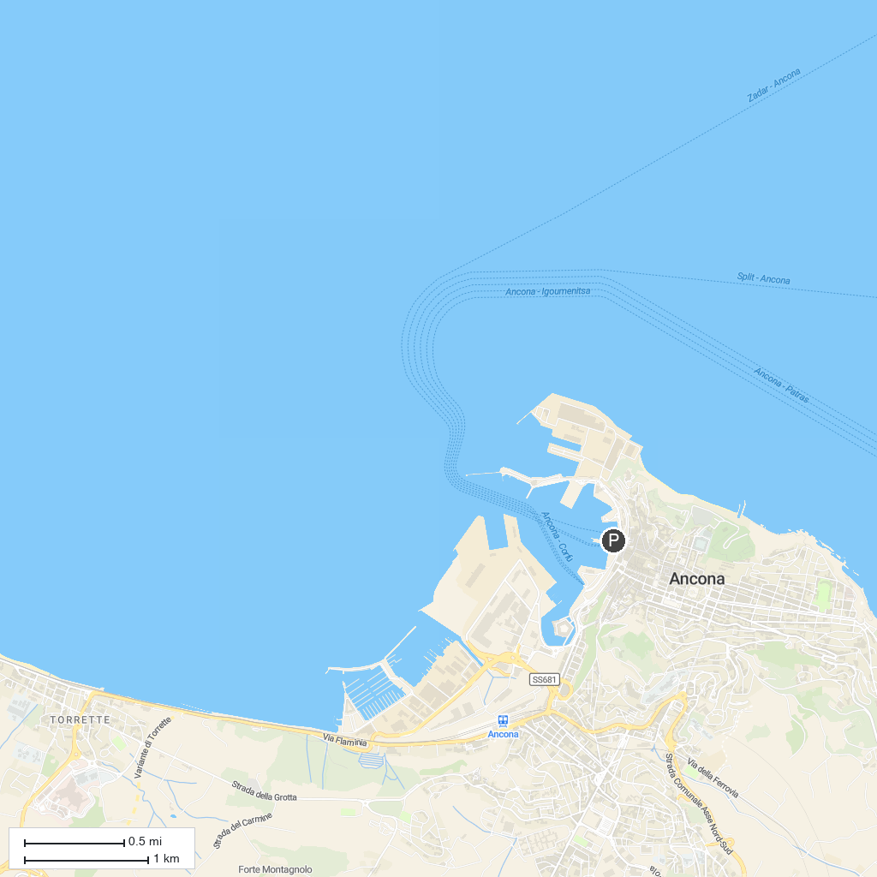
MAP KEY
1. Cattedrale San Settimio | 5. Biblioteca Comunale Planettiana
2. Riserva Naturale Ripa Bianca di Jesi | 6. Arco Clementino
3. Balcony of the Marches | 7. Palazzo Pianetti
4. St. Urbano's Abbey | 8. Parrocchia di Santa Maria del Piano
P. Cruise port / terminal
Map © MapTiler © OpenStreetMap contributors · cruiseports.org

