Andros Island, Bahamas
The Bahamas' largest and least-developed island draws nature lovers, divers, and anglers — not party crowds. Expect wild beaches, epic reef walls, and a genuinely unhurried pace.
⚓ Tender port · 🕒 Typical call: 6-8 hrs · 💵 USD / Bahamian Dollar (1:1) · 🗣️ English
✍️ MY DAY IN PORT (FILL IN)
Ship / Date
In port | arrive ______ · all aboard ______
Booked excursion
Notes / meeting point
GETTING ASHORE
- Docking: Tender — ships anchor offshore at Fresh Creek or Morgan's Bluff; no dedicated cruise terminal
- Walk to center: 5 min from tender dock to Andros Town; Morgan's Bluff is very small with little within walking range
- Best For: Diving, snorkeling, bonefishing, blue holes, unspoiled beaches
- Don't Miss: The Androsia Batik Factory in Fresh Creek and a snorkel on the barrier reef
GETTING AROUND
- 🚕 Taxi: $25–$70 — Pre-arranged taxis are the primary land transport from Fresh Creek Dock. Fares are government-set per vehicle; confirm t
- 📱 Rideshare: ❌ not available
TOP THINGS TO DO
- Andros Barrier Reef Snorkel or Dive — The third-longest barrier reef in the world runs 140 miles along Andros's east coast, with wall dives dropping to 6,000 feet.
- Blue Holes Exploration — Andros has more ocean and inland blue holes than anywhere on Earth.
- Bonefishing on the Flats — Andros is called the Bonefishing Capital of the World.
- Androsia Batik Factory Tour — A short walk from the Fresh Creek dock, Androsia is Andros's iconic hand-batik fabric studio.
- Mangrove Kayak & Wildlife — Paddle through Andros's vast mangrove creek systems, scanning for flamingos, herons, and (rarely) manatees.
BEST WALKS
- Fresh Creek Waterfront & Androsia Factory: 1.5 km · 30 min · Flat · Easy — From the tender dock, stroll along the creek waterfront past fishing boats and modest homes to the…
WEATHER · DAYLIGHT · MONEY
Month | High °F | Low °F | Rainy days
May | 83 | 75 | 18
Jul | 88 | 80 | 16
Sep | 87 | 79 | 20
Daylight: May 6:27AM–7:47PM · Jul 6:31AM–8:02PM · Sep 6:57AM–7:14PM
cruiseports.org/andros-island-bahamas · Confirm terminal & all-aboard time with your ship

Andros Island, Bahamas — Port Map
Red = walkable sights · Amber = excursions farther out · P = cruise terminal
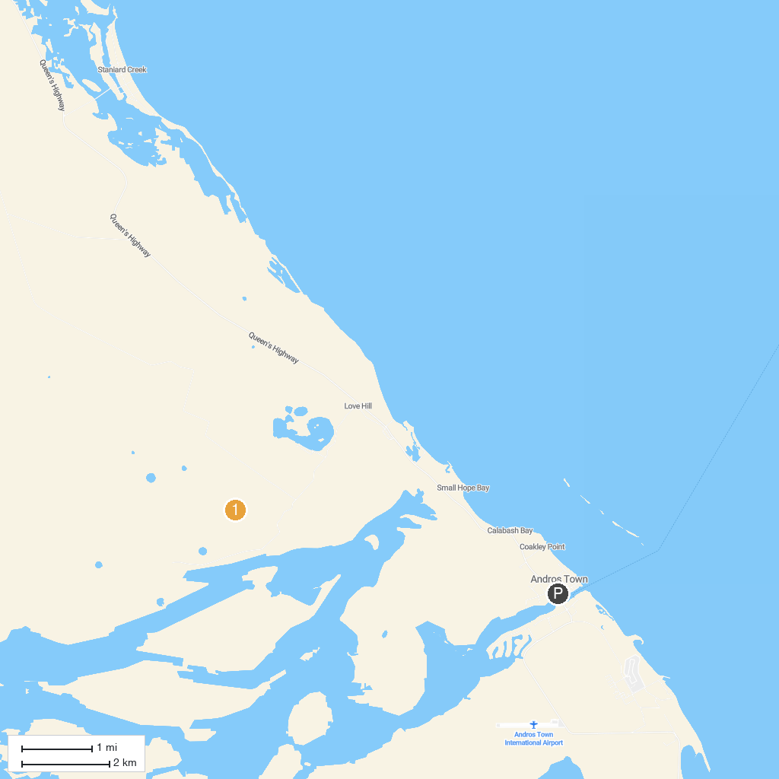
MAP KEY
1. Captain Bill's Blue Hole | 2. Blue Holes National Park
P. Cruise port / terminal
Map © MapTiler © OpenStreetMap contributors · cruiseports.org

