Angra do Heroísmo, Terceira, Azores, Portugal
Portugal's first UNESCO World Heritage city sits at the edge of a volcano, its cobblestone lanes and baroque churches spilling right to the harbor where your ship docks.
⚓ Pier (docked) · 🕒 Typical call: 7-9 hrs · 💶 Euro (€) · 🗣️ Portuguese · 🌿 UNESCO World Heritage
✍️ MY DAY IN PORT (FILL IN)
Ship / Date
In port | arrive ______ · all aboard ______
Booked excursion
Notes / meeting point
GETTING ASHORE
- Docking: Porto de Pipas (Porto das Pipas) — ships berth at the quay, right in town. No tender required.
- Walk to center: 2-5 min on foot to the historic center and main squares.
- Best For: History lovers, hikers, whale watchers, and volcanic geology fans.
- Don't Miss: Algar do Carvão — you can walk inside a dormant volcano.
GETTING AROUND
- 🚕 Taxi: €5–€10 (short city runs) — Taxis wait near the port and around the city center. Fares for longer island excursions (e.g. to Lajes Airport, ~20 km)
- 📱 Rideshare: ✅ Bolt
TOP THINGS TO DO
- UNESCO Historic Center Walk — Angra do Heroísmo was the first Portuguese site added to the UNESCO World Heritage list.
- Algar do Carvão — Walk Inside a Volcano — One of the world's few accessible volcanic chimneys, Algar do Carvão lets you descend into the bowels of a dormant volcano and…
- Whale & Dolphin Watching — The Azores are among the world's top cetacean destinations.
- Monte Brasil Hike & Viewpoint — Monte Brasil is a volcanic peninsula attached to the city.
- Terceira Island Full-Day Tour — Cover the island's highlights by minibus: Monte Brasil, the Serra do Cume viewpoint (patchwork green fields), Biscoitos natural…
BEST WALKS
- Historic Center Loop: 1.5 km · 45-60 min · Easy (some cobblestone slopes) — From the port gate, walk up Rua Direita to Praça Velha (main square), continue to the Sé Cathedral…
- Monte Brasil Coastal Loop: 5 km · 2 hrs · Moderate — Walk or e-bike from the port along the base of Monte Brasil's volcanic peninsula.
WEATHER · DAYLIGHT · MONEY
Month | High °F | Low °F | Rainy days
May | 65 | 59 | 16
Jul | 74 | 67 | 14
Sep | 74 | 67 | 16
Daylight: May 6:37AM–8:53PM · Jul 6:36AM–9:12PM · Sep 7:30AM–7:56PM
cruiseports.org/angra-do-heroismo · Confirm terminal & all-aboard time with your ship

Angra do Heroísmo, Terceira, Azores, Portugal — Port Map
Red = walkable sights · Amber = excursions farther out · P = cruise terminal
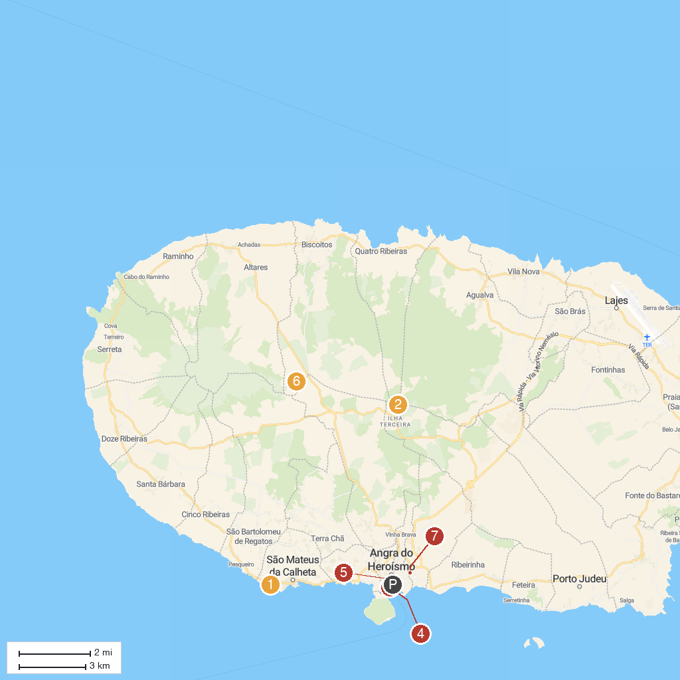
MAP KEY
1. Zona Balnear do Negrito | 5. MAH - Angra do Heroismo Museum
2. Algar do Carvão | 6. Gruta do Natal
3. Museu Vulcanoespeleológico | 7. Ladeira de São Bento
4. OceanEmotion Azores Whale Watching
P. Cruise port / terminal
Map © MapTiler © OpenStreetMap contributors · cruiseports.org

