Annapolis, Maryland, USA
America's sailing capital packs 300 years of colonial history, the U.S. Naval Academy, and blue-crab waterfront culture into one of the most walkable cities on the East Coast.
⚓ Docked — City Dock (small/expedition ships) · 🕒 Typical call: 7-10 hrs · 💵 US Dollar · 🗣️ English · 🦀 Famous for Maryland blue crabs
✍️ MY DAY IN PORT (FILL IN)
Ship / Date
In port | arrive ______ · all aboard ______
Booked excursion
Notes / meeting point
GETTING ASHORE
- Docking: City Dock (Ego Alley) — small & expedition ships only; large cruise ships use Baltimore (~30 mi)
- Walk to center: Steps — City Dock is the heart of historic downtown
- Best For: Colonial history, U.S. Naval Academy, waterfront dining, sailing excursions
- Don't Miss: Maryland State House, USNA Chapel & John Paul Jones crypt, William Paca House garden
GETTING AROUND
- 🚕 Taxi: $5–$15 — Local taxis (Annapolis City Taxi, Annapolis Area Cab) are readily available near City Dock. Fares start around $3 plus ~
- 📱 Rideshare: ✅ Uber, Lyft
TOP THINGS TO DO
- Colonial Annapolis Walking Tour — Guided tour (Watermark or self-guided NPS app) hits the Maryland State House — America's oldest state capitol in continuous use…
- U.S. Naval Academy Visit — Tour the 338-acre USNA campus: Bancroft Hall (one of the world's largest dormitories), the Naval Academy Museum, and the domed…
- Chesapeake Bay Schooner Sail — Sail aboard the 74-foot wooden Schooner Woodwind — help raise the sails, take the helm, and glide past the Bay Bridge and Thomas…
- Harbor & Naval Academy Cruise — Narrated 40-minute cruise aboard the Harbor Queen (Watermark Journey) glides past the Naval Academy waterfront and historic…
- Maryland Blue Crab & Waterfront Dining — Annapolis is ground zero for Maryland blue crabs.
BEST WALKS
- Historic Downtown Loop: 1.5 miles · Easy · ~45 min — From City Dock walk up Main Street past colonial storefronts, turn left on Maryland Avenue to the…
- Naval Academy & Historic Mansions: 2 miles · Easy · ~1 hr — From City Dock, walk along Compromise Street to the USNA Visitor Center, tour the campus, then…
WEATHER · DAYLIGHT · MONEY
Month | High °F | Low °F | Rainy days
May | 72 | 57 | 13
Jul | 85 | 71 | 15
Sep | 78 | 65 | 11
Daylight: May 5:53AM–8:11PM · Jul 5:53AM–8:30PM · Sep 6:47AM–7:13PM
cruiseports.org/annapolis-md · Confirm terminal & all-aboard time with your ship

Annapolis, Maryland, USA — Port Map
Red = walkable sights · Amber = excursions farther out · P = cruise terminal
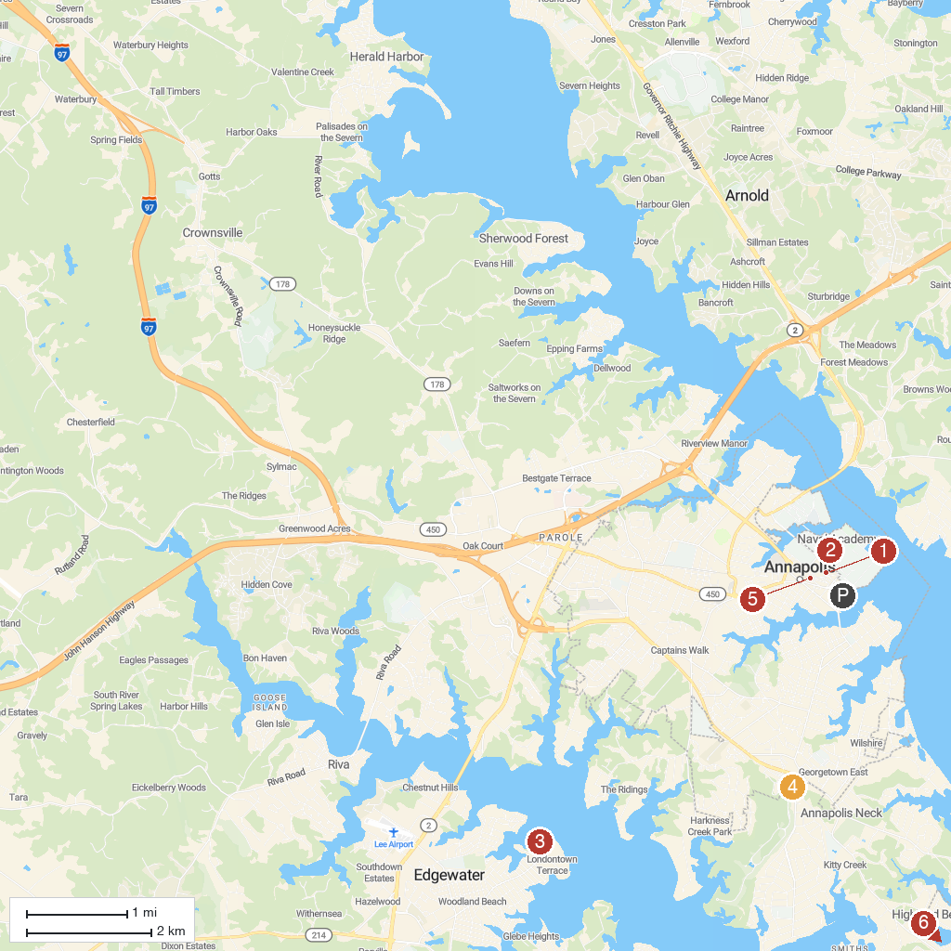
MAP KEY
1. William Paca House & Garden | 4. Quiet Waters Park
2. U.S. Naval Academy Museum | 5. Maryland State House
3. Historic London Town & Gardens | 6. Thomas Point Shoal Lighthouse
P. Cruise port / terminal
Map © MapTiler © OpenStreetMap contributors · cruiseports.org

