Antibes, Provence-Alpes-Côte d'Azur, France
Tucked between Nice and Cannes, Antibes pairs a sun-bleached medieval rampart town with one of the Riviera's best sandy beaches — all just a short stroll from Port Vauban, Europe's biggest yacht marina.
⚓ Docked or Tendered (size-dependent) · 🕒 Typical call: 7-9 hrs · 💶 Euro (EUR) · 🗣️ French
✍️ MY DAY IN PORT (FILL IN)
Ship / Date
In port | arrive ______ · all aboard ______
Booked excursion
Notes / meeting point
GETTING ASHORE
- Docking: Port Vauban — ships ≤230 m dock; larger ships tender. Terminal ~10-min walk to Old Town.
- Walk to centre: 10 min from pier to Vieil Antibes / Marché Provençal
- Best For: Art lovers, beach seekers, market browsers, French Riviera day-trippers
- Don't Miss: Musée Picasso in Château Grimaldi and the coastal path on Cap d'Antibes
GETTING AROUND
- 🚕 Taxi: ~€8–12 — Taxis queue at Port Vauban. Because the port is right next to the city center, fares are low — most in-town trips cost a
- 📱 Rideshare: ✅ Uber, Bolt
- 🚌 Hop-on hop-off: ✅ · from €15/day
TOP THINGS TO DO
- Vieil Antibes & Marché Provençal — Wander the labyrinth of cobbled lanes inside the 16th-century ramparts, then hit Cours Massena for the Provençal market — local…
- Musée Picasso (Château Grimaldi) — Picasso spent the autumn of 1946 in this clifftop castle overlooking the sea, and donated the works he made there.
- Sentier du Littoral — Cap d'Antibes Coastal Path — A stunning ~5 km clifftop trail around Cap d'Antibes with views across the Baie des Anges to Nice and the Alps.
- Plage de la Gravette & Riviera Beach Time — Unlike most Côte d'Azur beaches, Antibes has real sand.
- Riviera Day Trip — Cannes, Nice or Monaco — Antibes sits in the sweet spot: Cannes is 15 min by train, Nice 25 min, Monaco about an hour.
BEST WALKS
- Old Town Loop: 1.5 km · 45 min · Easy — Start at the port gates, walk up Rue Aubernon into the old town, browse Cours Massena market, visit…
- Cap d'Antibes Coastal Path (Sentier du Littoral): 5 km · 1.5-2 hrs · Moderate — A classic clifftop circuit around Cap d'Antibes.
WEATHER · DAYLIGHT · MONEY
Month | High °F | Low °F | Rainy days
May | 70 | 57 | 8
Jul | 84 | 70 | 3
Sep | 78 | 65 | 6
Daylight: May 6:06AM–8:49PM · Jul 6:04AM–9:10PM · Sep 7:11AM–7:41PM
cruiseports.org/antibes · Confirm terminal & all-aboard time with your ship

Antibes, Provence-Alpes-Côte d'Azur, France — Port Map
Red = walkable sights · Amber = excursions farther out · P = cruise terminal
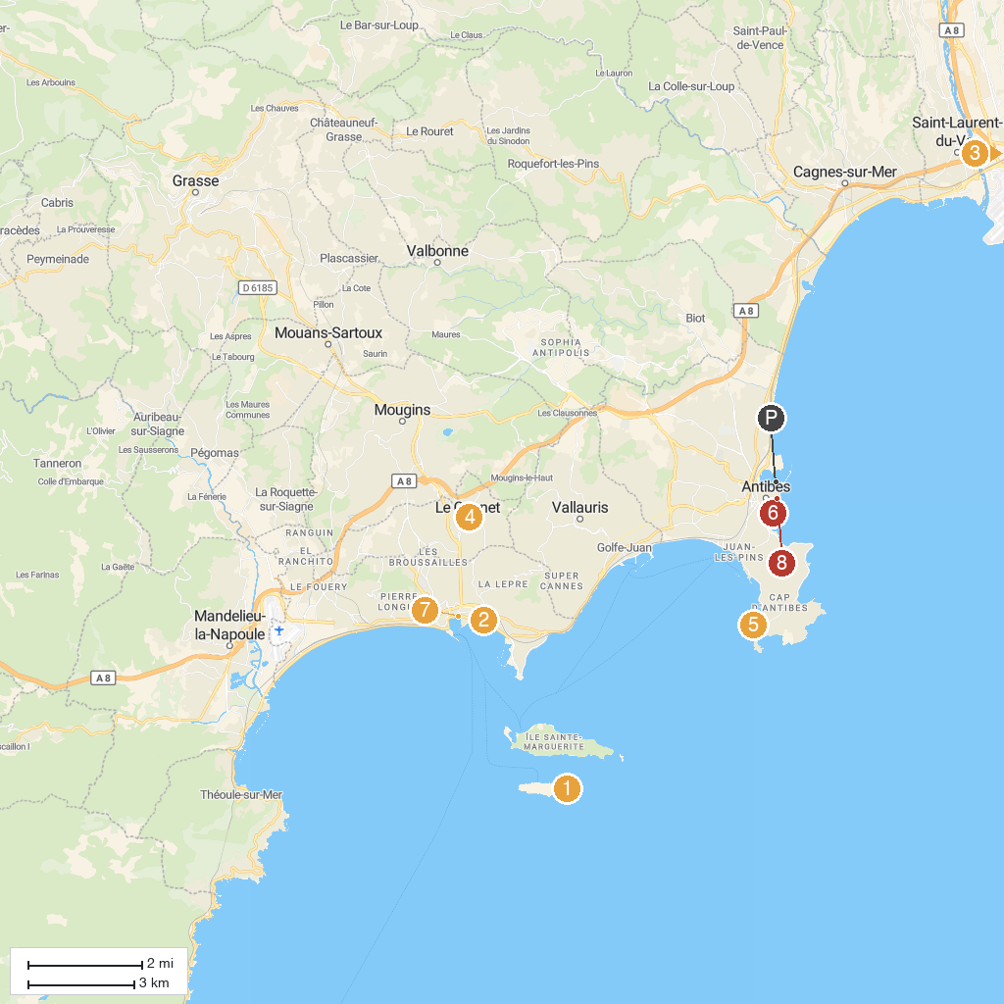
MAP KEY
1. Chapelle de la Trinité de Cannes | 5. Posidonia - Espace Mer et Littoral
2. La Malmaison | 6. musée d'archéologie d'Antibes
3. Parc Phœnix | 7. Petit Train de Cannes
4. Musée Bonnard | 8. Marché provençal
P. Cruise port / terminal
Map © MapTiler © OpenStreetMap contributors · cruiseports.org

