Antwerp, Flanders, Belgium
Europe's second-largest port city greets cruise passengers steps from a medieval fortress and a skyline of Gothic spires. Art, chocolate, diamonds, and some of the world's best beer — all within walking distance of the ship.
⚓ Docked (Antwerp Cruise Terminal, Steenplein) · 🕒 Typical call: 8-10 hrs · 💶 Euro (€) · 🗣️ Dutch (Flemish); English widely spoken
✍️ MY DAY IN PORT (FILL IN)
Ship / Date
In port | arrive ______ · all aboard ______
Booked excursion
Notes / meeting point
GETTING ASHORE
- Docking: Antwerp Cruise Terminal at Steenplein, beside Het Steen — walk straight into the historic center
- Walk to center: 5 min to Grote Markt; 8 min to Cathedral of Our Lady
- Best For: Art & architecture lovers, foodies (chocolate, waffles, beer), diamond district browsers
- Don't Miss: Rooftop panorama from MAS museum — free, open daily, 360° views over the Scheldt
GETTING AROUND
- 🚕 Taxi: €5–€20 — Taxis wait at the pier. Short city-center trips run €5–€8; a trip to Antwerp Central Station is roughly €35–€45.
- 📱 Rideshare: ✅ Uber, Bolt
- 🚌 Hop-on hop-off: ✅
TOP THINGS TO DO
- Grote Markt & Cathedral Walk — Antwerp's medieval heart — the Renaissance guild houses of Grote Markt, the Brabo Fountain, and the soaring Gothic Cathedral of…
- Rubenshuis (Rubens House) — The meticulously restored home and studio of Baroque master Peter Paul Rubens, filled with his paintings and period furnishings.
- MAS Museum Rooftop & Port History — Museum aan de Stroom tells Antwerp's story as a global trading city.
- Chocolate Nation & Belgian Tastings — Chocolate Nation, the world's largest Belgian chocolate museum, walks you through production history and ends with tastings.
- Day Trip to Bruges by Train — Antwerp's Central Station is a 15-minute walk from the pier.
BEST WALKS
- Riverside to Grote Markt: 1.2 km · ~20 min · Flat — Leave the terminal, pass Het Steen fortress, continue along the Scheldt promenade to Steenplein…
- Diamond District & Central Station Loop: 3 km · ~45 min · Flat — Walk east from the old town along Meir shopping street, continue to the Diamond District around…
WEATHER · DAYLIGHT · MONEY
Month | High °F | Low °F | Rainy days
May | 65 | 49 | 12
Jul | 74 | 58 | 12
Sep | 68 | 54 | 11
Daylight: May 5:51AM–9:26PM · Jul 5:44AM–9:51PM · Sep 7:18AM–7:56PM
cruiseports.org/antwerp · Confirm terminal & all-aboard time with your ship

Antwerp, Flanders, Belgium — Port Map
Red = walkable sights · Amber = excursions farther out · P = cruise terminal
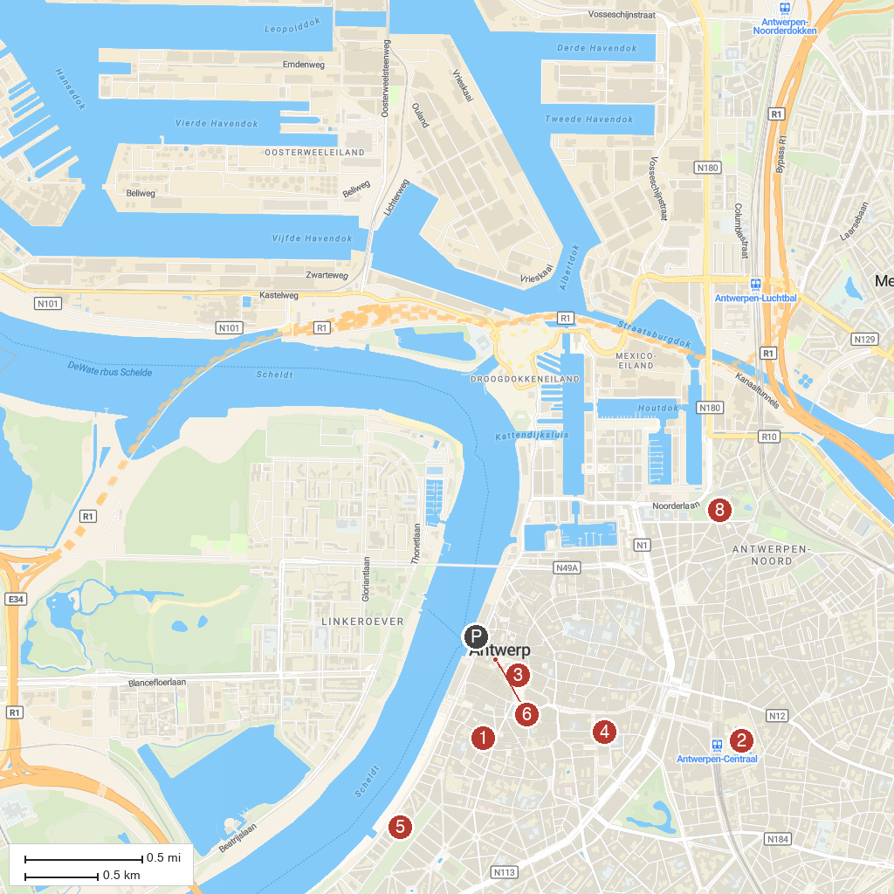
MAP KEY
1. St. Andrew's Church | 5. M HKA - Museum of Contemporary Art
2. Zoo Antwerpen | 6. Antwerp City Hall
3. Cathedral of Our Lady | 7. Het Steen
4. Rubenshuis | 8. Park Spoor Noord
P. Cruise port / terminal
Map © MapTiler © OpenStreetMap contributors · cruiseports.org

