Apia, Upolu, Samoa
The laid-back capital of Samoa sits on the north coast of Upolu — ships dock a short walk from town, where fales open onto turquoise lagoons, a Victorian-era novelist rests on a jungle hilltop, and one of the Pacific's most dramatic swimming holes awaits just down the road.
⚓ Docked (Matautu Wharf) · 🕒 Typical call: 7–9 hrs · 💵 Samoan Tala (WST) · 🗣️ Samoan / English
✍️ MY DAY IN PORT (FILL IN)
Ship / Date
In port | arrive ______ · all aboard ______
Booked excursion
Notes / meeting point
GETTING ASHORE
- Docking: Matautu Wharf, Apia Harbour
- Walk to center: ~10 min to Apia town
- Best For: Ocean Trench · RLS Museum
- Don't Miss: To Sua Ocean Trench
GETTING AROUND
- 🚕 Taxi: WST 5–15 (~$2–6 USD) — Taxis wait at Matautu Wharf and are the easiest way into downtown Apia, about 1–1.5 miles away. Fares are not metered —
- 📱 Rideshare: ❌ not available
TOP THINGS TO DO
- To Sua Ocean Trench — A giant natural swimming hole carved into the lava shelf on Upolu's south coast, connected to the sea via an underwater cave.
- Robert Louis Stevenson Museum & Mt Vaea Tomb — The Scottish author of Treasure Island spent his final years at Vailima, his grand estate above Apia.
- Lalomanu Beach — Consistently rated one of the finest beaches in the South Pacific — powder white sand, turquoise water, and traditional…
- Piula Cave Pool — A freshwater pool inside a sea cave beneath the Piula Methodist church on Upolu's north coast, about 20 minutes east of Apia.
- Papapapaitai Falls — One of the tallest waterfalls in Samoa, plunging roughly 100 metres into a rainforest gorge in the highlands above Apia.
BEST WALKS
- Apia Waterfront & Town Centre: ~2.5 km · 1.5 hrs · easy — Stroll Beach Road from the wharf past the Apia Fish Market, the Immaculate Conception Cathedral (a…
- Palolo Deep Marine Reserve: ~1 km snorkel · easy — A protected lagoon reserve a short walk from central Apia where healthy coral and reef fish are…
WEATHER · DAYLIGHT · MONEY
Month | High °F | Low °F | Rainy days
May | 84 | 77 | 26
Jul | 83 | 76 | 22
Sep | 83 | 76 | 23
Daylight: May 6:39AM–6:07PM · Jul 6:51AM–6:14PM · Sep 6:22AM–6:22PM
cruiseports.org/apia · Confirm terminal & all-aboard time with your ship

Apia, Upolu, Samoa — Port Map
Red = walkable sights · Amber = excursions farther out · P = cruise terminal
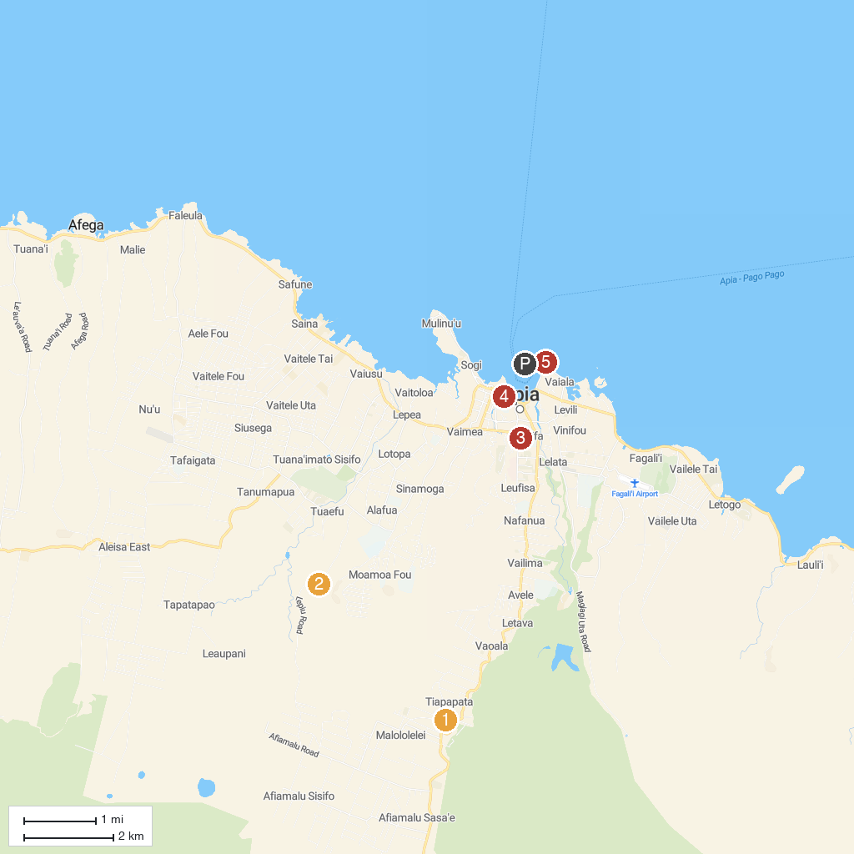
MAP KEY
1. Baha'i House Of Worship Samoa | 4. Immaculate Conception Cathedral
2. Papaseea Sliding Rocks | 5. Palolo Deep Marine Reserve
3. Museum Of Samoa | 6. Papapapaitai Falls
P. Cruise port / terminal
Map © MapTiler © OpenStreetMap contributors · cruiseports.org

