Arles, Provence, France
Where Roman legions left behind an amphitheatre still roaring with life, and Van Gogh chased starlight along the Rhône — Arles packs 2,000 years into a walkable old town.
⚓ River port — docked at quay · 🕒 Typical call: 8–10 hrs · 💶 Euro (€) · 🗣️ French
✍️ MY DAY IN PORT (FILL IN)
Ship / Date
In port | arrive ______ · all aboard ______
Booked excursion
Notes / meeting point
GETTING ASHORE
- Docking: Quai Segonnaux (east bank Rhône), ~10-min walk to old town
- Walk to centre: 10 min on foot; amphitheatre in 15 min
- Best For: Roman history, Van Gogh art trail, Camargue day trips
- Don't Miss: Les Arènes Roman amphitheatre (still hosts bullfights)
GETTING AROUND
- 🚕 Taxi: €10–20 — Regulated taxis are available at the port. The short ride to the city center should cost €10–20 depending on traffic and
- 📱 Rideshare: ✅ Uber
TOP THINGS TO DO
- Les Arènes Roman Amphitheatre — Built in 90 AD for 20,000 spectators, this UNESCO-listed colosseum is one of the best-preserved in the world.
- Van Gogh Art Trail — Self-guided walk linking the spots that inspired Van Gogh's most famous works — Espace Van Gogh (the hospital courtyard), Place…
- Camargue Safari — The Camargue wetlands begin just south of Arles — a vast delta famous for wild white horses, black bulls, and greater flamingos.
- Les Baux-de-Provence & Carrieres de Lumières — Ruined medieval fortress perched on a dramatic limestone ridge, plus the stunning Carrieres de Lumières immersive art projections…
- Alyscamps Necropolis & Arles Antique Museum — Stroll the atmospheric avenue of Roman sarcophagi at Alyscamps (painted by Van Gogh and Gauguin), then visit the striking blue…
BEST WALKS
- Roman & Van Gogh Old Town Loop: 3.5 km · ~1.5 hrs · easy, mostly flat — A circuit linking the big Roman monuments with Van Gogh's painting locations through the medieval…
- Alyscamps Afternoon Stroll: 1.5 km one-way · ~45 min · very easy — A peaceful detour to the ancient Roman necropolis painted by Van Gogh and Gauguin — tree-lined and…
WEATHER · DAYLIGHT · MONEY
Month | High °F | Low °F | Rainy days
May | 74 | 56 | 8
Jul | 90 | 69 | 3
Sep | 80 | 62 | 6
Daylight: May 6:16AM–8:59PM · Jul 6:14AM–9:20PM · Sep 7:21AM–7:51PM
cruiseports.org/arles · Confirm terminal & all-aboard time with your ship

Arles, Provence, France — Port Map
Red = walkable sights · Amber = excursions farther out · P = cruise terminal
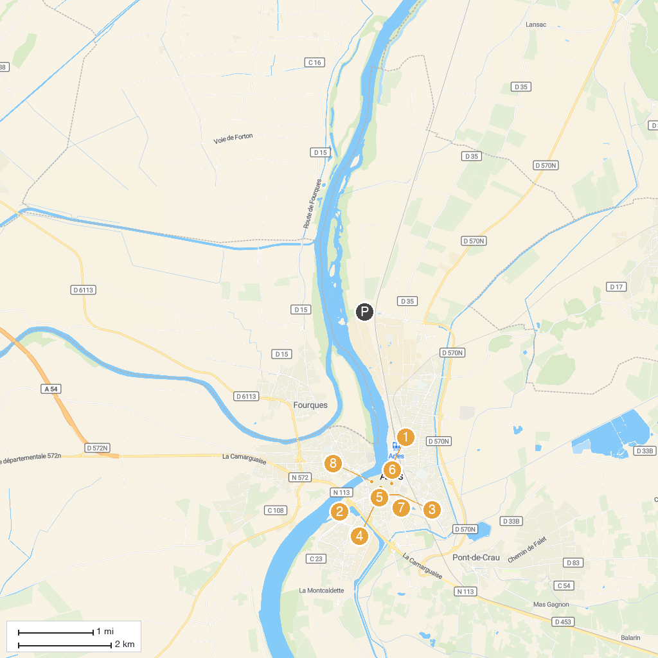
MAP KEY
1. Arles Amphitheatre | 5. The Arles market
2. Musée départemental Arles antique | 6. Amédée Pichot fountain
3. Jardin d'été | 7. Alyscamps
4. Manuel Rivera-Ortiz Foundation | 8. Fondation Vincent van Gogh Arles
P. Cruise port / terminal
Map © MapTiler © OpenStreetMap contributors · cruiseports.org

