Arnhem, Gelderland, Netherlands
Arnhem wears its scars with pride. The city rebuilt from the ruins of Operation Market Garden, and today its riverfront quay lands you steps from bridges, battlefields, and one of Europe's finest art museums.
⚓ Docked (river quay) · 🕒 Typical call: 6–8 hrs · 💶 Euro (€) · 🗣️ Dutch (English widely spoken)
✍️ MY DAY IN PORT (FILL IN)
Ship / Date
In port | arrive ______ · all aboard ______
Booked excursion
Notes / meeting point
GETTING ASHORE
- Docking: Rijnkade quay, ~1 km from city center — easy walk or short bus ride
- Walk to center: ~15 min on foot; trolleybus stops near the quay
- Best For: WWII history, Dutch culture, world-class art (Van Gogh), nature
- Don't Miss: Airborne Museum Hartenstein, Kröller-Müller Museum, John Frost Bridge
GETTING AROUND
- 🚕 Taxi: €7–15 — Taxis are available near the dock. Starting fare around €3–5 plus €2–3/km; short city-center trips typically run €7–12.
- 📱 Rideshare: ✅ Uber, Bolt
TOP THINGS TO DO
- Airborne Museum Hartenstein, Oosterbeek — The wartime HQ of the British 1st Airborne Division is now an award-winning museum covering Operation Market Garden through…
- John Frost Bridge & Airborne at the Bridge — Walk across the bridge renamed for the British lieutenant-colonel whose men held it for four days in 1944.
- Netherlands Open Air Museum (Nederlands Openluchtmuseum) — Around 80 authentic historic Dutch buildings — windmills, farmhouses, workshops — relocated from across the country to a…
- Hoge Veluwe National Park & Kröller-Müller Museum — One of the Netherlands' largest nature reserves pairs forests and heathland with the world's second-largest Van Gogh collection.
- Burgers' Zoo — One of Europe's most innovative zoos, with enormous climate-controlled biomes replicating a tropical rainforest, desert…
BEST WALKS
- Riverfront & City Center Loop: 2.5 km · 45 min · Easy · Flat — Head east along the Rijnkade past the John Frost Bridge, then cut up into the city center via…
- Sonsbeek Park Stroll: 3 km · 50 min · Easy · Some gentle slopes — Walk north from the station into Sonsbeek Park, Arnhem's grand 19th-century landscaped park.
WEATHER · DAYLIGHT · MONEY
Month | High °F | Low °F | Rainy days
May | 64 | 48 | 12
Jul | 73 | 58 | 14
Sep | 67 | 54 | 11
Daylight: May 5:42AM–9:23PM · Jul 5:34AM–9:49PM · Sep 7:11AM–7:50PM
cruiseports.org/arnhem · Confirm terminal & all-aboard time with your ship

Arnhem, Gelderland, Netherlands — Port Map
Red = walkable sights · Amber = excursions farther out · P = cruise terminal
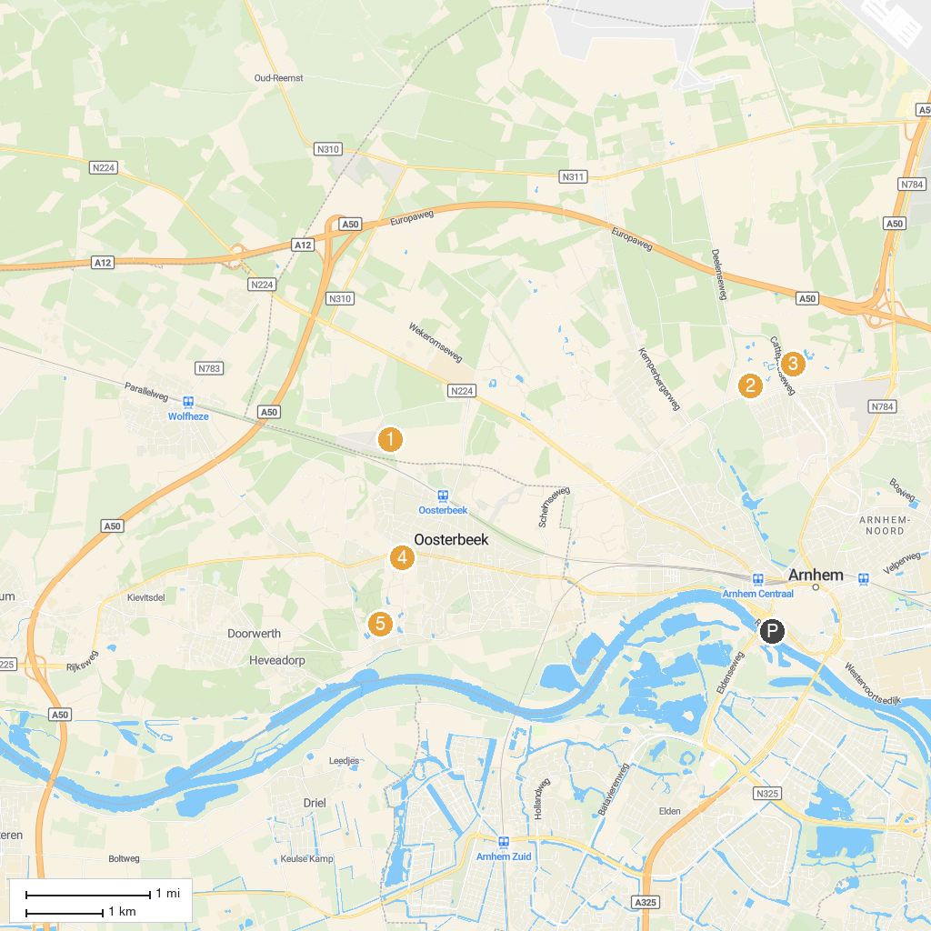
MAP KEY
1. Abbey Koningsoord | 5. Besiendershuis
2. Airborne Monument Ginkelse Heide | 6. Het Nationale Park De Hoge Veluwe
3. Burgers' Zoo | 7. Airbornemuseum Hartenstein
4. Netherlands Open Air Museum | 8. Landgoed Oorsprong
P. Cruise port / terminal
Map © MapTiler © OpenStreetMap contributors · cruiseports.org

