Ascension Island, South Atlantic, British Overseas Territory
A remote volcanic outpost in the middle of the South Atlantic, Ascension Island offers something genuinely rare: nesting green turtles, a cloud-capped mountain improbably lush with introduced trees, and a frontier-town feel that most cruisers never experience.
⚓ Tender port (no cruise pier) · 🕒 Typical call: 6-8 hrs · 💷 Saint Helena Pound / GBP (cash only) · 🗣️ English · 🌊 Swell-dependent — call may cancel
✍️ MY DAY IN PORT (FILL IN)
Ship / Date
In port | arrive ______ · all aboard ______
Booked excursion
Notes / meeting point
GETTING ASHORE
- Docking: Tender only; land at Georgetown Pier Head steps. Swell can cancel tendering entirely.
- Walk to center: Georgetown is immediately at the pier — the town is small and walkable in 20 minutes.
- Best For: Wildlife (green turtles, sooty terns), volcanic hiking, off-the-beaten-path history
- Don't Miss: Green Mountain National Park and (in season) guided turtle walks on the beaches around Georgetown
GETTING AROUND
- 🚕 Taxi: Varies — negotiate locally — A small number of taxis have been introduced on the island. Fares are not published; arrange and agree on price upon arr
TOP THINGS TO DO
- Green Mountain National Park Hike — What was once a barren volcanic peak is now a green oasis at 859 m — the result of a 19th-century plan to introduce plants from…
- Green Turtle Nesting Walk (Long Beach) — Ascension hosts the second-largest green sea turtle nesting population in the Atlantic, with over 25,000 nests a year.
- Sooty Tern Colony Visit — Ascension is a globally important seabird breeding site.
- Georgetown Heritage Walk — Wander past St.
- Comfortless Cove & Bonetta Cemetery — A scenic volcanic bay with clear water for swimming and snorkelling, combined with a poignant 19th-century cemetery for sailors…
BEST WALKS
- Georgetown Town Loop: 1.5 km · 30-40 min · Easy · Paved roads — From the pier, walk up to St.
- Green Mountain Trail: Approx. 5 km round trip · 2-3 hrs · Moderate-strenuous · Trail — Drive or hitch to the mountain base, then follow the network of maintained trails through bamboo…
WEATHER · DAYLIGHT · MONEY
Month | High °F | Low °F | Rainy days
May | 83 | 76 | 29
Jul | 83 | 76 | 29
Sep | 86 | 78 | 20
Daylight: May 7:01AM–6:46PM · Jul 7:12AM–6:54PM · Sep 6:51AM–6:54PM
Representative sunrise/sunset — 2025, 15th of each month; local civil time including DST (Atlantic/St_Helena). Source: Astral; not a forecast or climate average.
cruiseports.org/ascension-island · Confirm terminal & all-aboard time with your ship

Ascension Island, South Atlantic, British Overseas Territory — Port Map
Red = walkable sights · Amber = excursions farther out · P = cruise terminal
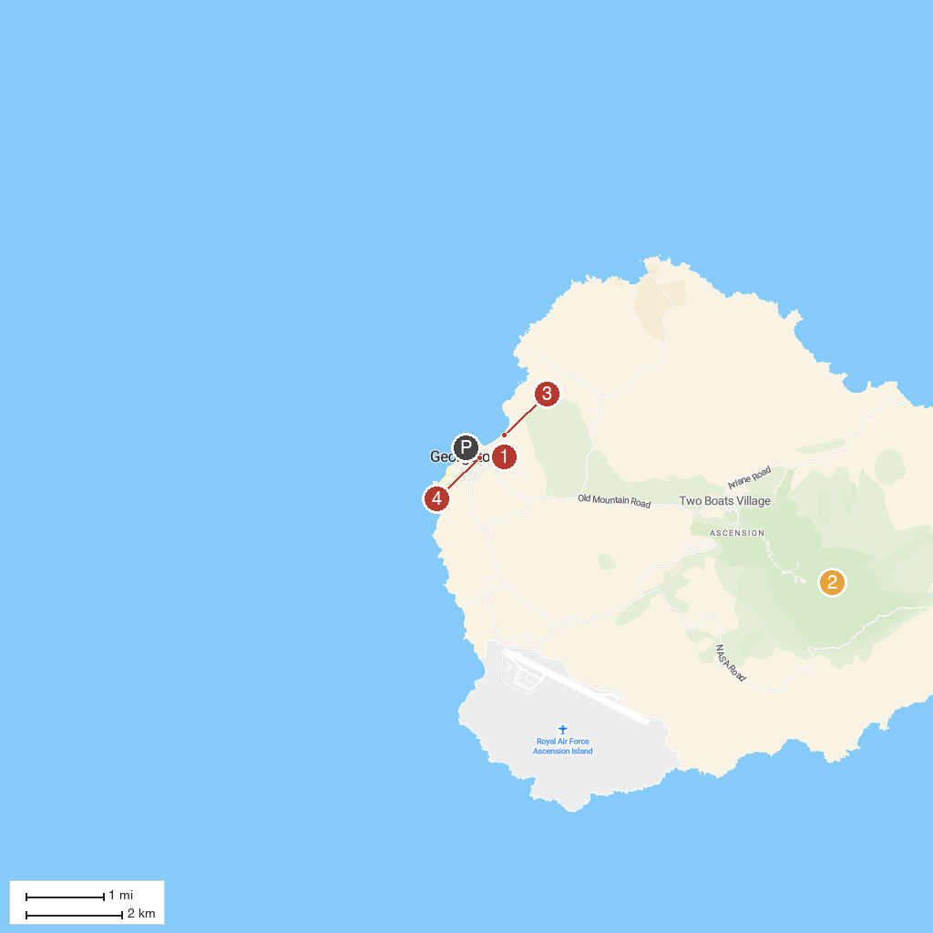
MAP KEY
1. Fort Bedford | 3. Long Beach Turtle Nesting Site
2. Green Mountain National Park | 4. St Mary's Church, Georgetown
P. Georgetown pier head landing steps — approximate map position, not surveyed and not for navigation.
Map © MapTiler © OpenStreetMap contributors · cruiseports.org

