Aschach an der Donau, Upper Austria, Austria
A quiet Upper Austrian market town where river cruise ships tie up alongside the Danube cycle path. The medieval center is a short stroll from the pier, and the flat Eferding Basin stretches invitingly into farm country beyond.
⚓ Docked (river pontoon) · 🕒 Typical call: 5–8 hrs · 💶 Euro (€) · 🗣️ German
✍️ MY DAY IN PORT (FILL IN)
Ship / Date
In port | arrive ______ · all aboard ______
Booked excursion
Notes / meeting point
GETTING ASHORE
- Docking: Pipe pontoon pier on the right bank, km 2160 — ships tie up directly in town
- Walk to center: 2–5 min on foot from the pier along the Danube promenade
- Best For: Cycling the Danube path, easy river walks, Schopper & Fishermen's Museum
- Don't Miss: Beer garden along the promenade and a side trip by coach to Linz or St. Florian Monastery
GETTING AROUND
- 🚕 Taxi: Metered, ask locally — Local taxis serve the area; rates follow Upper Austrian metered tariffs. Ask at the ship or tourist information for disp
TOP THINGS TO DO
- Danube Cycle Path Ride — Roll out directly from the pier onto the flat, well-marked Danube cycle path.
- Schopper & Fishermen's Museum — A compact local museum 500 m from the pier devoted to the traditional Schopper boat-builders who once shaped the river economy of…
- St. Florian Monastery Day Trip — An Augustinian abbey of staggering baroque grandeur about 40 km from Aschach (via Linz) — closely associated with composer Anton…
- Mauthausen Memorial — A sober and important visit to the former Nazi concentration camp, now a national memorial and museum, located roughly 45 km…
- Linz City Discovery — Austria's third city is just 25 km away — home to the spectacular Mariendom cathedral, the AEC (Ars Electronica Center) on the…
BEST WALKS
- Danube Promenade Stroll: 30–60 min | Flat | Paved riverside path — From the pier, walk the Danube promenade into the medieval market town.
- Cycle Path Loop to Pupping: 2–3 hrs by bike | Flat | Marked cycle path — Head west/upstream on the Danube cycle path through the Eferding Basin farmland to the village of…
WEATHER · DAYLIGHT · MONEY
Month | High °F | Low °F | Rainy days
May | 65 | 49 | 15
Jul | 78 | 60 | 12
Sep | 69 | 53 | 11
Daylight: May 5:24AM–8:37PM · Jul 5:19AM–9:00PM · Sep 6:41AM–7:16PM
cruiseports.org/aschach-an-der-donau · Confirm terminal & all-aboard time with your ship

Aschach an der Donau, Upper Austria, Austria — Port Map
Red = walkable sights · Amber = excursions farther out · P = cruise terminal
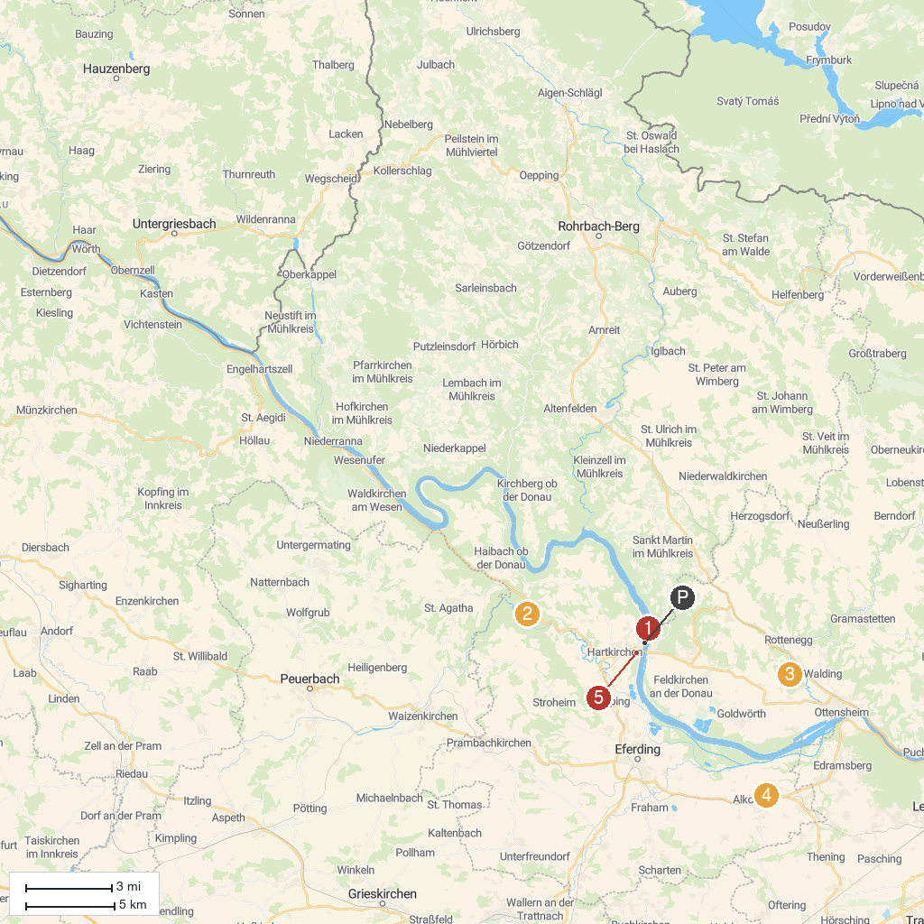
MAP KEY
1. Schopper- und Fischermuseum | 5. Tierpark Altenfelden
2. Burgruine Stauf | 6. Schloss Weidenholz
3. Walding Zoo | 7. Wilhering Abbey
4. Synthetic737 | 8. Schloss Aschach
P. Cruise port / terminal
Map © MapTiler © OpenStreetMap contributors · cruiseports.org

