Astrakhan, Astrakhan Oblast, Russia
Russia's ancient gateway to the Caspian Sea, Astrakhan blends Golden Horde history with Volga river culture, sturgeon caviar, and a striking white-walled Kremlin that rivals any in the country.
⚓ Docked (river terminal) · 🕒 Typical call: 8-10 hrs · 💵 Russian Ruble (RUB) · 🗣️ Russian
✍️ MY DAY IN PORT (FILL IN)
Ship / Date
In port | arrive ______ · all aboard ______
Booked excursion
Notes / meeting point
GETTING ASHORE
- Docking: Docked directly at Astrakhan River Passenger Terminal on the Volga
- Walk to center: 5–10 min walk from the passenger terminal to the Kremlin and embankment
- Best For: History, Kremlin, Volga embankment strolls, local caviar, river culture
- Don't Miss: Astrakhan Kremlin, Trinity Cathedral, Nikolskaya Street, fresh caviar
GETTING AROUND
- 🚕 Taxi: 150–600 RUB (~$2–7 USD) — The cruise pier is on the Volga River close to the city center. Short taxi rides to the Kremlin and main attractions are
TOP THINGS TO DO
- Astrakhan Kremlin & Cathedral Tour — The centerpiece of the city — a 16th-century white-stone fortress commissioned by Ivan the Terrible.
- City Walk: Nikolskaya Street & Embankment — Stroll Nikolskaya Street — Astrakhan's most handsome boulevard linking the Kremlin to the riverfront — then walk the Volga…
- Volga Delta Boat Excursion — The Volga Delta is one of Europe's largest river deltas and a UNESCO-recognized biosphere reserve.
- Sarai Batu — Golden Horde Reconstructed City — A remarkable open-air site reconstructing the streets and architecture of the Golden Horde capital.
- Caviar & Local Cuisine Tasting — Astrakhan is Russia's caviar capital — home to Beluga and Osetra sturgeon from the Volga.
BEST WALKS
- Kremlin to Embankment Walk: 1–2 km | Easy | ~45 min — From the passenger terminal, walk along the Volga embankment north to the Astrakhan Kremlin.
WEATHER · DAYLIGHT · MONEY
Month | High °F | Low °F | Rainy days
May | 78 | 57 | 6
Jul | 92 | 71 | 3
Sep | 77 | 58 | 4
Daylight: May 5:14AM–8:14PM · Jul 5:10AM–8:36PM · Sep 6:26AM–6:59PM
cruiseports.org/astrakhan · Confirm terminal & all-aboard time with your ship

Astrakhan, Astrakhan Oblast, Russia — Port Map
Red = walkable sights · Amber = excursions farther out · P = cruise terminal
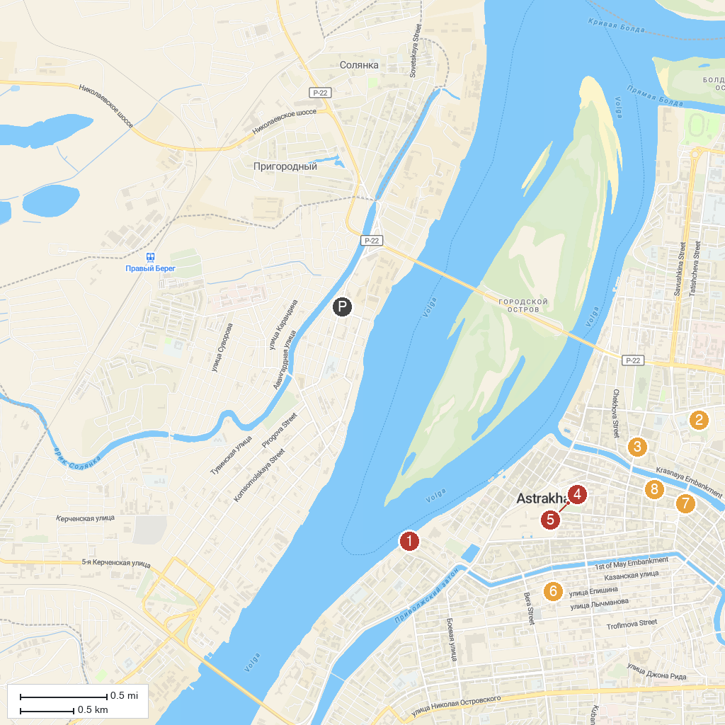
MAP KEY
1. Monument to Peter I | 5. Fraternal garden
2. Парк Аркадия | 6. Kara-Mechet'
3. Museum and Cultural Center "House of merchant G.V.Tetyushinova" | 7. The house-museum BM Kustodiev
4. Museum of Military Glory | 8. House-Museum of Velimir Khlebnikov
P. Cruise port / terminal
Map © MapTiler © OpenStreetMap contributors · cruiseports.org

