Astypalaia Island, Dodecanese, Greece
The 'Butterfly Island' of the Aegean — a whitewashed hilltop Chora crowned by a Venetian castle, vibrant windmills, and turquoise waters lapping uninhabited islets just offshore.
⚓ Tender (no cruise pier) · 🕒 Typical call: 6–8 hrs · 💶 Currency: Euro (€) · 🗣️ Language: Greek
✍️ MY DAY IN PORT (FILL IN)
Ship / Date
In port | arrive ______ · all aboard ______
Booked excursion
Notes / meeting point
GETTING ASHORE
- Docking: Tender to Pera Yialos (Skala Bay) — no large-ship pier
- Walk to Chora: ~10–15 min uphill on foot from the old port
- Best For: Charming village strolls, castle views, boat trips to islets
- Don't Miss: Venetian Querini Castle and the row of 8 whitewashed windmills
GETTING AROUND
- 🚕 Taxi: ~€5–€10 — Only a handful of taxis operate on the island — arrange a pick-up in advance if possible. Short port-to-town rides run c
- 📱 Rideshare: ❌ not available
TOP THINGS TO DO
- Chora & Venetian Castle — Climb the cobblestone lanes of the whitewashed Chora to the 13th-century Querini Castle.
- Boat Trip to Kounoupa & Koutsomiti Islets — Day cruise to the uninhabited islets just offshore, with some of the clearest azure water in the Dodecanese.
- Livadi Beach — A short walk from Chora (or quick bus ride), Livadi is Astypalaia's most organized beach — crystal-clear water, sunbeds…
- Self-Drive Boat Hire — Rent a small motorboat from Pera Yialos (no licence required for under 30hp) and explore Red Rock (Kokkinos Gremos), hidden…
- Windmills & Village Wander — Astypalaia's eight restored windmills line the ridge above Chora, painted white with maroon trim.
BEST WALKS
- Pera Yialos Port to Venetian Castle: ~1.5 km | 30–40 min up | Easy–Moderate — From the tender quay walk up through the lower waterfront, into Chora's winding lanes, past the…
- Chora to Livadi Beach: ~1 km | 15–20 min | Easy (downhill) — A gentle downhill walk from Chora leads to Livadi, the island's most popular beach.
WEATHER · DAYLIGHT · MONEY
Month | High °F | Low °F | Rainy days
May | 67 | 65 | 2
Jul | 77 | 75 | 0
Sep | 76 | 73 | 1
Daylight: May 6:07AM–8:14PM · Jul 6:08AM–8:32PM · Sep 6:57AM–7:21PM
cruiseports.org/astypalaia-island · Confirm terminal & all-aboard time with your ship

Astypalaia Island, Dodecanese, Greece — Port Map
Red = walkable sights · Amber = excursions farther out · P = cruise terminal
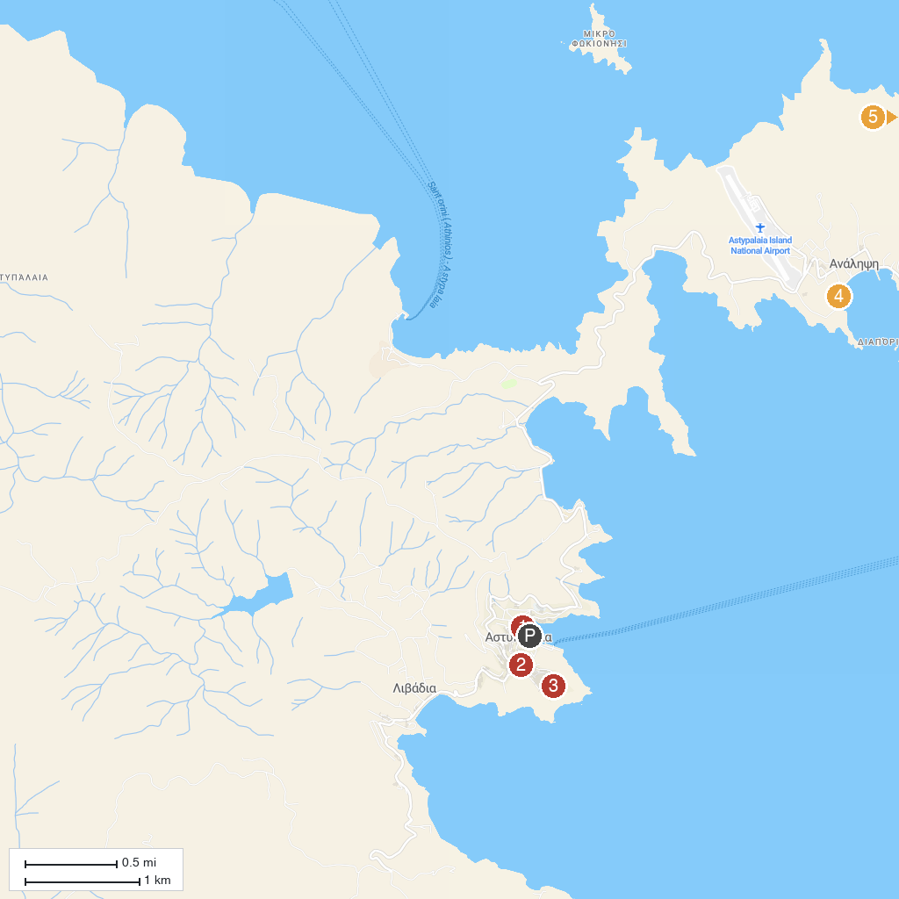
MAP KEY
1. Archaeological Museum of Astypalaia | 4. Maltezana Beach
2. Astypalea Mills | 5. RED CLIFF
3. Castle of Astypalea (Querini Castle)
P. Cruise port / terminal
Map © MapTiler © OpenStreetMap contributors · cruiseports.org

