Piraeus (Athens), Attica, Greece
One of the world's oldest ports and the gateway to the Greek capital. Whether you're chasing 2,500 years of history on the Acropolis or a lazy plate of grilled octopus at a harbourside taverna, a day in Piraeus delivers.
⚓ Docked (pier) · 🕒 Typical call: 8–12 hrs · 💵 Euro (€) · 🗣️ Greek / English widely spoken · 🏛️ UNESCO World Heritage
✍️ MY DAY IN PORT (FILL IN)
Ship / Date
In port | arrive ______ · all aboard ______
Booked excursion
Notes / meeting point
GETTING ASHORE
- Docking: Three dedicated cruise terminals (A, B, C) — always docked, never tendered
- Walk to Athens: Athens is 8–10 km away — you need metro, bus, or taxi to get there
- Best For: Ancient history, world-class museums, Greek cuisine, Aegean island hopping
- Don't Miss: Pre-book Acropolis timed-entry tickets or you will be turned away at the gate
GETTING AROUND
- 🚕 Taxi: €25–€40 — Metered taxis queue at the cruise terminals. Daytime fare to Athens city center runs €25–30; night rates (midnight–5am)
- 📱 Rideshare: ✅ Uber, Bolt, FREENOW
- 🚌 Hop-on hop-off: ✅ Hop-on hop-off · from 15 EUR
TOP THINGS TO DO
- The Acropolis & Acropolis Museum — The non-negotiable.
- Cape Sounion & Temple of Poseidon — If you've done the Acropolis before, this is the best alternative.
- Athens City Walk: Plaka, Monastiraki & Syntagma — The Plaka neighbourhood wraps around the north slopes of the Acropolis in a tangle of whitewashed lanes, tavernas, and souvenir…
- Athens Food & Market Tour — Dive into the Varvakios Central Market, sample feta, olives, honey, and loukoumades (Greek doughnuts), and eat souvlaki the way…
- Piraeus Waterfront: Mikrolimano & Zea Marina — If Athens feels too hectic, stay in Piraeus.
BEST WALKS
- Piraeus Waterfront Loop: 2.5 km · 35 min · flat · easy — From the cruise terminal gate, walk along Akti Miaouli past the main ferry terminal to Zea Marina…
- Athens: Acropolis to Plaka: 2 km · 45 min walking + metro transit · moderate — Take the metro to Monastiraki, walk uphill through the Plaka neighbourhood past the Tower of the…
WEATHER · DAYLIGHT · MONEY
Month | High °F | Low °F | Rainy days
May | 78 | 61 | 4
Jul | 93 | 74 | 1
Sep | 84 | 68 | 3
Daylight: May 6:15AM–8:28PM · Jul 6:15AM–8:47PM · Sep 7:07AM–7:33PM
ESSENTIAL TRAVEL QUALIFICATIONS
Metro; not Airport or X80: €1.20 adult / 90 minutes (checked 3 Oct 2026).
cruiseports.org/athens-piraeus · Confirm terminal & all-aboard time with your ship

Piraeus (Athens), Attica, Greece — Port Map
Red = walkable sights · Amber = excursions farther out · P = cruise terminal
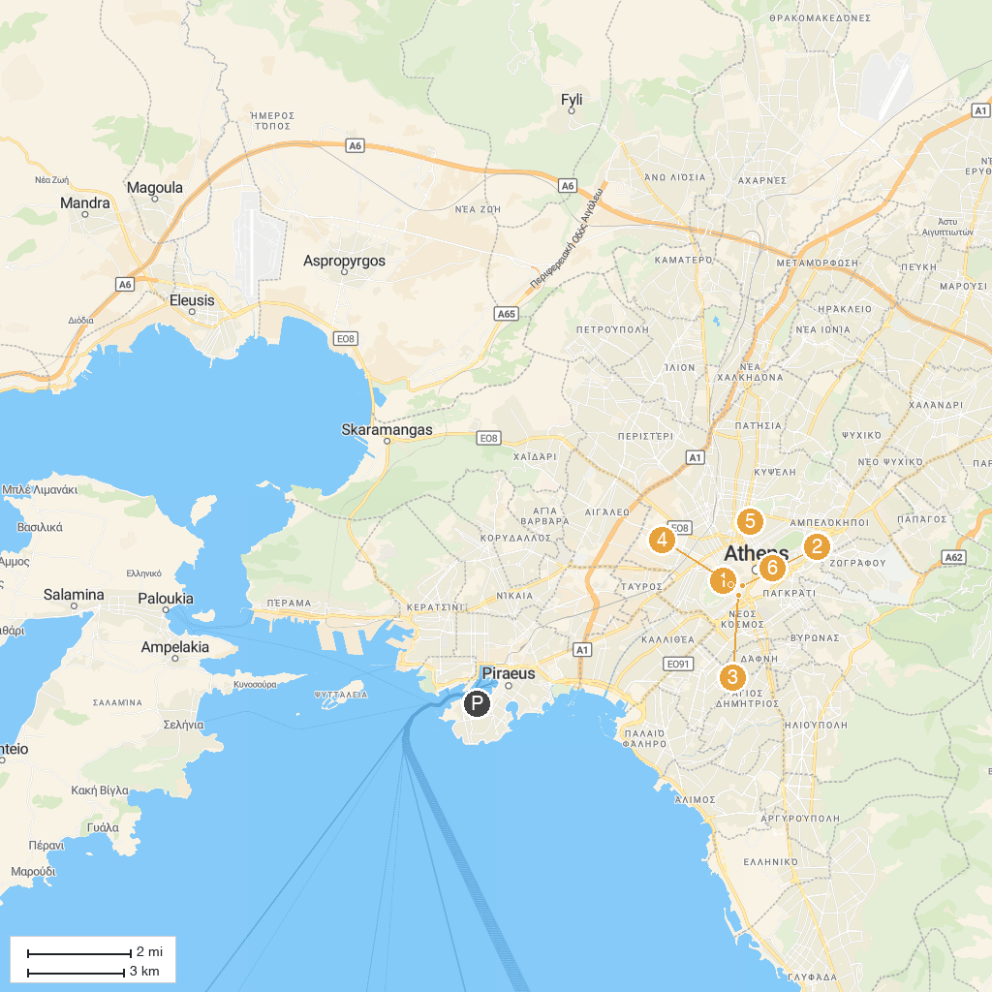
MAP KEY
1. Areopagus Hill | 4. Acropolis of Athens
2. Choragic Monument of Lysicrates | 5. National Archaeological Museum
3. Acropolis Museum | 6. Benaki Museum
P. Cruise port / terminal
Map © MapTiler © OpenStreetMap contributors · cruiseports.org

