Auckland Island, Subantarctic, New Zealand
One of the world's most pristine wilderness islands, the Auckland Islands sit 465 km south of New Zealand and host extraordinary wildlife that exists almost nowhere else on Earth.
⚓ Zodiac / tender (no pier) · 🕒 Typical call: 4–6 hrs · 💵 NZD (no shops ashore) · 🗣️ English · 🌿 DOC permit required
✍️ MY DAY IN PORT (FILL IN)
Ship / Date
In port | arrive ______ · all aboard ______
Booked excursion
Notes / meeting point
GETTING ASHORE
- Docking: Zodiac tender from anchored ship; no pier exists
- Walk to centre: No town — guided walks on Enderby Island only
- Best For: Wildlife photography, sea lions, penguins, albatross
- Don't Miss: Sandy Bay sea lion colony on Enderby Island
GETTING AROUND
- 📱 Rideshare: ❌ not available
TOP THINGS TO DO
- Sandy Bay Sea Lion Colony — Walk to Sandy Bay on Enderby Island, home to one of the most important breeding colonies of the critically rare Hooker's sea lion…
- Northern Cliffs Boardwalk & Albatross Nesting — A boardwalk trail winds through southern rātā forest to the northern cliffs of Enderby Island where Southern Royal Albatrosses…
- Zodiac Coastal Cruise — For days when landings are weather-limited, or as an add-on, Zodiacs cruise the dramatic basalt columns and cliff faces.
- Yellow-eyed Penguin Watching — Enderby Island is a breeding ground for the endangered yellow-eyed penguin (hoiho).
BEST WALKS
- Sandy Bay to Northern Cliffs Loop — Enderby Island: 4–5 km | 2–3 hrs | Easy–moderate | Guided only — The main visitor track on Enderby Island links the sea lion beach at Sandy Bay with the albatross…
WEATHER · DAYLIGHT · MONEY
Month | High °F | Low °F | Rainy days
May | 48 | 42 | 21
Jul | 45 | 40 | 20
Sep | 46 | 40 | 19
Daylight: May 8:24AM–5:18PM · Jul 8:50AM–5:12PM · Sep 7:00AM–6:41PM
cruiseports.org/auckland-island-nz · Confirm terminal & all-aboard time with your ship

Auckland Island, Subantarctic, New Zealand — Port Map
Red = walkable sights · Amber = excursions farther out · P = cruise terminal
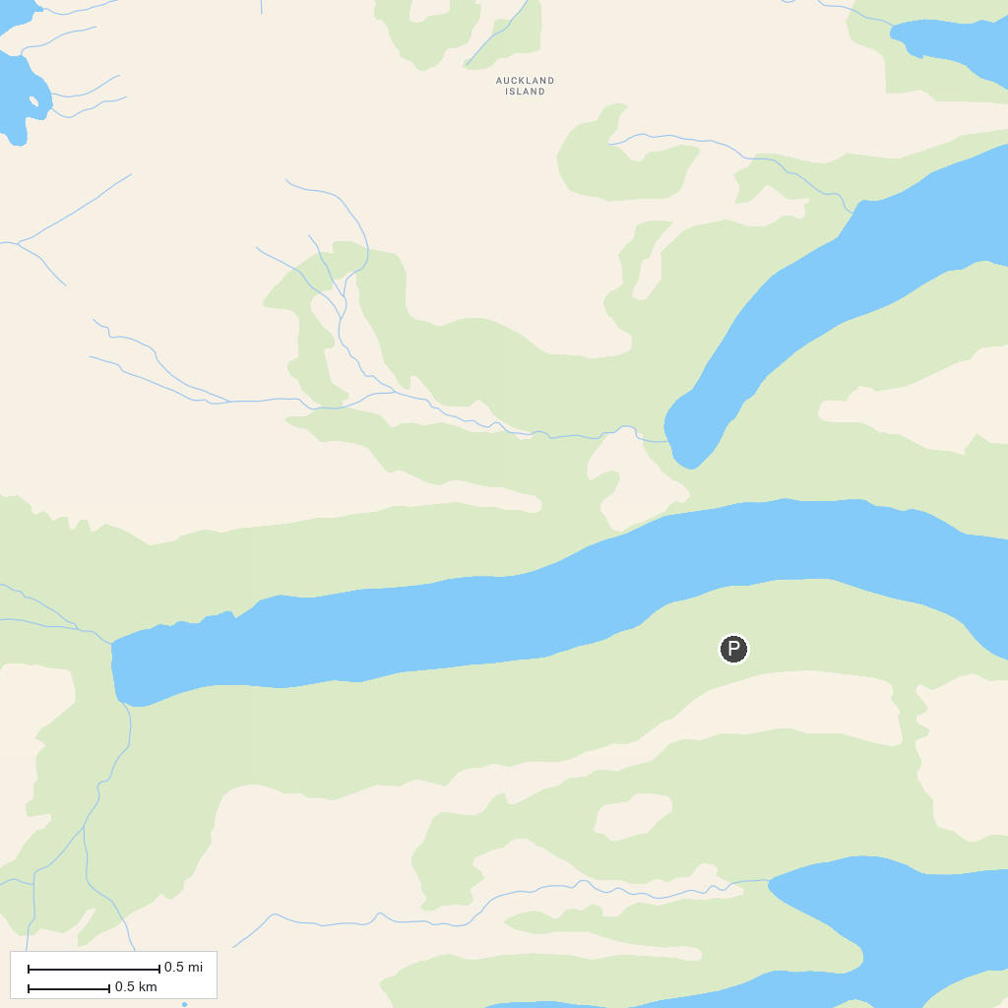
MAP KEY
1. Sandy Bay, Enderby Island | 3. Northern Circuit Boardwalk, Enderby Island
2. Derry Castle Reef
P. Cruise port / terminal
Map © MapTiler © OpenStreetMap contributors · cruiseports.org

