Augusta, Kentucky, USA
A perfectly preserved 1800s Ohio River village where paddle-wheelers still dock at the same levee that welcomed flatboats two centuries ago. Walk the Civil War battlefield, sip bourbon at a distillery dating to 1798, and ride the oldest continuously operating ferry in America.
⚓ Docked (river levee) · 🕒 Typical call: 6-8 hrs · 💵 USD · 🗣️ English · 🏛️ Historic rivertown
✍️ MY DAY IN PORT (FILL IN)
Ship / Date
In port | arrive ______ · all aboard ______
Booked excursion
Notes / meeting point
GETTING ASHORE
- Docking: Ships tie up at Augusta River Park levee on Riverside Drive — flat gangway, no tender
- Walk to center: Historic downtown Main Street is 2 blocks from the dock
- Best For: Civil War history, bourbon tastings, antique shops, Ohio River views
- Don't Miss: Baker-Bird Winery (est. 1798) and a ride on the Augusta Ferry to Ohio
GETTING AROUND
- 🚕 Taxi: Contact tourism office — No formal taxi stand at the dock. The Augusta/Bracken County Tourism Office (606-756-2183) can advise on any local car s
- 📱 Rideshare: ✅ Uber
TOP THINGS TO DO
- Civil War Battle of Augusta Walking Tour — On September 27, 1862, Confederate raiders under Basil Duke fought Union Home Guards through Augusta's streets.
- Rosemary Clooney House Museum — The Augusta home of singer and actress Rosemary Clooney (aunt of George Clooney) is now a museum filled with her personal…
- Baker-Bird Winery & Distillery — John Baker began distilling on this site in 1798, making it one of Kentucky's oldest documented bourbon operations.
- 1811 Augusta Jail & Appelman Park — The oldest jail in Kentucky still standing on its original foundation, used as a lockup until the 1970s.
- Augusta Ferry Crossing — The Augusta Ferry has operated since 1797, making it one of the oldest continuously operating ferries in America.
BEST WALKS
- Historic Main Street Loop: 1.5 miles · Flat · 60-90 min — From the River Park levee, head up to Riverside Drive and turn left toward the Welcome Center…
- Riverside Drive & Ferry Landing: 0.5 miles · Flat · 20 min — A short waterfront stroll along Riverside Drive from the cruise dock to the Augusta Ferry landing…
WEATHER · DAYLIGHT · MONEY
Month | High °F | Low °F | Rainy days
May | 65 | 46 | 9
Jul | 80 | 63 | 11
Sep | 72 | 56 | 8
Daylight: May 5:12AM–7:59PM · Jul 5:09AM–8:20PM · Sep 6:18AM–6:48PM
cruiseports.org/augusta-ky · Confirm terminal & all-aboard time with your ship

Augusta, Kentucky, USA — Port Map
Red = walkable sights · Amber = excursions farther out · P = cruise terminal
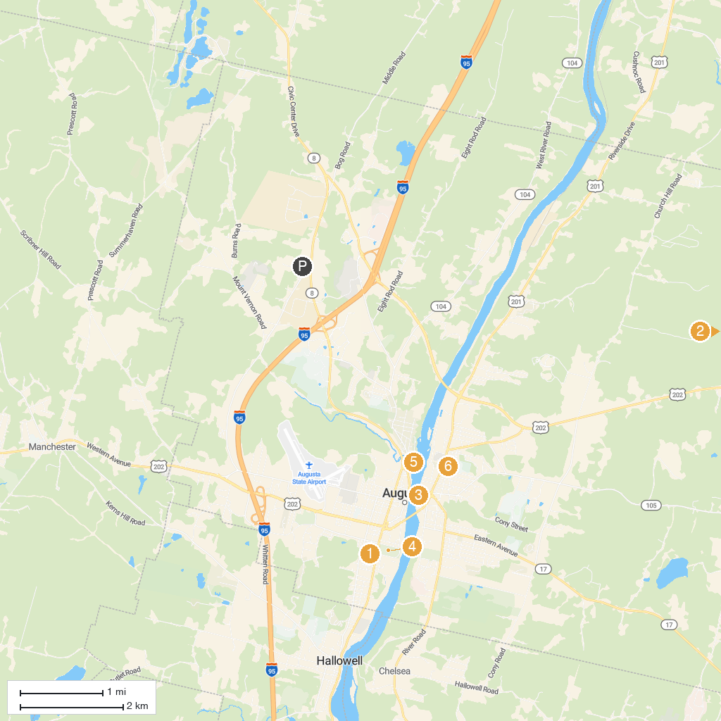
MAP KEY
1. Maine State Museum | 4. Capitol Park
2. Bicentennial Park | 5. Mill Park
3. Old Fort Western | 6. Williams Park
P. Cruise port / terminal
Map © MapTiler © OpenStreetMap contributors · cruiseports.org

