Austral Islands, French Polynesia
One of the most remote and least-visited archipelagos in French Polynesia, the Austral Islands reward adventurous cruisers with dramatic limestone caves, humpback whale encounters, and living Polynesian traditions barely touched by tourism.
⚓ Tender port (all islands) · 🕒 Typical call: 6-8 hrs · 💵 Currency: CFP Franc (XPF) · 🗣️ French & Tahitian
✍️ MY DAY IN PORT (FILL IN)
Ship / Date
In port | arrive ______ · all aboard ______
Booked excursion
Notes / meeting point
GETTING ASHORE
- Docking: All Austral Islands are tender-only; ships anchor offshore and ferry passengers by tender to small village landings
- Main Islands: Rurutu (caves), Tubuai (Bounty history), Raivavae (lagoon beauty), Rapa (remote), Rimatara (birds)
- Best For: Adventurous travelers seeking off-the-beaten-path Polynesia, whale watching (Jul–Oct), archaeology
- Don't Miss: Rurutu's Ana Ae'o limestone cave, Tubuai's Fort George, and traditional weaving demonstrations in village markets
GETTING AROUND
TOP THINGS TO DO
- Humpback Whale Watching (Rurutu) — Between July and October, humpback whales from Antarctica gather in Rurutu's waters to mate and calve.
- Rurutu Cave Tour — Ana Ae'o & Ana Taupe'e — Rurutu is dubbed the 'Troglodyte Island' for good reason.
- Tubuai: Bounty Mutineers & Fort George — After the Bounty mutiny in 1789, Fletcher Christian attempted to settle Tubuai, building an earthwork fort named Fort George at…
- Village Weaving & Craft Demonstrations — Rurutu is famous throughout French Polynesia for exceptionally fine woven pandanus products — hats, baskets, and mats.
- Raivavae Lagoon by Outrigger or Boat — Often called the 'Bora Bora of the South,' Raivavae has a stunning turquoise lagoon ringed by reef motu.
BEST WALKS
- Moerai Village & Coastal Walk (Rurutu): ~3 km · 1-1.5 hrs · Easy · Flat — From the Moerai tender quay, walk the coastal road south past the village church and waterfront…
- Tubuai North Coast — Bloody Bay & Fort George: ~3 km · 1-1.5 hrs · Easy · Flat coastal road — From the northern landing, follow the flat coastal road east toward Bloody Bay — the shoreline…
WEATHER · DAYLIGHT · MONEY
Month | High °F | Low °F | Rainy days
May | 77 | 74 | 13
Jul | 73 | 71 | 10
Sep | 73 | 70 | 9
Daylight: May 6:30AM–5:32PM · Jul 6:44AM–5:38PM · Sep 6:01AM–5:59PM
cruiseports.org/austral-islands · Confirm terminal & all-aboard time with your ship

Austral Islands, French Polynesia — Port Map
Red = walkable sights · Amber = excursions farther out · P = cruise terminal
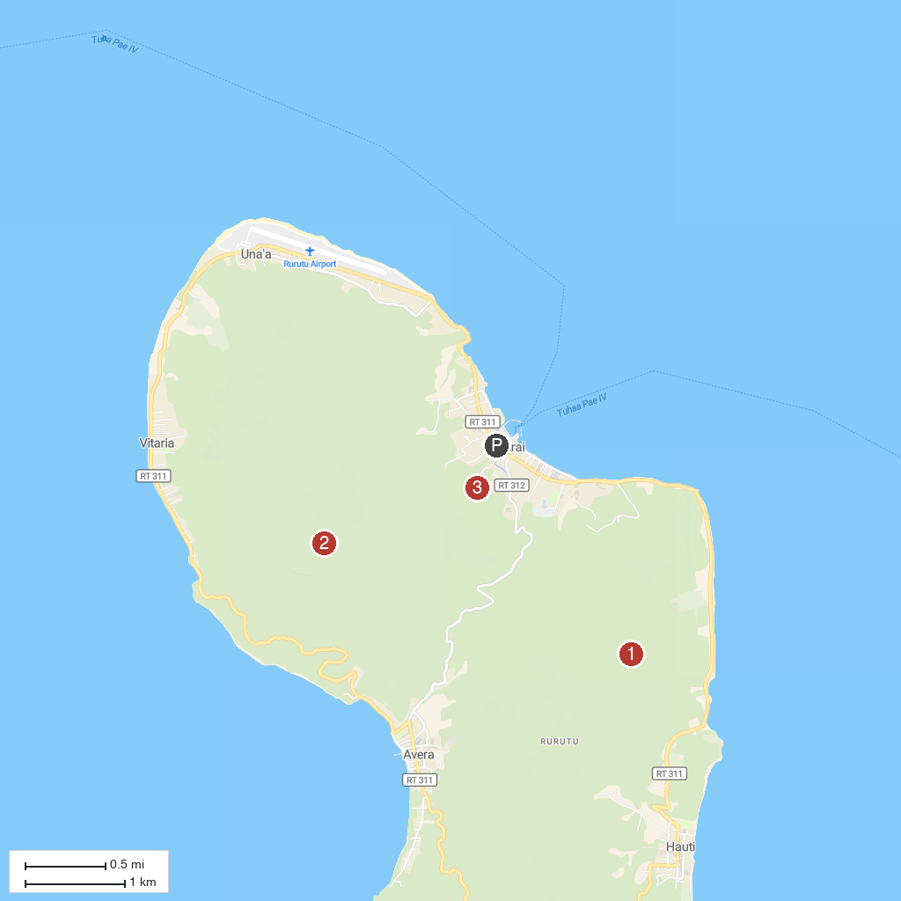
MAP KEY
1. Marae Ta'aroa, Vitaria | 3. Mount Pahia, Rurutu
2. Anaaeo Cave, Rurutu
P. Cruise port / terminal
Map © MapTiler © OpenStreetMap contributors · cruiseports.org

