Auvers-sur-Oise, Île-de-France, France
A village frozen in 1890, where Van Gogh painted around 75 canvases in his final 70 days. Every lane, church, and wheat field here echoes with Impressionist history — and it's all walkable from the quay.
⚓ River quay (docked) · 🕒 Typical call: 6-8 hrs · 💶 Euro · 🗣️ French · 🎨 Impressionist art mecca
✍️ MY DAY IN PORT (FILL IN)
Ship / Date
In port | arrive ______ · all aboard ______
Booked excursion
Notes / meeting point
GETTING ASHORE
- Docking: River cruise ships dock along the Oise quay; no tender required
- Walk to center: 5-10 min from the quay to Auberge Ravoux and the main village
- Best For: Van Gogh pilgrims, art lovers, slow walkers, history seekers
- Don't Miss: Van Gogh's preserved room at Auberge Ravoux and his grave in the village cemetery
GETTING AROUND
- 🚕 Taxi: €6–€15 — Several local taxi companies serve Auvers-sur-Oise (e.g. Taxi Lou, Cosy Taxi 95). Short rides within the village start a
- 📱 Rideshare: ✅ Uber
TOP THINGS TO DO
- Auberge Ravoux — Van Gogh's Final Room — The inn where Van Gogh lived and died in July 1890.
- Van Gogh Grave & Village Cemetery — Vincent and his brother Théo lie side by side beneath simple stone slabs covered in ivy, on a sunlit terrace above the wheat…
- Château d'Auvers — Impressionist Journey — A 17th-century château housing an acclaimed immersive multimedia experience on Impressionism — sound, light, and projections walk…
- Church of Notre-Dame d'Auvers & Painting Spots Walk — Stand in front of the 12th-century church Van Gogh immortalized in 1890 and follow the Artist's Pathway — plaques throughout the…
- Musée Daubigny & Doctor Gachet's House — The Musée Daubigny showcases Charles-François Daubigny, the Barbizon master who attracted artists to Auvers.
BEST WALKS
- Van Gogh Village Loop: 2-3 km · 1.5-2 hrs · Easy · Free — From the quay, walk to Auberge Ravoux, then to the Church of Notre-Dame, up to the village cemetery…
- Wheat Fields & Château Walk: 3-4 km · 1.5 hrs · Easy · Free — Head uphill from the village center through the wheat fields Van Gogh painted in his last days…
WEATHER · DAYLIGHT · MONEY
Month | High °F | Low °F | Rainy days
May | 65 | 49 | 12
Jul | 76 | 59 | 8
Sep | 71 | 54 | 8
Daylight: May 6:08AM–9:27PM · Jul 6:03AM–9:50PM · Sep 7:28AM–8:03PM
cruiseports.org/auvers-sur-oise · Confirm terminal & all-aboard time with your ship

Auvers-sur-Oise, Île-de-France, France — Port Map
Red = walkable sights · Amber = excursions farther out · P = cruise terminal
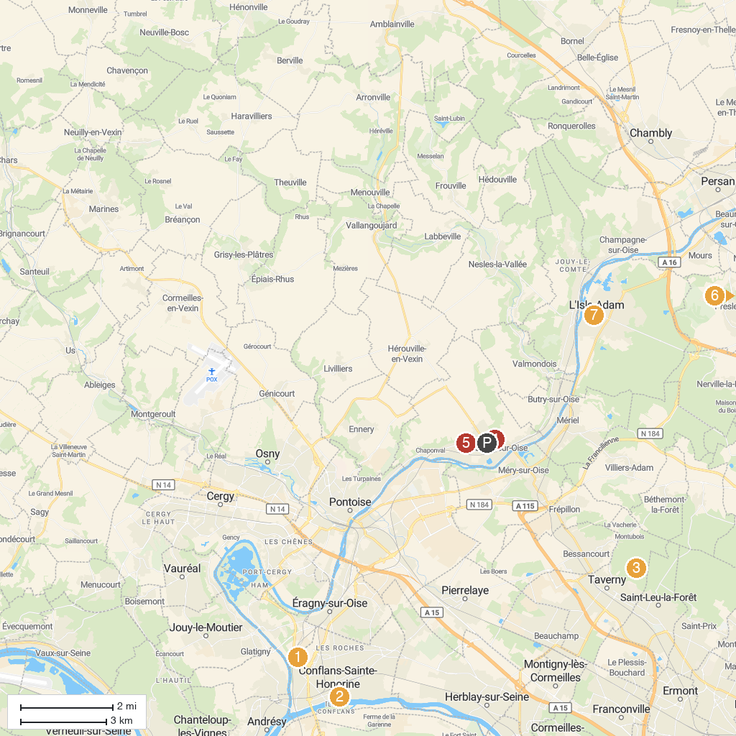
MAP KEY
1. Château de Maisons-Laffitte | 5. House-Workshop of Daubigny
2. Gulli Parc Conflans-Sainte-Honorine | 6. Maison du Docteur Gachet
3. Inland water transport museum | 7. Au Fil de l'Arbre - Fête de Lutte Ouvriere
4. Étang Godard | 8. Church of Saint Martin
P. Cruise port / terminal
Map © MapTiler © OpenStreetMap contributors · cruiseports.org

